Potential priority areas for conservation of the frugivorous fish in the Paraná-Paraguay Basin
Edivando V. do Couto, PhD., UTFPR, BRA
Leonardo S. Tomadon, Student, UTFPR, BR
Anielly G. de Oliveira, PhD, UEM, BRA
José H. Delconte, PhD, UTFPR, BRA
Valéria F. B. Silva, PhD, UEMS, BRA
Dayani Bailly, PhD, UEM, BRA

Abstract (300 word limit)
The environmental changes caused by humans have impacted the survival of species, especially those that depend on vegetation as food resource. The fish species Piaractus mesopotamicus (“pacu”), is a frugivorous species endemic to the Paraná-Paraguay basin, and because of deforestation and climate change, the protected areas are becoming increasingly important for species. The study aims is to identify the priority areas for conservation of the P. mesopotamicus, considering the climatic-biotic conditions and land use. The ecological niche modeling was used to estimate potential areas of occurrence, based on temperature, precipitation and hydrological variables, resulting in the frequency of occurrence, which was later, associated with land use data, and the result was the climatic-biotic suitability index. Finally, The Spatial Autocorrelation (Local Moran's I) index was used to identify patterns of spatial association that can be high and positive values and low equal values (clusters), and significantly low values (outliers). The suitable places for the presence of the species are located in the upper and lower Paraguay River, and in the upper and middle Paraná River, since they are regions that present the best climatic-environmental conditions for the species and the largest amount of remaining vegetation. When crossing the index data with the protected areas, there is little overlap between them, indicating the priority areas are not under protection. Currently, protected areas are proposed based only on terrestrial biota, and aquatic environments are left out, which difficult the conservation of aquatic biodiversity. Therefore climatic-biotic suitability index proved to be an efficient tool in the proposition of protected areas, as it managed to identify precisely which places need protection.
Image
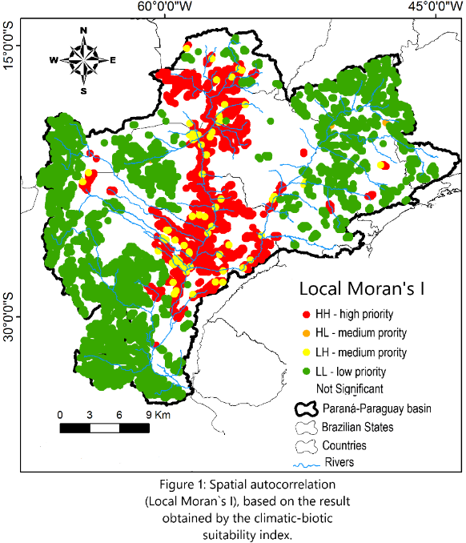
Recent Publications (minimum 5)
- Ceballos G, Ehrlich PR, Barnosly AD, Garcia A, Pringle RM, Palmer TM (2015) Accelerated modern human-induced species losses: Entering the sixth mass extinction. Science Advances 1(5): e1400253.
- Correa SB, Araujo JK, Penha J, Nunes CC, Bobier KE, Aanderson JT (2016) Stability and generalization in seed dispersal networks: a case study of frugivorous fish in Neotropical wetlands. Proceedings of the Royal Society B: Biological Sciences 283(1837):20161267.
- Guisan A, Thuiller W (2005) Predicting species distribution: offering more than simple habitat models. Ecology Letters, 8:993-1009.
- Hermoso V, ABbell R, Linke S, Boon P (2016) The role of protected areas for freshwater biodiversity conservation: challenges and opportunities in a rapidly changing world. Aquatic Conserv: Mar. Freshw, Ecosyst 26:3-11.
- Saunders DL, Meeuwig JJ, Vincent ACJ (2008) Freshwater Protected Areas: Strategies for Conservation. Conservation Biology 16(1):30-41.

Biography
Graduated in Geography from the State University of Maringá (UEM) 2008, Master in Geography (Environmental Analysis) from the State University of Maringá 2011 and Ph.D. in Geography from the Federal University of Paraná (UFPR) with an exchange period Center Européen de Recherche et D ' Enseignement des Géosciences de L'environnement / Aix-Marseille Université, 2015. I am currently a professor at the Federal Technological University of Paraná (UTFPR), at the Academic Department of Biodiversity and Nature Conservation (DABIC), where he teaches: Cartography and Biodiversity I am also a Young Doctor in the Postgraduate Program in Ecology of Continental Aquatic Environments (UEM) 2019 - 2020. I have expertise in the area of Geosciences and Applied Ecology.
Email: edivandocouto@gmail.com

