To a “Rio do Campo Limpo”- Assessment and management watershed in Brazil.
Luciane Maria Vieira, BEng, PhD, UTFPR, BRA
Karen Silvério Góis, Me, BIOL, UTFPR, BRA.
Edivando Vitor do Couto, BEng, PhD, UTFPR, BRA

Abstract

To a “Rio do Campo Limpo” project was developed to improve the environmental quality of watershed and the quality of life of residents of a small watershed in the interior of the state of Paraná, Brazil. Extension actions are developed by students and teachers with the community as environmental education activities, aiming to bring technical knowledge and sensitize them so that they become aware of the existing environmental problems and from this integration with the environment, can help in solving the problems. Among the environmental education activities already carried out, we highlight the offer of workshops and lectures with educators of early childhood school located around the Rio do Campo, workshops and scientific show with students, presentation of a model of the urban stretch of river a interviews with the surrounding residents and teachers to learn about their environmental perception of the basin. The environmental quality of the river is also monitored through physicochemical, heavy metals and herbicide analyzes in the river water and sediment in 4 points of the basin. These analyzes aim to diagnose pollution levels throughout the watershed and to relate to different types of land use and occupation using geoprocessing technological tools, making use of Remotely Piloted Aircraft (RPAs) in the imaging and identification of problems, in high definition. The analyzes have so far indicated at points downstream of the sewage treatment plant values above the environmental legislation by Escherichia coli and total Coliforms and that the sediments are enriched by Zn, Cd and Cr. It is noteworthy that the project is in progress, and that environmental education activities and watershed monitoring take place periodically.

Image
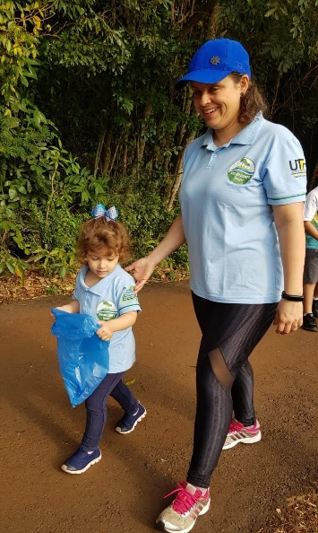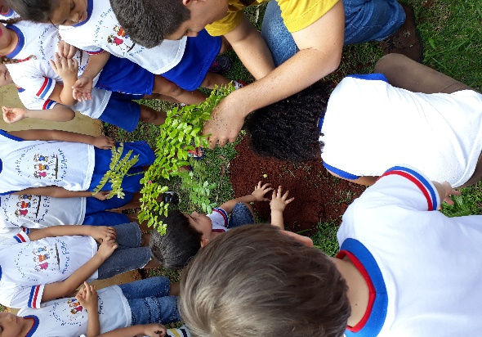
Figure 1: Waste collection for the families and environmental education with children, native especies “Pau-Brasil”.

Recent Publications (minimum 5)
Imhoff, M. L., Bounoua, l., Ricketts, T., Loucks, c., Harriss, r., & Lawrence, W. T. Global patterns in human consumption of net primary production. Nature, 429(6994), 870–873. 2004.
Kwok, K.H., Batley, G., Wenning, R., Zhu, L., Vangheluwe, M., Lee, S. Sediment quality guidelines: challenges and opportunities for improving sediment management. Environ. Sci. Pollut. Res. 21, 17–27. 2014.
Resolução do Conselho Nacional do Meio Ambiente, CONAMA N°357 de 2005.Brazil.
SANTOS, J. R. dos. Ética e natureza: o papel da educação na construção de um novo olhar. Revista Eletrônica Mestrado de Educação Ambiental, Rio Grande do Sul, v. 25, n. 1, p. 218- 232, jul./dez. 2010.
Vieira, L. M.; Neto, D. M.; Couto, E. V.; Lima, G. B.; Peron, A. P.; Halmeman, M. C. R.; Froehner, S. Contamination assessment and prediction of 27 trace elements in sediment core from na urban lake associated with land use. Environmental Monitoring and Assessment, 191:236, 2019.

 Biography
Graduated in Environmental Engineering (2004), Master in Environmental Science and Technology (2007) and PhD in Water and Environmental Engineering from the Federal University of Paraná (UFPR) with an exchange period, Institute of Environmental Assessment and Water Research, from CSIC, Barcelona, Spain (2014). I am currently a professor at the Federal Technological University of Paraná (UTFPR), at the Academic Department of Biodiversity and Nature Conservation (DABIC), where she teaches: Sanitation and Hydrology. I have expertise in the area of pollution of aquatic environments.
Email: lucianeutfpr@gmail.com

Notes/Comments:

