The ESI approach: integrating environmental, geographical and social data to assess sustainability in hydrographic basins
Edivando Vitor do Couto, Prof. Geogr. PhD, UTFPR, BRA
Pablo Boniol Oliveira, BSEE, UTFPR, BRA
Luciane Maria Vieira, BSEE PhD, UTFPR, BRA
Marcelo Henrique Schmitz, BSEE MSc, UEM, BRA
José Hilário Delconte Ferreira, Prof. Geogr. PhD, UTFPR, BRA

Abstract
The development and use of sustainability indicators have been considered an active and practical area of research and has several interactive applications, since they aim to assign a value that describes the complexity between social, environmental and ecological health. This approach, thus, exerts a fundamental role generating data about questions related to the environment and its impacts into processes like construction of planning, strategies and political decisions. Our aim was to elaborate an environmental sustainability index (ESI) for hydrographic basins. three factors were defined: the factor that characterizes the land use and occupation, the topographic attributes of the land and the socioeconomic and basic sanitation conditions, all recommended by the organization for economic cooperation and development (OECD) and which reflect the pressure - state - impact assessment model. the results allowed to identify the variation of the level of sustainability in the basin, being these levels distributed in five classes along the basin in the following proportion: very low 0%, low 16.68%, intermediate 72.49%, high 10.82% and very high 0.0004%. there is a notorious influence of the land use factor on the composition of the index. in areas where native vegetation is present, the environmental sustainability presented a much higher level than in areas with other types of use. The construction and application of the ESI for hydrographical basins using geoprocessing and remote sensing tools has shown consistent results, being able to be applied in several hydrographic basin scales in any region of the world. This approach presents low operational cost since the data that compose de ESI is public and financially accessible. This fact contributes to its application and favors the enhance of both technical-scientific knowledge and planning and management processes, strengthening public policies in order to achieve environmental sustainability for all society.

Image
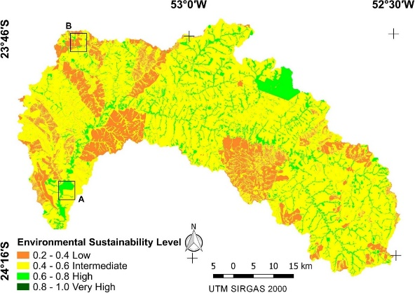
Recent Publications (minimum 5)
- Tomadon L S, Dettke G A, Caxambu M G, Ferreira I J M, Do Couto E V (2019) Significance of forest fragments for conservation of endangered vascular plant species in southern Brazil hotspots, Écoscience, 26:3, 221-235.
- Ferreira I J M, Bragion G R, Ferreira J H D, Benedito E, Do Couto E V (2019) Landscape pattern changes over 25 years across a hotspot zone in southern Brazil, Southern Forests: a Journal of Forest Science, 81:2, 175-184.
- Andrée BPJ, Chamorro A, Spencer P, Koomen E and Dogo H (2019) Revisiting the relation between economic growth and the environment; a global assessment of deforestation, pollution and carbon emission. Renewable and Sustainable Energy Reviews 114, 109221.
Böhringer C, Jochem PE (2007) Measuring the immeasurable: a survey of sustainability indices. Ecological Economics 63(1), 1–8.
5. Dizdaroglu D (2017) The role of indicator-based sustainability assessment in policy and the decision-making process: a review and outlook. Sustainability 9(6), 5512–5534.

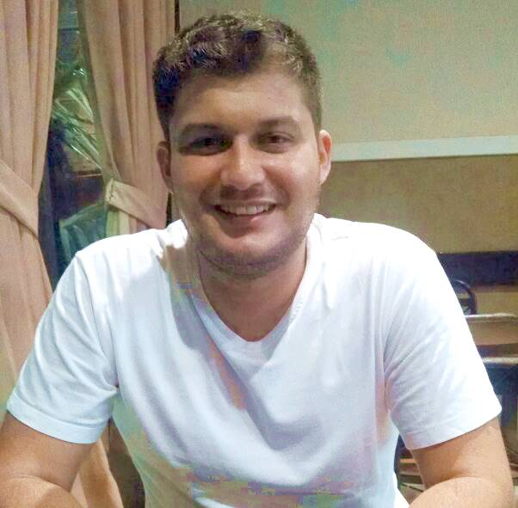 Biography
Graduated in Geography from the State University of Maringá (UEM) 2008, Master in Geography (Environmental Analysis) from the State University of Maringá 2011 and PhD in Geography from the Federal University of Paraná (UFPR) with an exchange period Center Européen de Recherche et D ' Enseignement des Géosciences de L'environnement / Aix-Marseille Université, 2015. I am currently a professor at the Federal Technological University of Paraná (UTFPR), at the Academic Department of Biodiversity and Nature Conservation (DABIC), where he teaches: Cartography and Biodiversity I am also a Young Doctor in the Postgraduate Program in Ecology of Continental Aquatic Environments (UEM) 2019 - 2020. I have expertise in the area of Geosciences and Applied Ecology.
Email: edivandocouto@gmail.com

