Flow Forming Process and Heat Treatment Effects on

2024 Aluminium Tubes

Senai Yalcinkaya PhD, Department of Mechanical Engineering, Technology Faculty of Marmara University, Istanbul,TURKEY

Abstract
Flow forming is a cold metal forming technique that enables the production of high precision thin-walled axisymmetric tubes or hollow parts with high strength and smooth surface. This technique is a continuous cold forming process and it reduces the wall thickness of the cylindrical shape starting part, stretching and extruding the workpiece with forming rollers. While wall thickness of the material reduces, the material flows plastically along a mandrel during the flow forming process. This technique is used in mainly aerospace, defence and energy industries in order to produce drive shafts, rocket motor cases, high precision hydraulic cylinders and hollow tubular parts. The aim of this study is to determine mechanical and microstructure properties of 2024 aluminium tubes which are produced by flow forming technique and make the comparison between flow formed 2024, full annealed (2024-O) and solution heat treated (2024-T6) temper aluminium tubes. 2024-O temper material was used before the flow forming process and this process which was performed on 2024-O tubing preform. The starting part which is named preform was annealed with 410 °C and hold at this temperature 2 hours in order to produce 2024-O temper according to AMS2772 standard. The solution heat treatment and artificially aging operation was applied to make 2024-T6 temper as per AMS2772. Moreover, %70 reduction rate was applied on the 2024-O temper material by flow forming and cold-working effects were analysed on the 2024 aluminium material. It was observed that grain orientations occurred, hardness and yield strength almost doubled but strain reduced after the flow forming operation. All of these samples showed the ductile fracture mode for tensile fracture surfaces, plus they exhibited that 2024-O tube could be plastically deformed by applying more than 70% thickness reduction. However, the 2024 –T6 applied AA alloy could be more dissolved in order to reduce the secondary phase rate during the solution heat treatment.

Image

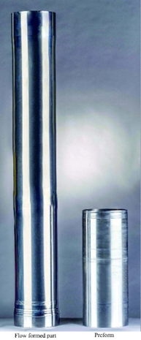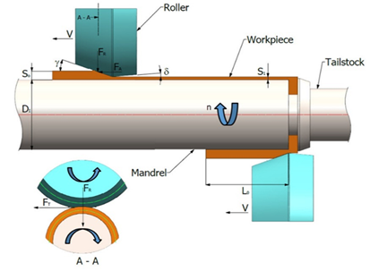

- (b)

S_{O} Starting wall thickness (mm) | γ Leading angle (degree,°) | F_{A} Axial force (N or Kg)
S₁ Finished wall thickness (mm) | δ Trailing angle(degree,°) | F_{R} Radial force (N)
L_{O} Starting length (mm) | R Nose radius(mm) | F_{T} Tangential force (N)
D_{I} Inside diameter (mm) | V Feed rate (mm/minute) | n Spindle Speed (rpm)
Figure 1. Illustration of Flow formed part, preform (a) and Flow forming Principle (b)

Recent Publications (minimum 5)
- R. J. Bhatt and H. K. Raval,(2016), “Influence of Operating Variables during Flow Forming Process,” in Procedia CIRP, vol. 55, pp. 146–151.
- Kocabiçak A. C., Yalçinkaya S. (2020)."Investigation of the Effects of Flowforming Process in Terms of Micro-Structure and Strength Applied to AISI 5140 Steel". “Technological Developments in Engineering”, Editors: Prof. Dr. Hülya KALAYCIOĞLU and Assist Prof.Dr. Senai YALÇINKAYA, Güven Plus Publications: 45/2020, Istanbul,Turkey, pp.53-75,
- M. Joseph Davidson, K. Balasubramanian, and G. R. N. Tagore, (2008), “An experimental study on the quality of flow-formed AA6061 tubes,” J. Mater. Process. Technol., vol. 203, no. 1–3, pp. 321–325.
- R. J. Bhatt and H. K. Raval, (2015), “Comparative Study of Forward and Backward Flow Forming Process using Finite Element Analysis,” Bonfring Int. J. Ind. Eng. Manag. Sci., vol. 5, no. 2, pp. 46–50.
- C. W. Lin, K. J. Chen, F. Y. Hung, T. S. Lui, and H. P. Chen,(2019), “Impact of solid-solution treatment on microstructural characteristics and formability of rotary-swaged 2024 alloy tubes,” J. Mater. Res. Technol., vol. 8, no. 3, pp. 3137–3148.
- Karakaş A., Kocabiçak A. C. , Yalçinkaya S. , Şahin Y. (2021), Flow Forming Process for Annealed AISI 5140 Alloy Steel Tube, Proceedings of the 8th International Conference on Fracture, Fatigue and Wear, cilt.8, sa.8, ss.153-164.
- Repkon (2020), Machine and Tool Industry and Trade Inc., 34980, Istanbul, Turkey,


Biography
Dr.Senai YALÇINKAYA working as an Assistant Prof in Marmara University Faculty of Technology Department of Mechanical Engineering.
He continues to work as a research and teaching member at Istanbul Marmara University. He is the editor of International Symposiums, books, and journals and has many international papers and published research studies. He conducted academic research studies at Minho University in Portugal and at Stuttgart University in Germany.
He has presented more than 20 book chapters published in books in the field of engineering and more than 60 international papers. He has over 25 published articles.
Research Areas
Metal cutting principles, Manufacturing Processes, Cutting Tools, Wear and Friction, Tool Design, Corrosion, and Surface Protection Materials in Machine, Experimental Design, and Analysis. Friction and wear theories, Corrosion and surface protection of machine materials, 3D Printer Extruder.
Education Activities
Metal cutting principles, Manufacturing processes, Machine design, Experimental design &Analysis, SLS, Friction and wear theories, Corrosion and surface protection of machine materials, 3D printer, Tribology, Machining processes, Additive Manufacturing

Email:syalcinkaya@marmara.edu.tr

Notes/Comments:

