Materiality Matrix Use in Aligning and Determining a Firm’s
Sustainable Business Model Archetype and Triple Bottom Line Impact on Stakeholders.

Valeska V. Geldres-Weiss, PhD, Universidad de La Frontera, Chile.
Nicolás Gambetta, PhD, Universidad ORT Uruguay, Uruguay.
Nathaniel P. Massa, PhD, University of Malta, Malta.
Skania L. Geldres-Weiss, Doctoral Candidate in Marketing, Universidad de La Serena, Chile.

Abstract (300 word limit)

The materiality matrix is a tool that helps companies understand how the stakeholders’ view of material issues in environmental, social, and economic/governance dimensions influences their value creation process, and creates triple bottom line impacts through shaping their strategic business model elements. Building on the multidimensional definition of materiality, we propose to use the materiality matrix as a tool to aid the transformation of a company’s existing traditional business model into a more sustainable one (inside-out approach), and to enable the identification of the most appropriate business model archetype to incorporate innovation into its sustainable business model (outside-in approach). This paper presents the materiality matrix as a new tool to enhance and transpose a company’s business model towards sustainability—as illustrated through the analysis of the Viña Concha y Toro business model case. This new tool contributes to sustainable business model literature and stakeholder theory by incorporating the materiality matrix as a gateway to business model innovation, and as a tool to explain the dynamics in the sustainable value creation process and concomitant impact on stakeholders.

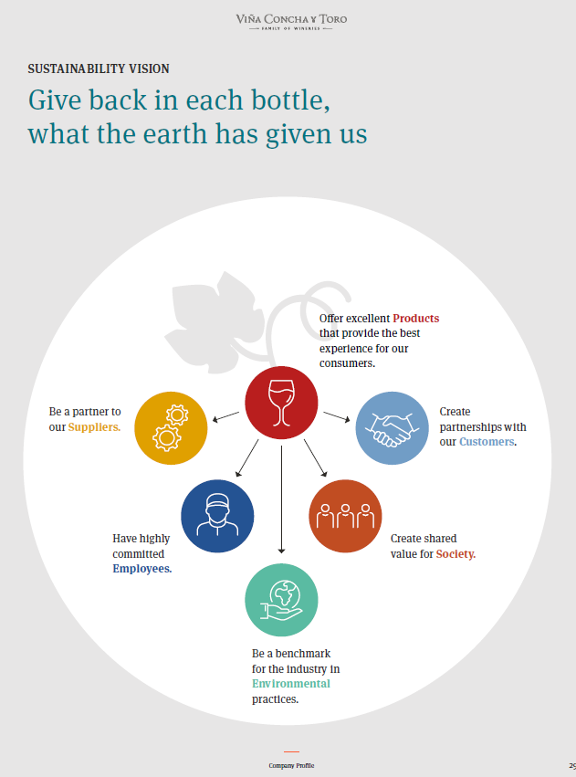
Recent Publications

Geldres-Weiss, V. V., Gambetta, N., Massa, N. P., & Geldres-Weiss, S. L. (2021). Materiality Matrix Use in Aligning and Determining a Firm’s Sustainable Business Model Archetype and Triple Bottom Line Impact on Stakeholders. Sustainability, 13(3), 1065.

Cattaneo, C., Geldres-Weiss, S.L., & Candelino, E. (2020): Derecho a la información y consumo saludable: algunos elementos para el análisis de una relación compleja”. En: DURAND, P; GELABERT, C. (Comps.): “Aportes de los Objetivos de Desarrollo Sostenible para una Agricultura Sustentable en la Argentina: Una mirada Social desde la Universidad. Cap. 12, págs. 194-209. Editorial Facultad de Agronomía, Universidad de Buenos Aires, Argentina, ISBN 978-987-3738-31-9

Biography
Skania L. Geldres-Weiss is Agronomist Engineer, Master's Degree in Business Administration, and Doctoral Candidate in Marketing at Valencia University. Currently is Researcher at Department of Economics and Business at Universidad de La Serena, and Marketing Consultants Director. Her research interests are International Business; Digital Marketing and Sustainability. She has developed international business in the food industry in the world, her expertise are prospection, promotion, and maintenance of international markets. She drove the sales growth, value creation, and marketing strategies in the B2B international arena. She has participated in Food and Beverage International Trade Shows, as exhibitor and visitor.
Email: skania.geldres@userena.cl

