how to leverage modern eco-friendly materials in an educational context
Thomas Baldauf, BA Informatikmanagement, University of Vienna, Austria

Abstract
Facing global warming and the general waste of materials, upcycling, reusing and disintegration of existing products is key for a saver planet and a saver environment. If we only learn this as adults, there is way more time needed for training or changing of the behavior. To scale this problem on a global scale, new approaches in teaching and education are needed, so we can educate young children without fear, but with joy, with new technologies and saving our planet.
One interesting new approach to this, are the makerspaces that emerge around the world next to schools and in schools and become more accepted by educators as an expanding toolset to fulfill their respective curriculum in K8 and K12 schools. If this is combined with championships (hackathons) and other forms of competitive and cooperative extra tasks, pupils feel proud of their products, showcase them and by creating and improving them in their environment they take leadership in their learnings and learning becomes more relevant for them-
If we face K8 and K12 pupils with real life problems based on the 17 UN Sustainable Development Goals (SDGs) in a Makerspace it is possible to set requirements like: (1) reuse existing trash (2) deconstruct existing products (3) improve things through adapters that are 3D printed (4) improvise whenever needed. In that scenario pupils learn to use modern 3D technologies for digital and analogue prototypes, learn about manufacturing processes, gain knowledge of different materials and as a result respect their environment more while solving problems our communities are facing around the world.
To scale this educational approach around the world, not each school or school district needs all the expertise needed to run a makerspace that way but can reach out to the surrounding communities whenever needed – creating shared common values and strengthen existing partnerships.

Image
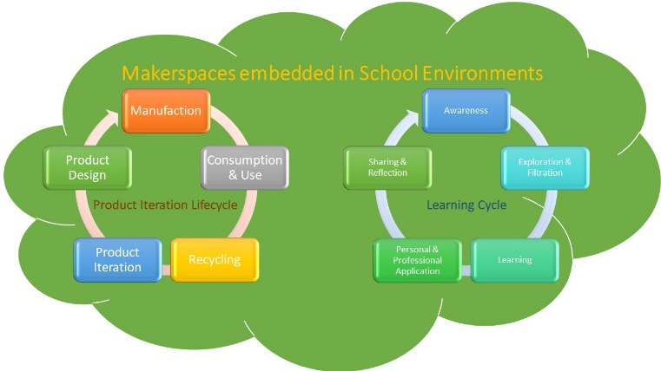
Makerspaces embedded in School Environments – showcasing the product iteration lifecycle and the learning cycle
Recent Publications
- Schön, S., Friebel, L., Braun, C., Ebner, M., & Eder, J. (2019). Makerspaces zur Wissenschaftsvermittlung und Innovationsraum der neuen Generation. In J. Hafer, M. Mauch, & M. Schumann (Eds.), Teilhabe in der digitalen Bildungswelt: GMW Proceedings 2019, Medien in der Wissenschaft (pp. 187-197). (Medien in der Wissenschaft; Vol. 75). Münster: Waxmann.
- Vuorikari, R., Ferrari, A. and Punie, Y., Makerspaces for Education and Training: Exploring future implications for Europe , EUR 29819 EN, Publications Office of the European Union, Luxembourg, 2019, ISBN 978-92-76-09032-8 (online), doi:10.2760/946996 (online), JRC117481.
- http://www.makerspaceforeducation.com/inventions-with-recycled-materials.html, Roffey Trish (since 2016)
- Thompson Ruth (2016) Plastics, ISBN 978-1583409381
- https://www.youthhackathon.com/, MadeByKids, DaVinciLab (since 2017)

Biography
Thomas Baldauf has worked in digitalization in the last 12 years in different roles and environments, always passionately exploring new emerging technologies. After graduation of a higher secondary technical school in Austria, he started his bachelor’s degree in 2005 at the University of Vienna. In 2008 he joined the Startup Softtec Austria as Project Manager and Programmer for Food Automation Systems running entire Food Processing Sites. In 2011 he finished his Bachelor and joined the Austrian Education System as an IT-Teacher. In 2012 he became head of the biggest secondary school of Austria. In 2016 he was promoted by the Ministry or Education as main coordinator of IT-Teachers of a particular school type. In 2021 he will have his own company.
Email: t_baldauf@web.de

Notes/Comments:

