Process of Analyzing Data in Statistics
Hazhar Blbas, MSc in Statistics at UCF-USA
Lecturer in Statistics Department at Salahaddin University

Abstract (300 word limit)
Statement of the Problem: Statistics is the king of science and it is one of the most powerful major around the world. Process of analyzing data in Statistics is important and every Statistician has to follow these steps such as selecting the problem or phenomenon, collecting data, organizing data, analyzing data, interpreting data, and make a decision from the result. After selecting the problem in any kind of research we have to collect the data either by primary source data or secondary source data. Primary source data is collecting data by yourself by creating questionnaire form while secondary source data is a collecting data from someone else that they have used data before. Also we have two methods for choosing sample from population such as probability and non-probability sampling. Probability Sampling includes Simple Random Sapling, Stratified Sampling, Systematic Sampling, Cluster Sampling and Multistage Sampling. In the other hand, non-probability sampling includes Judgment Sampling, Convenes Sampling, Quota Sampling and Snowball Sampling. Third step, we have to organize and prepare data before analyzing the data. Next step, we can use several statistical tests or models such as, Descriptive Statistics, One Sample T Test, Independent Sample T Test, Paired Sample T Test, One Way ANOVA, Chi-Square Test, Correlation, Regression Analysis, Logistic Regression, Factor Analysis, Cluster Analysis, …, etc. depending on your data and your objective on your research. Finally, you can interpret your result and get some conclusions and recommendations according to your result.

Image
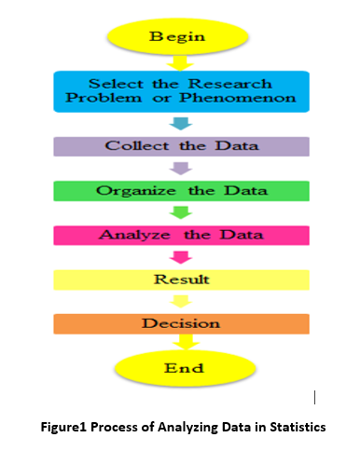
Recent Publications (minimum 5)
- Blbas, H. T., Aziz, K. F., Nejad, S. H., & Barzinjy, A. A. (2020). Phenomenon of depression and anxiety related to precautions for prevention among population during the outbreak of COVID-19 in Kurdistan Region of Iraq: Based on questionnaire survey. Journal of Public Health. doi:10.1007/s10389-020-01325-9
- Blbas, H.T., & Kadir, D.H. (2019). An Application of Factor Analysis to Identify the Most Effective Reasons that University Students Hate to Read Books.
- Blbas, H.T. (2019). Statistical Analysis for the Most Influential Reasons for Divorce between Men and Women in Erbil-Iraq.
- Blbas H. et al., (2017), “A Comparison results of factor analysis and cluster analysis to the migration of young people from the Kurdistan Region to Europe (Published at Zanko Journal), ZJPAS: 29(4): 44-55.
- Blbas H. et al., (2017) “A statistical study to investigate reasons that graduate students do not get job at Salahaddin University-Erbil using Factor Analysis (Published at Raparin University journal), Journal Raparin University: 11(4): 197-226. (By Kurdish Language)
- Karen Aroian, Nizam Uddin & Hazar Blbas (2017), “Longitudinal study of stress, social support, and depression in married Arab immigrant women”, Health Care for Women International, 38:2, 100-117, DOI: 10.1080/07399332.2016.1253698

Biography (150 word limit)
He gained a scholarship and completed his master’s degree in the Statistical Computing Department at the University of Central Florida on May 2014 with GPA 3.425 out of 4. After finishing, he has been working in Statistics Department at Salahaddin University as a lecturer. Most of his master’s degree classes were Applied Statistics, such as, Biostatistics, Nonparametric, Regression, Logistic Regression, Experimental Design, and Sampling. In the last six years, he has taught several classes such as Principles of Statistics, Math I, Math II, Calculus, Biostatistics, Survey, Regression Analysis, Excel and SPSS. Also, he has a founder of STAT Office for Statistical Data Analysis and Training. In this center he helps students finish their theses or dissertations in practical sections.
Email: hazhar.abubaker@su.edu.krd

Notes/Comments:

