Biomaterials for sustainable packaging: FISH4FISH project
Daniele Spinelli, Next Technology Tecnotessile, Italy
Maria Fernandez-Lobato, CSIC, Spain
Ana Garcia Cabado, ANFACO CECOPESCA, Spain
Vanesa Martinez, TECNOPACKAGING, Spain
Raffaele Saladino, University of Tuscia, Italy
Rebecca Pogni, University of Siena, Italy

Abstract
Statement of the Problem: The fish industry produces huge amounts of plastic containers and more than 10,000 tons/year of shellfish food waste. Packaging plays a critical role in the fish supply chain and can be part of the solution to tackle food waste. The main targets are: (a) reduce environmental damage with the use of biodegradable materials; (b) make sure that the plastic used for the packaging does not interfere with the food integrity causing potential long-term side effects through the release of toxic additives. Methodology & Theoretical Orientation: The FISH4FISH project aims to produce innovative active and sustainable packaging material based on chitinolytic derivatives, using marine biomass wastes. Such packaging enhances fish shelf-life and, once it is wasted, it can be used as fertilizer and microbial preservatives for plants. Chitin obtained from marine biowastes will be treated to obtain chitosan and chito-oligomers. Lignin functionalized nanoparticles used as biofiller in the preparation of the new polymeric material with improved functional properties. Findings: The objective of FISH4FISH project is to obtain a low-cost active material to be exploited for the industrial applications of fish packaging. In this way, renewable resources are exploited in a sustainable manner, promoting bio-based, environmentally friendly and beneficial technologies, and create high-performing materials for a wide range of applications. Conclusion & Significance: In this context the ambition of the FISH4FISH project is to fill the gap, considering the potential of developing food packaging from seafood processing waste and biorefinery residues in order to create business for fish and in general food industries, being aware of the food quality demanded by consumers and the environmental care demanded by institutions and society.

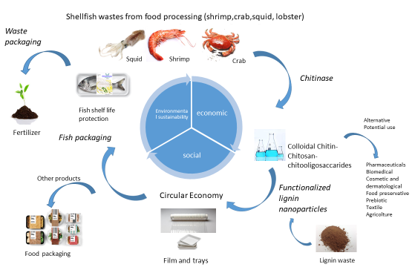
Project concept
Recent Publications
- Gallo et al. (2018) Marine litter plastics and microp plastics and their toxic chemicals components: the need for urgent preventive measures. Environmental Sciences Europe volume 30:11.
- Report 2018 on blue strategy economy https://ec.europa.eu/maritimeaffairs/sites/maritimeaffairs/files/2018-annual-economic-report-on-blue- economy_en.pdf.
- Peter Elias Kidibule, et al. (2020) Endo-chitinase Chit33 specificity on different chitinolytic materials allows the production of unexplored chitooligosaccharides with antioxidant activity. Biotechnology Reports 27: e00500.
- Peter E. Kidibule, et al. (2021) Production and characterization of chitooligosaccharides by the fungal chitinase Chit42 immobilized on magnetic nanoparticles and chitosan beads: selectivity, specificity and improved operational utility. RSC Adv. 11:5529.
5. Eliana Capecchi, et al. (2020) Lignin nanoparticles are renewable and functional platforms for the concanavalin a oriented immobilization of glucose oxidase–peroxidase in cascade bio-sensing. RSC Adv. 10:29031.

 Biography
PhD degree in Chemical Sciences (University of Siena). Since 2017 he is working in Next Technology Tecnotessile as member of the chemical and technological research unit. He has a wide experience in EU funded projects: Biscol and Smartpro (FP Programme), Photocitytex (Life Programme), Optisolv (Eurotransbio), Waste2Fuels, Smartpro, Bio4Self, Ecobulk, Sealive, Preserve and Sunrise (H2020), Bluenet and Fish4Fish (EMFF). He is also responsible of the environmental evaluation of industrial value chains by LCA methodology.
Email: chemtech@tecnotex.it

