Development of novel ultrafiltration membrane made from nano-spinel on phosphate support for dye removal application
Abdessamad Belgada*¹, Fatima Zohra Charik¹, Saad Alami Younssi¹, Mohamed Ouammou¹, Vasyl Mikhaylovych³ and Alexandra Raluca IORDAN²
(1) Laboratory of Materials, Membranes and Environment, Faculty of Science and Techniques of Mohammedia, Hassan II University of Casablanca, Morocco
(2) Faculty of Chemistry, Alexandru Ioan Cuza Universityof Iasi, Romania
(3) Department of General Chemistry and Material Science, Yuriy Fedkovych Chernivtsi National University, 2, Kotsubinsky St., 58012, Chernivtsi, Ukraine

Abstract
As well known, the most of dyes present in textile effluents are toxic and may cause damages for humans and environment. Therefore, it is necessary to treat the textile effluent before discharging into aquatic areas. Ultrafiltration (UF) is considered as one of the most effective processes used for the treatment of discharged colored wastewater generated from textile industries [1].
This work aims to develop a novel cost effective UF ceramic membrane based on spinel nanomaterials. Firstly, ceramic support was prepared from natural phosphate via dry pressing method. Afterwards, copper-based spinel nanomaterial was synthesized via sol-gel auto-combustion method using tartaric acid as the fuel agent [2]. After optimizing the preparation process, the synthesized spinel nanomaterial was dispersed in a polyvinyl alcohol solution and deposited on the ceramic support using spin-coating method and then sintered in a programmable furnace at 350 °C [2]. Subsequently, the resulted membrane was thoroughly characterized by several techniques such as Fourier Transform Infrared spectroscopy, transmission electron microscopy, scanning electron microscope (SEM), pore size and contact angle as well as the assessment of its performance in terms of permeability and rejection rate. As shown in figure 1, nano-spinel material covered all of the support surface and exhibits a homogeneous and uniform morphology.

The developed UF membrane was then applied for direct red (DR) dye removal via tangential filtration process. Preliminary results show that the prepared membrane could reject up to 95% of DR from water.

References:
[1] H. Ouaddari, A. Karim, B. Achiou, S. Saja, A. Aaddane, J. Bennazha, I. El Amrani El Hassani, M. Ouammou, A. Albizane, New low-cost ultrafiltration membrane made from purified natural clays for direct Red 80 dye removal, J. Environ. Chem. Eng. 7 (2019) 103268.
[2] A.M. Dumitrescu, P.M. Samoila, V. Nica, F. Doroftei, A.R. Iordan, M.N. Palamaru, Study of the chelating/fuel agents influence on NiFe2O4 samples with potential catalytic properties, Powder Technol. 243 (2013) 9–17.
Acknowledgements: The authors gratefully acknowledge the MESRSFC (Ministère de l′Enseignement Supérieur, de la Recherche Scientifique et de la Formation des cadres, Morocco), CNRST (Centre National pour la Recherche Scientifique et Technique, Morocco) (Project: PPR/2015/72) and Erasmus+ EU programme for their support.

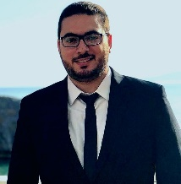
Biography: I am pursuing my doctoral studies in Chemical and Environmental Engineering - Membrane Technology at the Laboratory of Materials, Membranes and Environment, Hassan II University of Casablanca, Morocco. I am working on the preparation and the characterization of low-cost ceramic membranes and nanomaterials, for the pretreatment of seawater prior to reverse osmosis desalination as well as for industrial wastewater treatment. I had the chance to work at the Laboratory of Inorganic Chemistry, Alexandru Ioan Cuza University in Isai, Romania in the context of Erasmus+ mobility, where I synthesized some nano-spinel materials and apply them in membrane technology field. The third phase of my doctoral studies will be carried out in the Chemical and Environmental Engineering Department at Yale University, USA as a Fulbright scholar, where I will develop low-cost membranes for pervaporation and membrane distillation applications responding to the Energy-Water Nexus.

Email: abdessamad.belgada-etu@etu.univh2c.ma

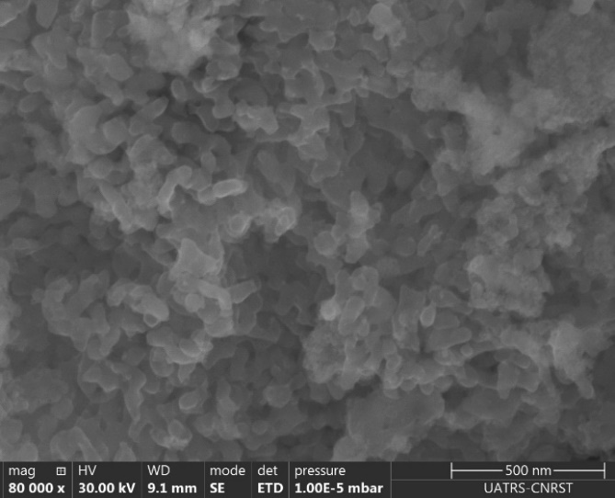
Figure 1: SEM micrographs of top-surface of prepared UF membranes
Recent Publications
- A. Belgada, B. Achiou, S. A. Younssi, F. Z. Charik, M. Ouammou, J. A. Cody, R. Benhida, K. Khaless, Low-cost ceramic microfiltration membrane made from natural phosphate for pretreatment of raw seawater for desalination, Journal of the European Ceramic Society 2020, 41: 1613–1621
- A. Belgada, F. Z. Charik, B. Achiou, T. N. Kambuyi, S. A. Younssi, R. Beniazza, A. Dani, R. Benhida, M. Ouammou, Optimization of phosphate/kaolinite microfiltration membrane using Box–Behnken design for treatment of industrial wastewater, Journal of Environmental Chemical Engineering 2021, 9: 104972
- F.Z. Charik, B. Achiou, A. Belgada, M. Ouammou, S.A. Younssi, Zeolite materials in service of membrane technology, in: A. Mahler (Ed.), Zeolites: Advances in Research and Applications, Nova Science Publishers Inc, New York, 2020, pp. 133–162
- H. Ouaddari, A. Karim, B. Achiou, S. Saja, A. Aaddane, J. Bennazha, I. H. Hassani, M. Ouammou, A. Albizane, New low-cost ultrafiltration membrane made from purified natural clays for direct Red 80 dye removal, Journal of Environmental Chemical Engineering 2019, 7:103268
- S. Saja, A. Bouazizi, B. Achiou, H. Ouaddari, A. Karim, M. Ouammou, A. Aaddane, J. Bennazha, S. Alami Younssi Fabrication of low-cost ceramic ultrafiltration membrane made from bentonite clay and its application for soluble dyes removal, Journal of the European Ceramic Society 2020, 40: 2453-2462

