From a smoke-free policy to an end of waste proposal at the University of Milano-Bicocca

Massimiliano Rossetti, Sustainability Specialist, University of Milano-Bicocca
Niccolò Lamanna, Research fellow, University of Milano-Bicocca
Luca Zoia, Researcher, University of Milano-Bicocca
Andrea Franzetti, Associate Professor, University of Milano-Bicocca

Abstract (300 word limit)
The sustainability team of the University of Milano-Bicocca promotes healthy life style for students and staff. Starting from 2019, the University introduced a Smoke-free policy within the whole campus in order to avoid littering phenomena and preserve the students and staff wellbeing. Coherently to the prohibition, few smoking areas have been settled far from the entrances in order to let to the smokers a delimitated space. These smoking areas have been equipped with benches and ballot bins with the scope to attract smokers and keep streets clean.
Beyond this, the aim is to recover the undifferentiated scrap in the form of cigarette butts, in order to obtain a secondary industrial product that will be reintroduced into the economic cycle. The growing global problem of littering, with attention to the cigarette butts and their externalities in terms of environmental toxicity due mainly to the chemical compounds they contain, it has become a serious issue. Cigarette butts are the most littered item in the world, with 4.5 trillion discarded each year. Estimates on the required time for cigarette butts to break down vary, ranging from five years to 400 years for complete degradation. The environment deterioration depends not only from cellulose acetate the filter is made of but also from the chemical compounds produced by the combustion of tobacco and retained by the filter and also from tobacco residues, such as lignin. Therefore, the aim will be twofold. First, few smoking areas have been furnished with ballot bins to protect the environment and human health. Second, the idea is to move towards an end of waste proposal by implementing a cellulose recycling chain. Our proposal has been based on a review of the literature and some early laboratory-scale experiments regarding the treatment of cigarette butts.

Image
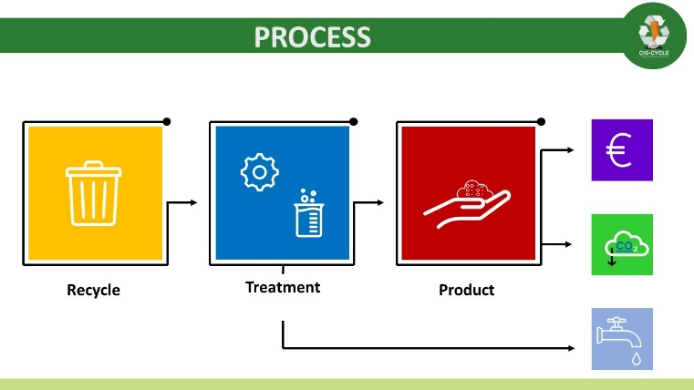
Recent Publications (minimum 5)
- Luca Daconto, Simone Caiello, Mario Boffi, Massimiliano Rossetti, Matteo Colleoni (2020) Emergency (Im)mobilities. Insights from the pandemic of coronavirus in Italy. FuoriLuogo.
- Matteo Colleoni, Massimiliano Rossetti, Giacomo Magatti, Paola Palestini, Giovanna Iannantuoni (accepted) “A nudging approach to promote healthier and more sustainable food consumption and lifestyles at the University of Milano-Bicocca” In Proceedings of the 6th International Workshop on UI GreenMetric World University Rankings (IWGM 2019)
- Colleoni M., Rossetti M. (a cura di) (2019), Università e governance della mobilità sostenibile, Franco Angeli, Milano.
- Colleoni, M; Rossetti, M; Magatti, G; Labra, M; Orlandi, M; Messa, C (2019) “Sustainable mobility management at the University of Milan-Bicocca”. pp.161-168. In Proceedings of the 5th International Workshop on UI GreenMetric World University Rankings (IWGM 2019) - ISBN:9789794567999
- Messa, C; Magatti, G; Rossetti, M; Colleoni, M; Labra, M; Camatini, M (2018) “BASE: A sustainable path for the University of Milano-Bicocca”. DOI:10.1051/e3sconf/20184804005. pp.04005. In E3S Web of Conferences. In E3S WEB OF CONFERENCES - ISSN:2267-1242 vol. 48

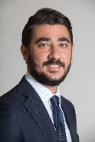Biography (150 word limit)
Massimiliano Rossetti is sustainability specialist at the University of Milano-Bicocca. He is an urban sociologist with particular attention to mobility analysis and the socio-urban structure of the territory with the use of GIS tools. Its fields of interest and study concern the field of sustainability: from waste to mobility and from food policy to life quality in urban societies. He also cooperates in the field of air quality and climate change with the researcher’s team of the POLARIS Research Center - Department of Environmental Sciences at the University of Milano-Bicocca. He is member of the Italian University Network for Sustainable Development (RUS), International Sustainable Campus Network and the Italian Interdisciplinary Committee on Waste and Health (CIRS).
Email: massimiliano.rossetti@unimib.it
Notes/Comments

