Transition metal free Green Synthesis of heterocyclic compounds in Water based solutions
Priya
Department of Chemistry, Panjab University, Chandigarh, India

Abstract
In the epoch of globalization, progress has always been an indispensable issue among nations. But the latest development trends which have been highlighted by the reports of various international organizations exhibit that most of the modern development practices do not align with international environment standards. Economic development, especially through industries, poses a serious challenge for the global fraternity as it is depreciating the quality of the environment. These days, climate change is not only an indigenous problem but global intimidation. Thus, there is an urgent need to move towards sustainable development by employing efficient, clean processes and technology to lessen environmental impacts. Green research is emerging as one of the important threads of development to reduce hazardous waste. My research focuses on the development of such procedures for the synthesis of industrially important heterocyclic compounds.
The highlights of the work done are:
1. Substituted carbazoles were synthesized from 2-aminobiaryls by means of C (sp²)-H functionalization and C-N bond formation using TBAB as phase transfer catalyst and persulfate as oxidant in aqueous solutions. The scope of this methodology was extended to the series of 2-aminobiaryls with diverse functional groups.
2. Following this, we worked in the field of visible light photocatalysis, where phenanthridine-6-carboxylates were synthesized via intramolecular cyclisation reaction of N-biarylglycine esters. The reaction was carried out in water using catalytic amount of rose Bengal as photocatalyst and blue LEDs.
Thus, heterocyclic compounds have been synthesised using eco friendly reagents and in aqueous solutions following all the principles of green chemistry.
Methodologies used:
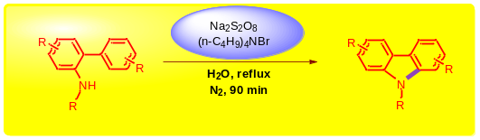

Scheme 1: Transition-metal and organic solvent-free conversion of N-substituted 2-aminobiaryls into corresponding carbazoles
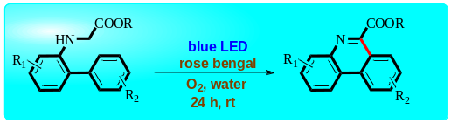

Scheme 2: Metal-free, visible light promoted oxidative radical cyclization of N-biarylglycine esters for synthesis of phenanthridine -6-carboxylates in water

Publications
- Natarajan P, Chaudhary R, Priya and Venugopalan P (2016) Metal-Free, One-Pot Synthesis of Nitrocoumarins via Consecutive Pechmann Condensation and Nitration Catalyzed by Cellulose Sulfuric Acid as a Green and Reusable Catalyst. Advances in Chemistry Research (ISBN: 978-1-53612-150-6), Chapter 2, Volume 38, Ed., James C. Taylor, Hauppauge, NY, USA.
- Natarajan P, Priya, Chuskit D (2017) Transition-Metal-Free and Organic Solvent-Free Conversion of N-Substituted 2-Aminobiaryls into Corresponding Carbazoles via Intramolecular Oxidative Radical Cyclization Induced by Peroxodisulfate. Green Chemistry 19:5854–5861.
- Natarajan P, Chuskit D, Priya (2019) Metal-free, visible-light-promoted oxidative radical cyclization of N-biarylglycine esters: one-pot construction of phenanthridine-6-carboxylates in water. Green Chemistry 21:4406-4411

- Natarajan P, Priya (2020) An Overview on the Organic Synthesis and Transformations Initiated by Sulfate Radical Anions (So 4•-) Produced from Aqueous Persulfate Solutions under Transition Metal-Free Conditions.
E-Book ISBN: 978-0-429-32860-2

- Natarajan P, Kumar N, Priya (2020) Eosin Y‐Catalyzed Visible‐Light‐Mediated Synthesis of 2‐Mercaptobenzothiazoles from 2‐Azidoarenediazonium Tetrafluoroborates and Carbon Disulfide. Chemistry Select 5:4862-4865

 Biography
Priya is a fourth -year doctoral student working under the supervision of Dr Palani Natarajan in organic chemistry at Panjab University, Chandigarh. She holds MSc (Hons) degree in theoretical chemistry and her topic of MSc project was “Developing Electron Correlation based QSPR models for Acidity constant of Carboxylic Acids”. Her PhD research focuses on the organic synthesis and functionalization of heteroaromatic compounds in aqueous solutions. One of her biggest ventures for doctoral project is development of sustainable synthetic procedures avoiding the use of toxic transition metals and organic solvents. She is successful in doing so with two research publications in Green Chemistry. Along with classical synthesis, Priya is working on visible light photocatalysis and Microwave Assisted Organic Synthesis (MAOS). Parallel to academic career, she has been actively participating in extracurricular activities and is fond of reading literature and listening music.
Email: gargp003@gmail.com

Notes/Comments:

