Title: Is peritoneal lavage with water the optimal washout as a preventative method for peritoneal disease following colorectal cancer resection? A systematic review

Authors: Nadia Youssef,¹ James Beddingham,¹ Faris Saliman, ² Keshav Swarnkar ¹
¹ Aneurin Bevan University Health Board
² Cardiff University, UK

Abstract (300 word limit)

Aim: To study available data on the advantages of peritoneal lavage with distilled water following CRC resection, and compare that to Betadine® and saline peritoneal lavages in improving overall patient outcomes.
Methods: PubMed, Google Scholar, and Cochrane database were searched until October 2020. References from relevant articles were reviewed to widen the search.
Results: Overall, 3 experimental studies were identified. Water was found to be superior to other peritoneal lavage solutions in inducing tumorigenic cell lysis in vitro. Mice who underwent peritoneal lavage with water survived longer and had a significantly reduced peritoneal tumour burden compared to mice who did not undergo lavage, or those treated with saline lavage solution. Peritoneal secretions were found to contaminate water lavage and reduce its cell-lytic effect. Nonetheless, complete cell lysis was achieved in vivo by prolonging the time of cell exposure to contaminated lavage solution by 20 min.
Conclusion: This systematic review appreciates that water would not eliminate the risk of disease recurrence, but it could potentially reduce it. As peritoneal lavage is a simple, inexpensive and well-practiced technique in cancer surgery, despite any overwhelming evidence, we suggest adjusting the procedure and utilising distilled water, as murine model studies suggest it may improve prognosis in patients with disseminated disease. Further evidence is required to regard sequential peritoneal lavages with water as beneficial and safe in humans.

Image

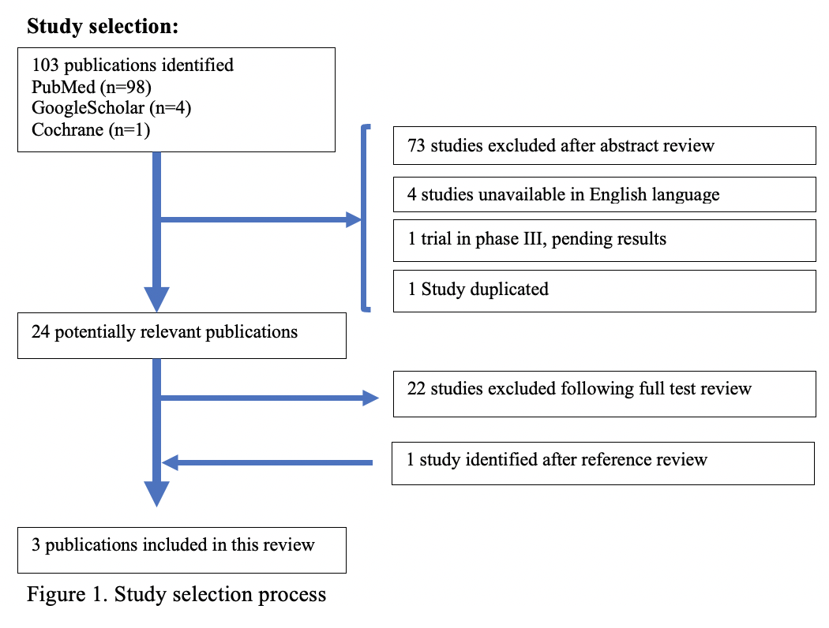

Biography
Dr. Nadia Youssef studied Medical sciences at University of South Wales and graduated with first class honours in 2016. She then studied Medicine and graduated from Cardiff University in 2020. Like many final year medical students, Nadia graduated early to help tackle the COVID crisis in Aneurin Bevan University Health Board. As a keen new doctor with a strong passion in colorectal surgery, she was able to complete two audits and a systematic review and she presented her findings in local and national conferences.

Email: youssef.nadia@hotmail.com

Notes/Comments:

