Challenges for an arteriovenous fistula for hemodialysis
Arturo Vizcarra Cardiovascular Surgeon Buenos Aires Argentina, avizcarra2@gmail.com +5491140713952

Abstract

Introduction
In many young patients, blood pressure with a tendency to be low associated with fine vessels causes many arteriovenous fistulas for hemodialysis (AVF) in upper limbs with prostheses to fail.
These patients remain for months or for life with indwelling catheters, with the risk of infection that means and a decrease in their quality of life. In some, another AVF is made with prostheses in femoral vessels, but the problems associated with the prostheses continue.
For this reason we think of a technique that is with a vein, which these patients would benefit.
In this way we avoid the risk of occlusion due to hypotension and infections typical of AVF with prostheses.
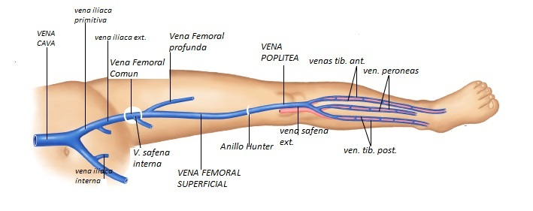
Objective
Avoid indwelling catheters and AVFs with femoral prostheses in young patients with exhaustion of vascular accesses.
Material and method
Between July and October 2020, 5 patients were operated on with transposition of the femoral vein.
It was used in 4 patients under 30 years of age and in a 57-year-old patient.
In all 5, access to upper limbs was exhausted. The 57-year-old also had a left femoral AVF with prosthesis.
Varicose veins and lower limb arteriopathy were ruled out in the 5 patients.
Results
In all the patients they began to puncture at approximately 30 days; with flows greater than 300 ml / min and venous resistance less than 200 mmHg.
The punctures were started with needle No. 17, currently No. 15. The pump flow is between 300 and 400 ml / min, the venous resistance is less than 200 mmHg. The KTV around 1.5.

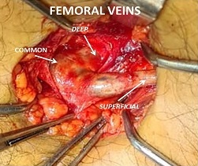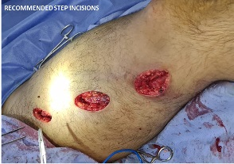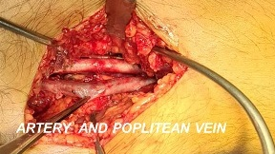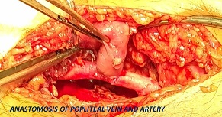
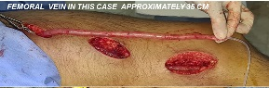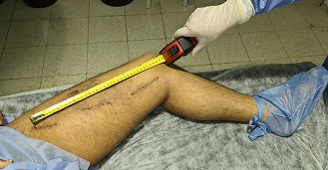
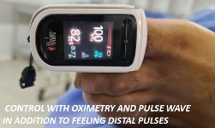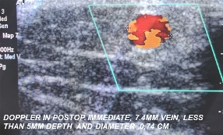

Conclusions
Patients under 30, with their access working, improved the quality of dialysis, as evidenced by the KTV.
Likewise, the patients report an improvement in their quality of life since the permanent catheter could be removed.
Long-term results are awaited, since it is a technique little used in our environment.
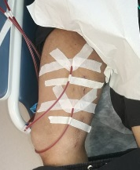
Bibliography:

1.- Construccion de una f ıstula arteriovenosa femoral y braquial con vena femoral superficial: experiencia de un centro Carlos A. Rueda, Mark R. Nehler, Traci A. Kimball, Kelly R. Dimond, Thomas A. Whitehill y Brian D. Peyton, Denver, Colorado, Estados Unidos. Ann Vasc Surg 2008; 22: 806-814 DOI: 10.1016/j.acvsp.2008.08.007 Annals of Vascular Surgery Inc. Publicado en la red: 22 de septiembre de 2008
2.- End-stage vascular access failure: can we define
and can we classify? Clinical Kidney Journal, 2015, vol. 8, no. 5, 590–593
3.- Saphenofemoral arteriovenous fistula as hemodialysis Access João A Correa1*, Luiz Carlos de Abreu2; Correa et al. BMC Surgery 2010, 10:28
http://www.biomedcentral.com/1471-2482/10/28
4.- Femoral Vein Transposition Arteriovenous Fistula
is a Feasible Option in “Selected” Patients as Hemodialysis Access Zia Ur Rehman, MBBS, FCPS, ChM Vascular and Endovascular Surgery, Asa Arham, MBBS, and Ziad Sophie, MD;
Annals of Vascular Diseases Advance Published Date: January 10, 2019
5.- Lower Extremity Permanent Dialysis Vascular Access Vishal B. Parekh,* Vandana D. Niyyar,* and Tushar J. Vachharajani
CJASN ePress. Published on May 27, 2016 as doi: 10.2215/CJN.01780216

Biography:
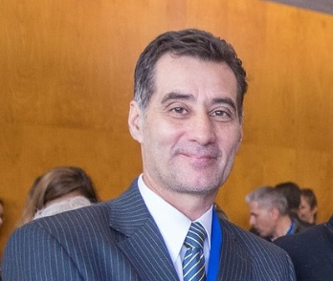

I am 53 year old; 29 years old as a doctor, specialist in general and cardiovascular surgery. I founded a cardiovascular surgery service in a public hospital.
Currently head of the Cardiovascular Surgeons Team in Argentina, SCIRE CARDIOVASCULAR, 60/70 surgeries per month
Most important results:
100% surgery survival in cardiac surgery; 94% after-year survival, l in 5 years cardiac surgery, 95 % permeability in lower limbs by pass
More than 5000 surgeries for hemodialysis 98% effective
Endovascular surgery wide experience
Vascular trauma surgery wide experience
Visiting professor, university of mississippi
Design and manufacture of surgical instrumental
Collaborating book in tc and mr cardiovascular
Full Name: Arturo Vizcarra
Contact number: +54 911 40713952
Twitter account: @avizcarra2
Linked In account:www.linkedin.com/in/arturo-vizcarra-7a883630
Session name/ number:
Category: (Oral presentation/ Poster presentation)
Passport Number: AAC 174716

