Robotic Vascular Surgery, 500 Cases

Petr Štádler, Department of Vascular and Robotic Surgery, Na Homolce Hospital, Prague, Czech Republic

Abstract
Objective: The aim of this retrospective study was to describe and evaluate our single center experience with robotic aortic and non-aortic vascular surgery to treat mostly occlusive disease and aneurysms. The da Vinci system has been used by a variety of disciplines for laparoscopic procedures but the use of robots in vascular surgery is still relatively uncommon.
Methods: From November 2005 to June 2020, 500 robot assisted vascular operations were performed. 326 patients were prospectively evaluated for occlusive disease, 127 patients for abdominal aortic aneurysm (AAA), 5 for a common iliac artery aneurysm, 10 for a splenic artery aneurysm, 1 for a internal mammary artery aneurysm, 16 patients for median arcuate ligament release, 10 for endoleak II treatment post endovascular aneurysm repair (EVAR), 2 for renal artery reconstruction and 3 cases were inoperable. 5 hybrid procedures in study were performed.
Results: 477 cases (95,4%) were successfully completed robotically, 3 patient's surgery (0,6%) was discontinued due to heavy aortic calcification and severe peri-aortitis respectively. In 20 patients (4%) conversion was necessary. The thirty-day mortality rate was 0,4% (2 patients), and early non-lethal postoperative complications were observed in 8 patients (1,7%).
Conclusions: Our experience with robot-assisted laparoscopic surgery has demonstrated the feasibility of this technique for occlusive diseases, aneurysms, endoleak II treatment post EVAR, for median arcuate ligament release and hybrid procedures. The robotic system provides a real opportunity for minimally invasive surgery in the field of vascular surgery and offers true mini-invasive surgical vascular interventions with all its advantages. Robotic AAA treatment and aorto-femoral represent the standard operations in vascular surgery, and they are not only possible but also safe and successful.

Image
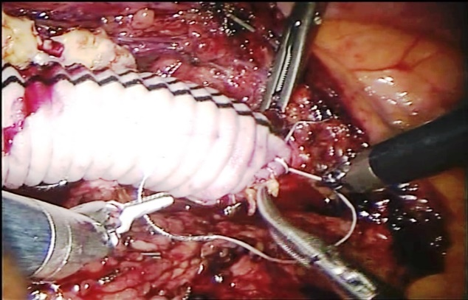
Fig. The central anastomosis of the robotic abdominal
aortic aneurysm repair
Recent Publications
- Štádler P., Dvořáček L., Vitásek P., Matouš P. The Application of Robotic Surgery in Vascular Medicine. Innovations. 2012, 7, 4, 247-253.
- Bonatti J., Vetrovec G., Riga C., Wazni O., Stadler P. Robotic Technology in cardiovascular medicine. Nat Rev Cardiol. 2014, 11(5), 266-275.
- Štádler P. Laparoskopie versus EVAR zur AAA-Behandlung bei sehr alten Patienten. Gefaessmedicin Scan, 2015, 2, 106-7.
- Štádler P., Dvořáček L., Vitásek P., Matouš P. Robot assisted Aortic and Non-aortic Vascular Operations. Eur J Vasc Endovasc Surg. 2016, 52, (6): 22-28.
- Stadler P. Minimally Invasive Vascular Surgery. Clin Surg. 2019, 4:
2651: 1-2.

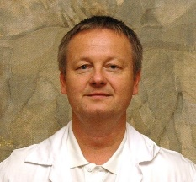
Biography
Petr Stadler, M.D., Ph.D., Head Department of Vascular Surgery, Na Homolce Hospital in Prague, Czech Republic. He was certified as a console surgeon for the da Vinci surgical system in August, 2005 at the University of California, Irvine. Dr. Stadler is a member of the Czech Association of Cardiovascular Surgery, the ESVS, the ISMICS, the SRS and a founding member of the International Endovascular and Laparoscopic Society. He has also received a few prestigious honors from the Czech Association of Cardiovascular Surgery for the best publications in 2004 and 2006, the Letter of Appreciation from Korean Society of Endoscopic and Laparoscopic Surgeons in May 2008, the price of the Czech Society of Angiology for the publication in the year 2007 and the best audiovisual presentation in 2009 in USA (ISMICS), in 2013 in USA (SCVS) and in 2020 (P.A.Wetter Award, SLS MIS Virtual Meeting). He performed also the robot-assisted vascular operations in South Korea, Russia, Poland and India.
Email: petr.stadler@homolka.cz

Notes/Comments:

