A RARE CASE OF GIANT LOWER ABDOMINAL SWELLING DIAGNOSED AS PERITONEAL SIMPLE MESOTHELIAL CYST

Dr. Setu Ladani¹, Dr. Jatin G Bhatt², Dr. Jignesh P Dave³, Dr. Siddharth Jindal⁴ ,Dr. Devendrakumar Rathore⁴
- Senior Resident; Department of General Surgery, P.D.U. Govt. Medical College and Civil Hospital; Rajkot
- Professor and Head; Department of General Surgery, P.D.U. Govt. Medical College and Civil Hospital; Rajkot
- Associate Professor; Department of General Surgery, P.D.U. Govt. Medical College and Civil Hospital; Rajkot
- Junior Resident; Department of General Surgery, P.D.U. Govt. Medical College and Civil Hospital; Rajkot

ABSTRACT:
A peritoneal simple mesothelial cyst is a very rare mesenteric cyst. Though the lesion being generally asymptomatic, it usually ranges between a few centimeters to 10 cm; however, occasionally it presents with various, non-specific symptoms, which makes correct pre-operative diagnosis difficult. We present a case of a giant peritoneal simple mesothelial cyst that was successfully managed by complete surgical excision without any known intra and post operative surgical complications.
Keywords: mesenteric cyst, peritoneal simple mesothelial cyst
INTRODUCTION:
Perotineal cysts of mesothelial origin are a rare surgical finding, which is seldom discussed in today’s available surgical literature; hence lacking proper guidelines for its management. However as per the latest known classification given by Perrot et al [1], we classified our intra-abdominal swelling as a mesenteric peritoneal cyst of mesothelial origin.
Peritoneal simple mesothelial cyst [PSMC] often presents as a confusing pre-operative image, as it has a vague clinical presentation, thereby making it challenging for the clinician. Our case deals with a middle aged woman who presented with vague constitutional signs and symptoms, being diagnosed with PSMC.
CASE REVIEW:
We present a case of 50 year old female who presented to our outpatient clinic with complaints of lower abdominal discomfort and distension for 15 days; this was associated with varied episodes of fever with no chills & rigors and was also accompanied by lower abdominal pain of mild to moderate intensity with no other constitutional signs and symptoms. On further enquiry, patient was found to have been operated for tubal ligation 25 years ago; and patient’s personal, family and social history were found to be non contributory.
On per abdomen examination, a single, non tender, smooth, ovoid mass of size 25 X 15 cm was palpated. It extended from epigastrium to the pelvis in cranio-caudal direction and from right mid axillary line to left anterior axillary line in the horizontal meridian; which moved with respiration. It didn’t reveal any signs suggestive of local rise in temperature, reducibility or compressibility on cough impulse.
On doing Ultrasonography, it revealed a huge abdominal cystic mass of size 24 X 13 cm with internal septations; which on CT conveyed a large well defined multi-loculated cystic lesion of size 17x21x18.5 cm within the peritoneum with prominent vascular channels seen at the lower/inferior part of the lesion, reaching upto the skin surface anteriorly.
A pre-operative probable diagnosis of mesenteric cyst was made; and surgery being the primary modality of choice in such lesions, a midline exploratory laparotomy was planned for the patient [4-7]; where in we found the cyst attached to the anterior abdominal wall inferiorly (fig.1).
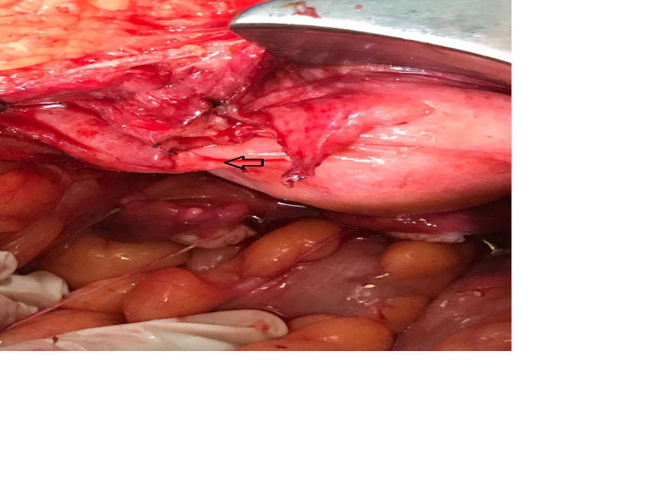
Fig 1: Intra-operative photograph of the cystic mass before excision (mark showing its attachment to inferior wall)

However, after releasing the intervening adhesions between the lesion and the small bowel loops, omentum and the anterior abdominal wall; the cystic mass was punctured which drained an ouput of 3000 ml of dark brown fluid. To check any abnormal fistulous connection between the baldder and the cyst, bladder was inflated with 500ml of saline and no connection was proved on successful attempt of this manouvre; hence, the mass was set free from the adjoining bowel loops after tactful handling of the flimsy adhesions by sterile gauze. Furthermore, we continued with the excision of the cyst and closed the abdomen along with insertion of an abdominal drain.
Based on the biopsy results of excised cystic mass, diagnosis of peritoneal simple mesothelial cyst was established. Patient’s post-operative recovery was uneventful and was discharged on the 6th post-operative day. She was followed up regularly in our institute’s outpatient clinic, which was fairly unremarkable.
DISCUSSION:
Peritoneal simple mesothelial cyst has an unclear aetiopathogenesis, of which the hypotheses suggests, that it results due to congenital incomplete fusion of the mesothelial-lined peritoneal surfaces [2-3]. It could also be linked to chronic inflammatory processes involving the peritoneum, which results in a reactive hyperplastic and dysplastic transformation of mesothelial cells. Others suggest a more primitive neoplastic origin of the peritoneal serosa without strict association with coexistent chronic inflammatory insult. As per the current epidemiological data available, PSMC generally presents in younger age group [2] however, we reported a case of middle aged woman of asian ethnicity in our setting being diagnosed with such a cystic lesion.

On gross examination of the cyst, it shows a large single unilocular of size, containing serous material, as in our case; while reviewing the biopsy of the lesion, the cut section revealed an inner surface lined by flat, cuboidal and columnar mesothelial cells and its wall is fibrotic without any lymphatic or musculous structures which is suggestive of PSMC (fig. 2).

Due to rarity of such lesions presenting with such varied and vague symptomology it is very essential to rule out common differentials as per the presenting anatomic location by means of both clinical as well as radiological evaluation. Since plain radiographs are generally inconclusive, sophisticated imaging modalities in form of MR and CT is essential in such cases.

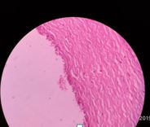
Fig 2: Biopsy slide of the lesion

Since the cyst lies in proximity to many pelvic viscera, it is rather beneficial to check for any possible secondaries and its relations in the form of abnormal connections, tracts, and metastasis from its adjacent organs; since, clinically the cyst maybe giant mimicking ascites or an ovarian tumour. However, in this case, on CT, the cyst had no such abnormal connections with either the bladder or the ovary per se. When explored internally while operating this case, we were able to appreciate the pair of ovaries distinct from the primary pathology.

As these cysts are generally large, they cause a compressive effect on the neighbouring organs which leads to patient’s discomfort; hence inducing patient’s initial symptoms, commanding the patient to seek medical help. These symptoms may vary from urinary discomfort, gynaecological problems, to nausea and vomiting, etc depending on the organ being compressed by the cystic mass with the abdominal cavity. Since the cyst is generally mobile, it can easily present as a case of acute abdomen owing to its dreadful complications such as infection, torsion, rupture or haemorrhage within the cyst.

The primary treatment modality for PSMC is complete surgical excision by means of enucleation by surrounding leaves of mesentery [4-7]. The two best known contemporary approaches for the same being either laparotomy, like we did with this case or a laparoscopic approach; the size, location and surgeon’s experience determines the surgical approach. Since the size of the cyst that we reported was massive, a conventional laparotomy was planned which was carried out successfully. In case of suspicion for malignancy and in order to prevent any post operative complications; resection of adjacent might be necessary varying from case to case.

Peritoneal simple mesothelial cyst, though rare; but if diagnosed and managed judiciously, has a favourable prognostic outcome.

CONCLUSION:
Giant peritoneal simple mesothelial cyst presenting with vague lower abdominal discomfort is a rare surgical entity, hence it should not be ignored while considering differentials for any pelvic cystic pathology. PSMC, being rare doesn’t have any standard guidelines at present for its evaluation, treatment and follow-up. Multicentre registries of various mesenteric cysts of such origin along with consequential follow-up of these cases can help us improve the current scientific knowledge about this rare surgical disease.
REFERENCES:
- De Perrot M, Brudler M, Totsch M, Mentha G, Morel P: Mesenteric cyst. Toward less confusion? Dig Surg 2000, 17:323-328.
- Ros PR, Olmsted WW, Moser RP Jr, Dachman AH, Hjermstad BH, Sohin SH: Mesenteric and omental cysts: histologic classification with imaging correlation. Radiology 1987, 164:327-332.
- Stoupis C, Ros PR, Abbitt PL, Burton SS, Gauger J: Bubbles in the belly: imaging of cystic mesenteric or omental masses. Radiographics 1994, 14:729-737.
- Miljković D, Gmijović D, Radojković M, Gligorijević J, Radovanović Z: Mesenteric cysts. Arch Oncol 2007, 15:91-93.
- Patel A, Lefemine V, Ramanand BS: A rare case of a peritoneal cyst arising from the falciform ligament. Cases J 2009, 2:134.
- . Fernandez Ramos J, Vazquez Rueda F, Azpilicueta Idarreta M, Diaz Aguilar C: Mesothelial giant cyst of great omentum. An Pediatr (Barc) 2009, 71:180-181.
- Theodoridis TD, Zepiridis L, Athanatos D, Tzevelekis F, Kellartzis D, Bontis JN: Laparoscopic management of mesenteric cyst: a case report. Cases J 2009, 2:132.

