Mechanical Thrombectomy in Stroke: Are There New Lessons to Learn?
Amie L Hoefnagel MD, University of Florida College of Medicine, Jacksonville, Florida, USA
Joyce Yao MD, University of Florida College of Medicine, Jacksonville, Florida, USA
Dinesh Rao MD, University of Florida College of Medicine, Jacksonville, Florida, USA
Paul D Mongan MD, University of Florida College of Medicine, Jacksonville, Florida, USA

Abstract (300 word limit)

Statement of the Problem: Endovascular mechanical thrombectomy (EMT), along with administration of intravenous (IV) tissue plasminogen activator (tPA), are standard of care for treatment for patients presenting with acute ischemic stroke (AIS). With the rapid advancements in both stroke intervention techniques, and patient selection, it is important determine if there are differences in clinical outcome between the use of general anesthesia (GA) and conscious sedation (SED). It remains unclear if GA by itself is a risk factor for poorer clinical outcomes in patients undergoing mechanical thrombectomy.

Methodology: This retrospective study was approved by the University of Florida Institutional Review Board (UF IRB). Data was collected and analyzed from 88 consecutive patients who presented to the UF Health Jacksonville emergency department from January 2017 to November 2019. This study included 88 patients who were diagnosed with AIS with large vessel occlusion in the anterior circulation, and subsequently underwent mechanical thrombectomy with or without prior IV tPA under GA (34 patients) or SED (54 patients). Patients with occlusion of the internal carotid artery, M1 and/or M2 segment of the middle cerebral artery were included. Data was collected including demographics, clinical data, imaging data, and procedural times (table 1).

Findings: Table 1 demonstrates comparative analysis between anesthesia type and intervention times. Door to groin puncture time and door to recanalization were statistically significant with SED group having faster times. Table 2 shows additional analysis for mortality which was not statistically significant between the groups.

Conclusion and Significance: Patients undergoing MET for with SED had lower door to needle times and better radiographic recanalization compared to patients with GA, however no changes in mortality or post event functional status were seen. Both anesthetic techniques were shown to be acceptable.
Image
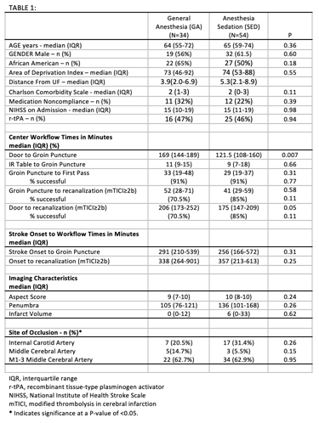
Recent Publications (minimum 5)
- Chen CJ, Chuang TY, Hansen L, Dutta S, Ding D, Buell TJ, Ironside N, Patibandla MR, Southerland AM, Worrall BB, Kalani MYS. Predictors of 30-day mortality after endovascular mechanical thrombectomy for acute ischemic stroke. J Clin Neurosci 2018;57:38-42.
- Zhang Y, Jia L, Fang F, Ma L, Cai B, Faramand A. General Anesthesia Versus Conscious Sedation for Intracranial Mechanical Thrombectomy: A Systematic Review and Meta-analysis of Randomized Clinical Trials. J Am Heart Assoc 2019;8:e011754.
- Lowhagen Henden P, Rentzos A, Karlsson JE, Rosengren L, Leiram B, Sundeman H, Dunker D, Schnabel K, Wikholm G, Hellstrom M, Ricksten SE. General Anesthesia Versus Conscious Sedation for Endovascular Treatment of Acute Ischemic Stroke: The AnStroke Trial (Anesthesia During Stroke). Stroke 2017;48:1601-7.
- Schönenberger S, Hendén PL, Simonsen CZ, Uhlmann L, Klose C, Pfaff JAR, YooAJ, Sørensen LH, Ringleb PA, Wick W, Kieser M, Möhlenbruch MA, Rasmussen M,Rentzos A, Bösel J. Association of General Anesthesia vs Procedural Sedation WithFunctional Outcome Among Patients With Acute Ischemic Stroke UndergoingThrombectomy: A Systematic Review and Meta-analysis. JAMA. 2019 Oct1;322(13):1283-1293.
- Brinjikhi W, Murad MH, Rabinstein AA, Cloft HJ, Lanzino G, Kallmes DF. Conscious Sedation versus General Anesthesia during Endovascular Acute Ischemic Stroke Treatment: A Systematic Review and Meta-Analysis.

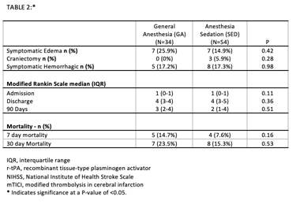

Biography (150 word limit)
Dr. Amie Hoefnagel is an Associate Professor at the University of Florida in Jacksonville Florida. In addition to her love of teaching residents and other medical trainees the intricacies of neuroanesthesia, she has many administrative roles including serving as the associate chair for clinical operations and the director of quality improvement in the department of Anesthesiology. She is an active member of the Society of Neuroscience in Anesthesia and Critical Care (SNACC) and encourages others to become members of this amazing group.
Email: amie.hoefnagel@jax.ufl.edu

Notes/Comments:

