 | Department of Health  East Avenue Medical Center  D e p a r t m e n t o f S u r g e r y  East Avenue, Diliman, Quezon City • (02) 929-7746 | 

A Rare Perforated Gastrointestinal Stromal Tumor in the Jejunum:
A Case Report
Jan Edward P. Albano, MD, Tito Apollo A. Quitoriano, MD, Felicidad Claudia R. Ordonez, MD, Amihan A. Banaag, MD and Nilo C. de los Santos, MD

Department of General Surgery, East Avenue Medical Center, East Avenue, Quezon City, Philippines

ABSTRACT

A Gastrointestinal Stromal Tumor (GIST) of the small intestine is relatively rare and often present with vague symptoms. A clinical manifestation of acute abdomen due to tumor perforation is extremely rare. We report a 62-year old Filipino male who presented with acute abdomen and weight loss. Scout Film Abdomen (SFA) and Whole Abdominal Computed Tomography Scan (WA-CT Scan) revealed partial intestinal obstruction with jejunal tumor mass approximately 5x7cm in size. Emergency exploratory laparotomy was performed and resection of the small bowel (jejunum), end-to-end anastomosis, jejunostomy tube insertion, lavage, and drain was done with intra-operative finding of small bowel mass measuring approximately 3 feet in length (convoluted) with tumor perforation, ~3 feet from the Ligament of Treitz (LOT). Histopathological examination confirmed the tumor to be GIST with line of resection viable and free of tumor with c-KIT staining (+). A high degree of suspicion along with complete clinical evaluation and appropriate ancillary procedures lead to early diagnosis of this rare complication of GIST. Emergency laparotomy and complete resection of tumor is essential as morbidity rates increase from delayed intervention. Adjuvant tyrosine kinase inhibitor therapy after surgical resection should be considered for prevention of early recurrence.

INTRODUCTION
Gastrointestinal Stromal Tumors (GISTs) are rare, representing only 0.2% of all gastrointestinal (GI) tumors. GISTs are mesenchymal tumors of the digestive tract that originate from interstitial Cajal cells. These tumors are usually located in the stomach and small intestine but also occur anywhere in the GI tract, including the omentum and peritoneum. GISTs are submucosal lesions and most frequently grow endophytically in parallel with the lumen of the affected structure. GISTs have a silent behavior and are diagnosed incidentally. These tumors are characterized by indolent clinical symptoms including vague abdominal pain, weight loss, and occult GI bleeding and obstruction due to tumor growth. GISTs often present at advanced stage at the time of definitive treatment due to difficult diagnosis and delayed evaluation. GISTs have a wide range of malignancy degree with malignancy rates of 20-30%, and it is preferable that these tumors be considered and treated as potentially malignant lesions. Small tumors that are completely resected and are of intermediate malignancy seldom create postoperative complications, while larger tumors may recur after resection or present with intraperitoneal infiltration or hepatic metastasis. Approximately 40% of GIST cases cause intestinal bleeding. Perforation is rarely observed in GISTs, and the prognosis is poor. Thus, complete surgical removal of the tumor is necessary

CASE REPORT

A 62-year old male was referred to service of General Surgery with history of intermittent left upper quadrant abdominal pain with palpable mass for almost 1 year in duration. There was no melena, hematochezia, or decreased caliber of stools. 6 months prior to consult, patient noticed that the left lower quadrant mass was slightly enlarging. Weight loss was noted from 54 kg to 51 kg, prompting consult. Patient is a non-hypertensive, non-diabetic with family history of hepatocellular carcinoma. He denied any history of blood transfusion, alcohol abuse or medication. He is a smoker 0f 5 pack years smoker, an occasional drinker, work as auto mechanic and denies drug use.
On physical examination patient had globular abdomen, hypoactive bowel sound, dull sound in percussion, palpable fixed mass on deep palpation of LUQ with direct and rebound tenderness at the left upper quadrant.
Whole abdominal computed tomography (CT) scan with triple contrast revealed a 5x7cm, non-uniformly enhancing mass with minimal air in the jejunum (Figure 2). Patient was scheduled for elective resection however, he presented with peritonitis few days after consult. Scout film abdomen showed pneumoperitoneum, dilation of proximal bowel with multiple air fluid levels (Figure 1). He underwent emergency exploratory laparotomy, resection of small (jejunum), end-to-end anastomosis, jejunostomy tube insertion, lavage, and drain. Intraoperative findings include a small bowel mass measuring approximately 3 feet in length (jejunum) with tumor perforation, ~3 feet from the Ligament of Treitz (LOT) and smooth liver with mesenteric lymph nodes (Figure 3). Final histopathology revealed GIST with mitotic figures abundant at >5 in 50 HPF and lines of resection viable and free of tumor. Sections taken from the lymph node dissected showed sinus histiocytosis. Patient had uneventful post operative course and went home recovered.
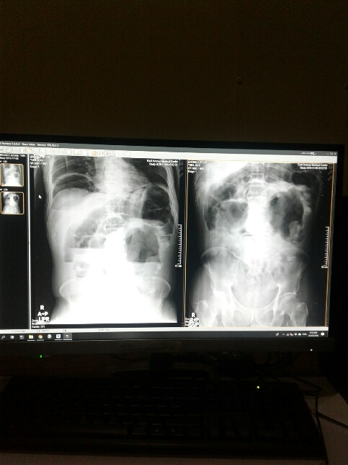

Figure 1. Scout Film Abdomen with pneuoperitoneum, dilated small bowell with multiple air-fluid levels

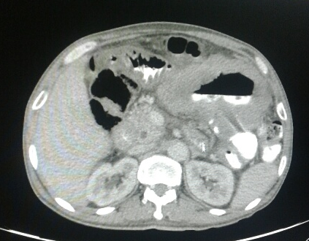
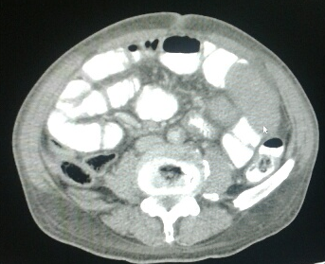

Figure 2. Whole Abdominal CT Scan with triple contrast images demonstrated an approximately 5cm x 7 cm, non-uniformly enhanced, hard tissue mass with some air to the jejunum.

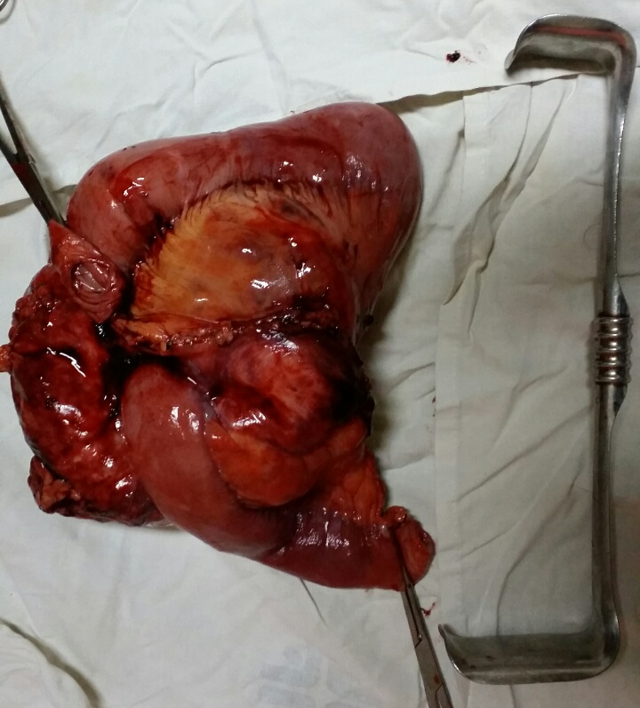
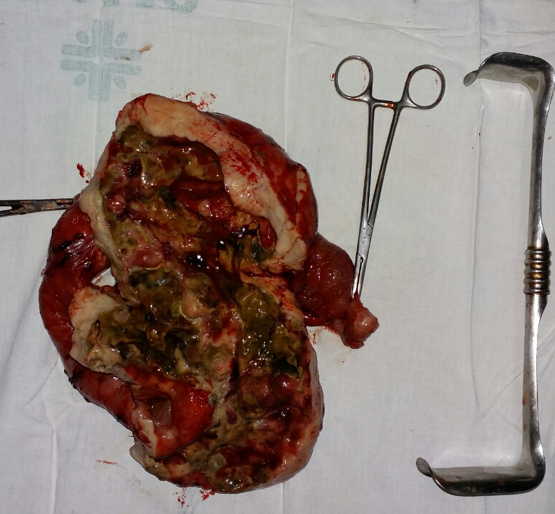

Figure 3. Jejunal Mass with cut specimen.

DISCUSSION

GIST is a visceral tumor arising from any site of the gastrointestinal tract. Approximately 60–70% of cases occur in the stomach, 25–35% in the duodenum and ileum and 10% in the jejunum; while the esophagus, colon, rectum and appendix are rarely affected. Approximately 10–30% of patients with GISTs may be asymptomatic. The most common symptoms associated with jejunal GISTs are vague, non-specific abdominal pain or discomfort. Patients who have jejunal GIST usually suffer from abdominal pain or palpable mass, and also complain of early satiety or abdominal fullness. Jejunal GISTs may cause symptoms secondary to obstruction or hemorrhage. Pressure necrosis and ulceration of the overlying mucosa may cause gastrointestinal bleeding, and patients who experience significant blood loss may suffer from malaise and fatigue. Obstruction may result from the intraluminal growth of the tumor or luminal compression from an exophytic lesion. Fever, anorexia and weight loss are rarely observed and GISTs originating from the jejunum seldom cause perforation and acute diffuse peritonitis.
It is difficult to diagnose a jejunal GIST preoperatively due to the nonspecific and variable clinical symptoms, and it is also difficult to distinguish the tumor based solely on images. Although a CT scan is a commonly offered imaging modality for patients with suspected abdominal GISTs, magnetic resonance imaging (MRI) provides better information than CT in the preoperative workup. The definitive diagnosis of the majority of jejunal GISTs is revealed by histopathological examination of the specimen. Approximately 95% of GISTs express CD117, which is part of the KIT receptor tyrosine kinase. Additionally, DOG1, a recently defined mo noclonal antibody against a chloride channel protein expressed by GIST, is positively expressed in 95% of GISTs. DOG1 is a novel marker of GISTs as it has a higher sensitivity and specificity compared with CD34, particularly in the detection of moderate and high risk GIST. Therefore, the present case was diagnosed by immunohistochemical examination of C-KIT and DOG1 positivity.
Under risk stratification of GIST as described in figure 4, the patient has a 90% chance of disease progression and would benefit from adjuvant Imatinib therapy.
To date, surgery is the only potentially curative therapy for patients with primary, resectable GIST. Nonmetastatic GISTs greater than 2 cm should be resected. A lymphadenectomy is not conducted because lymph node metastases are rare. Although the size of tumor in this case was large, there were no harvested positive lymph nodes in the present case. The management of GIST has undergone significant revolution over last decade. Tyrosine kinase inhibitor therapy has significantly improved overall survival in patients with advanced disease and should be continued indefinitely. Prior to the development of imatinib, recurrences were common even in patients undergoing surgery. Adjuvant imatinib for 3 years should be considered in patients undergoing resection for primary disease.
In conclusion, we report a rare case of a male with a perforated GIST in the jejunum causing acute diffuse peritonitis. The clinical outcome is worse when this tumor presents with bowel perforation and peritonitis. Preoperative imaging is very important in the evaluation of GIST. A high degree of suspicion is necessary in view of the high morbidity rates resulting from a delayed diagnosis of the disease.
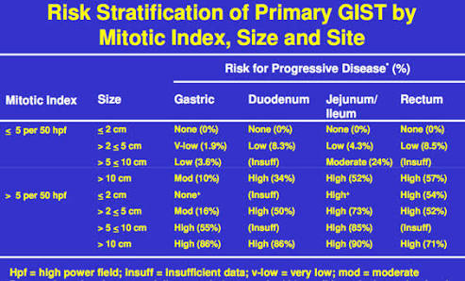

Figure 4. Risk Stratification of Primary GIST.

REFERENCES
- Fletcher CD, Berman JJ, Corless C, et al. Diagnosis of gastrointestinal stromal tumors: a consensus approach. Hum Pathol 2002; 33: 459-65.
- Min KW, Leabu M. Interstitial cells of Cajal (ICC) and gastrointestinal stromal tumor (GIST): facts, speculations, and myths. J Cell Mol Med 2006; 10: 995-1013.
- Chen LL, Holden JA, Choi H, et al. Evolution from heterozygous to homozygous KIT mutation in gastrointestinal stromal tumor correlates with the mechanism of mitotic nondisjunction and significant tumor progression. Mod Pathol 2008; 21: 826-36.
- Hirota S, Isozaki K, Moriyama Y, et al. Gain-of-function mutations of c-kit in human gastrointestinal stromal tumors. Science 1998; 279: 577-80.
- Beliakov IS, Anurova OA, Snigur PV, et al. c-Kit and PDGFRA mutations and clinicomorphological features of gastrointestinal stromal tumors. Vopr Onkol 2007; 53: 677- 81.
- Nowain A, Bhakta H, Pais S, et al. Gastrointestinal stromal tumors: clinical profile, pathogenesis, treatment strategies and prognosis. J Gastroenterol Hepatol 2005; 20: 818-24.

