Title: Pscyhomotor recovery of dexmedetomidine compared with propofol after sedation during spinal anesthesia.
Suman Lata, Parika Tilak, Lenin Babu
Department of Anaesthesiology and Critical Care, JIPMER, Puducherry, India

Keywords: Spinal Anaesthesia, Post-op recovery, Psychomotor Function
I.Abstract body
Early psychomotor recovery is an essential part of day care surgery which depends on brain integration of motor and sensory co-ordination. Even though dexmedetomidine is commonly used for day care procedures, the recovery profile was not studied. Hence this study was designed to evaluate the psychomotor recovery of sedation with dexmedetomidine during spinal anesthesia and also to compare with propofol .Sixty six patients were included. Group D received dexmedetomidine 0.5 µg /kg (loading dose) followed by 0.2-1 µg/kg/hr .Group P received propofol infusion of 25-100 µg /kg/minute. Psychomotor recovery was assessed by Finger-tapping, Manual dexterity, Visual spatial memory capacity and pen & paper tests. Psychomotor tasks were given to the patients postoperatively at every 30 minutes for 2 hours followed by every hour up to 4 hrs after surgery. The motor recovery using finger tapping test was faster in group D than Group P ((73.94±42.13 vs 101.21±37.98min, p value 0.007).Motor recovery using peg board test was faster in Group P than Group D (82.12 ± 40.37 vs 99.39 ± 43.08 minutes, p value 0.098).Visual spatial capacity memory test, pen &paper tests were unaffected. We conclude that patients who received dexmedetomidine showed earlier recovery with finger tapping test. Hence we suggest to use dexmedetomidine for complete psychomotor recovery and fast track discharging of the patient after spinal anesthesia.
II. Image:

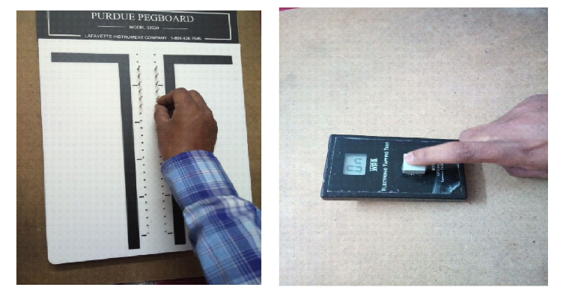
III. Reference:
1.Hall JE, Uhrich TD, Barney JA, Arain SR , Ebert TJ. Sedative, amnestic, and analgesic properties of small-dose dexmedetomidine infusions. Anesth Analg.2000;90(3):699–705.
- Arain SR, Ebert TJ. The efficacy, side effects, and recovery characteristics of dexmedetomidine versus propofol when used for intraoperative sedation. AnesthAnalg2002;95:461–6.

- Pawar S, Malde A. Time course of psychomotor, cognitive and ambulatory recovery after propofol daycare anesthesia. The Internet Journal of Anesthesiology.2009Volume23Number1.
Biography:
I have completed MBBS, DCH & MD (ANAESTHESIOLOGY) Patna & Ranchi University RIMS School of Medicine, Ranchi India. Presently working as Faculty in, a premier organization JIPMER India. I have published more than 25 papers in reputed journals and has been serving as reviewer of reputed national journals. Have presented papers in national and international conferences. Took training in transplant anaesthesia. Also under went short course in hospital administration from ministry of health and family welfare.
IV. Presenting author details



Full Name: Dr. Suman Lata
Contact number:+919488830091
Session name –Anaesthesia recovery
Category: E-Poster presentation)
Passport Number: R 7316380 India

