Title – An Experience with Craniocervical Junction Dural Arteriovenous Fistula – A Rare Entity
Authors: Dr. Gagan Dhall [1], Dr. Batuk Diyora [1]

Affiliation: Department of Neurosurgery, Lokmanya Tilak Municipal Medical College, Mumbai, India

Introduction:
Arteriovenous fistulas (AVF) can be Cranial, Spinal or Craniocervical junction (CCJ). AVF at CCJ are rare amongst neurosurgical vascular malformations. Out of five angiographic types, type I is CCJ Dural AVF amongst others like radicular, epidural and perimedullary. Variable arterial supply and venous drainage along with complicated anatomy adds to further intricacy. In present era, studies comparing open vs endovascular management are pushing the boundaries further.
Case report:
32yrs old male presented to emergency department with headache a/w vomiting, left sided weakness, change in voice and swallowing difficulty since six days. History was s/o intermittent occipito-cervical headache since 3 years. CT angiography, MRI and digital subtraction angiography (DSA) were performed. Patient had diffuse subarachnoid hemorrhage (SAH), intraventricular hemorrhage and medullary bleed. An abnormal conglomeration of vessels at the left CCJ was identified with afferents from meningeal branch of left vertebral artery draining into left sigmoid sinus. Far lateral suboccipital craniotomy was planned. Fistula was clipped. Intraoperative Doppler confirmed clip location and absent distil flow.
Pt. had no headache and hoarseness at discharge. Power in limbs improved. Patient had residual swallowing difficulty.
Review of literature:
In studies by Wang et al and Zhao et al, SAH and myelopathy were major and brain stem dysfunction was amongst rare presentations. Both confirm higher surgical efficacy of open procedure and, include microsurgery as factor determining overall improvement.
Conclusion:
Dural AVF at CCJ has wide presentations. Intracranial drainage and presence of varices has higher risk of SAH. Six-vessel DSA is gold standard. Microsurgery has higher rate of obliteration compared to embolization.

Images:
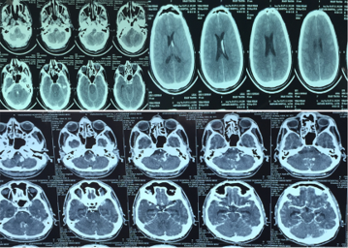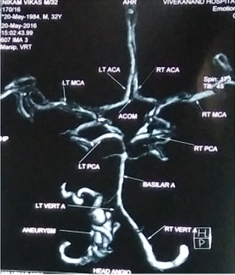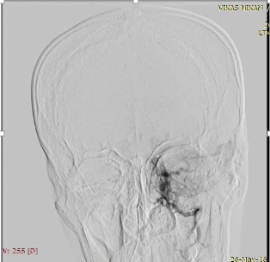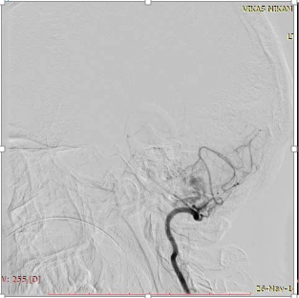
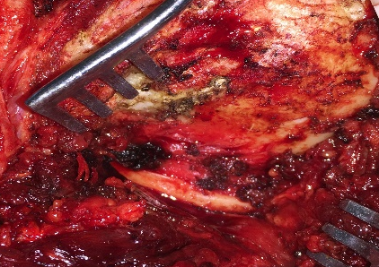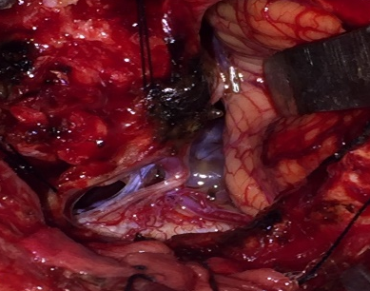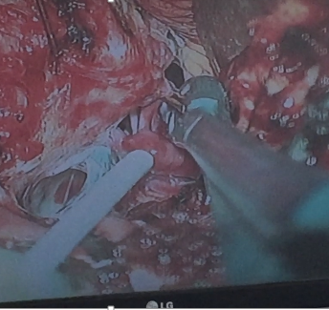
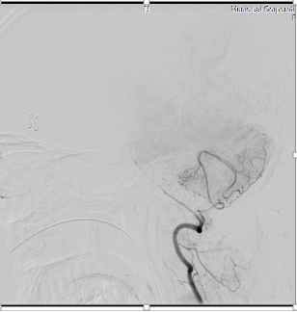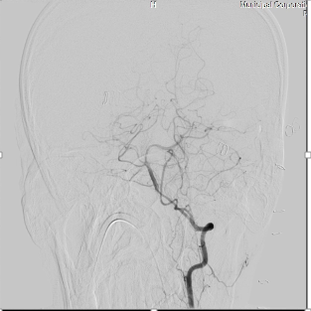
References:
- Masafumi Hiramatsu, Kenji Sugiu, Tomoya Ishiguro, Hiro Kiyosue, KenichiSato, Keisuke Takai, Yuji Matsumaru. Angioarchitecture of arteriovenous fistulas at the craniocervical junction: a multicenter cohort study of 54 patients. Journal of Neurosurgery. 2017 September 1:1-11.10.3171/2017.3.
- Joanna Y. Wang, Joseph Molenda, Ali Bydon, Geoffrey P. Colby, Alexander L. Coon, Rafael J. Tamargo, Judy Huang. Natural history and treatment of craniocervical junction dural arteriovenous fistulas. Journal of Clinical Neuroscience. 2015 November; 22(11):1701-7.
- Zhao J1, Xu F, Ren J, Manjila S, Bambakidis NC. Dural arteriovenous fistulas at the craniocervical junction: a systematic review. 2015 June; 8(6):648-53.

Presenting Author details:

Full name: Dr. Gagan Dhall
Contact number: +91 – 8291433954
Session name/ Number: Neurosurgery
Category: Poster presentation
Passport number: H6269499

