Title: An Experience with Laparoscopic Management of an Uncommon Entity – Renal Paratransplant Hernia
Authors: Dr. Richa Jaiswal [1]
Dr.SumitTalwar [1];
Affiliation: [1] Department of General Surgery,
Manipal Hospitals Bangalore, India

Intoduction:
Paratransplant hernia (PH) consists of an unusual variant of internal hernia, which was first reported by Kyriakides et al [1] as entrapment of bowel through a defect in the peritoneum covering the transplanted kidney. It is an uncommon, but potentially fatal complication of renal transplantation. To our knowledge, nine cases have been previously reported [2, 3].
Case Report:
A 40-year-old man presented to our emergency department with a 24-hour symptoms of abdominal pain, distension and nausea. Eight-months ago he underwent right sided Renal transplantation for IgA Nephropathy. Clinically patient was febrile and tachycardiac. On examination tenderness in the right lower quadrant, bowel sounds were exaggerated and rectum was empty. Plain abdominal Xray demonstrated multiple air-fluid levels. A nasogastric tube was inserted to release the distension. Abdominal computed tomography (CT)-scan was to confirm diagnosis which large right lateral abdominal wall incisional hernia containing multiple small bowel loops with closed loop small bowel obstruction abutting the transplanted kidney. Diagnostic laparoscopy was done. A gangrenous 25 cm long segment of completely obstructed small bowel was herniating through the peritoneal defect at the site of allograft, 10 cm from ileo-caecal junction. Resection and side to side endostapler anastomosis was done. In left spinoumbilical line proximal defunctioning ileostomy done and the peritoneal defect was closed primarily. The patient had a sound postoperative course and was discharged at 5th postoperative day. Loop ileostomy was reversed after 3 months of surgery.
Review of literature:
A total of 10 cases , including our case have been reported in literature. Although ours is the first case to be able to complete entirely by laparoscopy.
4 out 10 cases had required bowel resection and 1 patient had expired due to sepsis on day 7 of exploratory laparotomy.

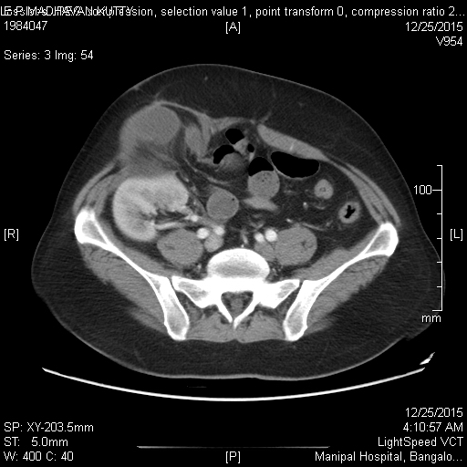
Preoperative CECT image:
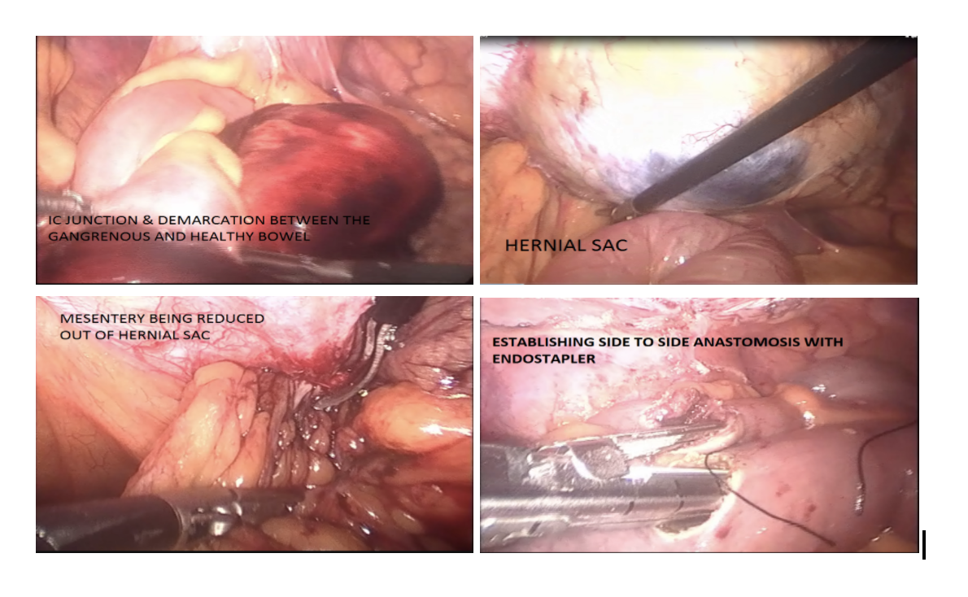
Intraoperative image
Conclusion:
Recommend - early diagnosis by CECT, minimally invasive surgery for treatment of renal paratransplant hernia. Equally effective as compared to open surgery. Has all the advantages and benefits of the minimal access surgery.Better and quick post operative recovery.

References :
- Kyriakides GK, Simmons RL, Buls J, Najarian JS. Paratransplant hernia. Three patients with a new variant of internal hernia. Am J Surg 1978;136:629–30
- Gao Z, Zhao J, Sun D, Yang D, Wang L, Shi L. Renal paratransplant hernia: a surgical complication of kidney transplantation. Langenbecks Arch Surg. 2011;396(3):403-6.
- Cascales-Sanchez P, Martinez-Moreno A, Vazquez-Aragon P, et al. Renal paratransplant hernia: an unusual complication of renal transplantation? Transplant Proc 2007;39:2267–8
- Skandalkis PN.Zoras O.Skadalakis JE,Mirilas P. Richter hernia: surgical anatomy and technique of repair. Am Surg.2006;72(2):180-4.
- Martin LC, Merkle EM, Thompson WM. Review of internal hernias: radiographic and clinical findings. AJR Am J Roentgenol 2006;186:703–17

PRESENTING AUTHOR DETAILS:

Full name: Dr. Richa Jaiswal
Contact number: +917349369814
Session name/number: General Surgery
Category: Poster presentation
Passport number: P4432440

