Title : EVALUATION OF METABOLIC EFFECTS OF BARIATRIC SURGERY ON MORBIDLY OBESE PATIENTS
-Dr. Richa Jaiswal¹ , Dr. Sumit Talwar² , Dr. Karthik Prabhakar³
¹Department of General Surgery, Manipal Hospital , Bangalore , India.
² Department of General and Bariatric Surgery, Manipal Hospital , Bangalore , India.
Department of Endocrinology , Manipal Hospital , Bangalore , India.

KEYWORDS: BMI, Weight loss, FBS, HbA1c, Lipid parameters, Laparoscopic sleeve Gastrectomy, Laparoscopic Roux en Y Gastric Bypass.

- ABSTRACT BODY:
Metabolic syndrome is a known association of obesity and carries risk of diabetes and cardiovascular disease. Hence, we evaluated the metabolic effects of bariatric surgery on morbidly obese patients. We recruited 40 morbidly obese patients; 26 underwent Laparoscopic sleeve gastrectomy and 14 underwent Roux-en-Y gastric bypass of which seven and nine were diabetic respectively. All patients were evaluated for weight, BMI, FBS, PPBS, HbA1c, C-Peptide, Lipid parameters, Mean Arterial Pressure at baseline and at two-weeks and at six-months post-surgery. We achieved significant reduction in weight (p<0.0001; paired Friedman test) at and six months (94.3kg) postoperative as compared to baseline (129.7 kg). A mean weight loss of 52% for %Excess weight loss and %Excess BMI loss. Fasting Blood Glucose was significantly reduced at two weeks (132.2mg/dl; p=0.04) and six months (96.7mg/dl; p=0.01) postoperatively. A total of 56.3% diabetic patients achieved an HbA1c levels <5.5 at six months post-surgery. Fifteen (94%) diabetic patients achieved an HbA1c ≤6.5 at 6 months post-surgery. C-Peptide levels showed significant difference as compared to baseline (6.3) to those at 6 months (3.8; p=0.03) and also there was a significant difference in reduction of use of antidiabetic medications at six months post-surgery (0.3; p<0.0001) when compared to baseline(1.4). Difference in improvement in deranged lipid parameters (p<0.0001) and Mean Arterial Pressure (p<0.0001) became quite significant at six months post-surgery. These results are in coherence with other studies.^{[1,2]} Bariatric surgery thus helps in reducing weight and also helps in improving diabetes, lipid profile and Mean arterial blood pressure.

- IMAGE^{[3]} :
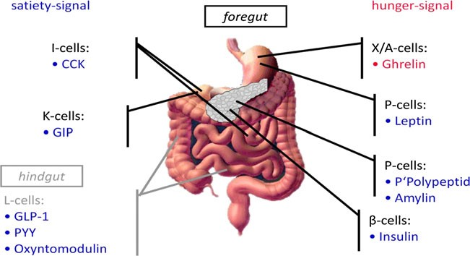

- REFERENCES:
- Philip R. Schauer, M.D., Deepak L. Bhatt, M.D., M.P.H., John P. Kirwan, Ph.D.,et al. Bariatric Surgery versus Intensive Medical Therapy for Diabetes — 3-Year Outcomes The new england journal of medicine.2014;
- Lee WJ, Hur K, Lakadawala M, et al. Predicting the Success of Metabolic Surgery: Age, Body Mass Index, C-peptide, and Duration Score. SurgObesRelat Dis. 2013;9(3):379–384.

- BIOGRAPHY:
Dr. Richa Jaiswal has completed her MBBS (Graduation) from a government Medical college in Maharashtra, India in year 2014. She is pursuing her DNB General Surgery (Post Graduation) in Manipal Hospital Bangalore through All India Merit Rank. She has published and presented internationally an article in Journal of Gastroentology in 2017 in Hong Kong. She has secured second position in SSB conference for a paper presentation.

- PRESENTING AUTHOR DETAILS:

Full name: Dr. Richa Jaiswal
Contact number: +917349369814
Session name/number: Young Scientist Award, Bariatric Surgery
Category: Young Scientist Award - Oral presentation
Passport number: P4432440

