Mixed neuroendocrine - non neuroendocrine (MiNEN) tumour in ascending colon: A case report
Amasi Muthukumarana ¹, Kanchana Amarawickrama ² ,Sonali Rodrigo ²,S A Gunawardena ¹
1) Surgical unit-Sri Jayawardenapura General Hospital,sri lanka
2) Pathology department-Sri Jayawardenapura General Hospital,sri lanka

Abstract
Mixed neuroendocrine-non neuroendocrine neoplasms(MiNEN) are mixed epithelial neoplasms in which a neuroendocrine component is combined with a nonneuroendocrine component, each of which is morphologically and immunohistochemically recognizable as a discrete component and constitute at least 30% of the neoplasm. MiNEN represents roughly 1–2% of all colorectal malignancies. Since its heterogeneity and rareness, timely recognition and accurate diagnosis of these tumours remain a challenge.

We present a case report of a 50 year old male with symptomatic anaemia. Faecal immunochemical test for occult blood was positive. Colonoscopy revealed a growth in the ascending colon. Contrast enhanced computed tomography(CECT) also confirmed it as a locally advanced ascending colonic tumour. Carcinoembryonic antigen level was 2.4 ng/dl.
A right hemicolectomy was done. Histology revealed an infiltrating malignant tumour with two distinct morphologies; one area showing well formed complex glandular structures lined by atypical columnar cells and there was an abrupt transition to areas showing sheets of single discohesive cells with markedly pleomorphic nuclei and granular chromatin with conspicuous nucleoli. Immunohistochemical markers showed constituent cells of the glandular areas of tumour had strong nuclear positivity for CDX2 and strong cytoplasmic positivity for CK20. They were negative for chromogranin and synaptophysin. Constituent cells of the sheet like areas of tumour showed cytoplasmic positivity for synaptophysin and focal patchy positivity for chromogranin. They were negative for CDX2 and CK20, and both components approximate over 30 percent of the tumour. Therefore, an ascending colonic MiNEN was diagnosed.
The patient was referred for further oncological treatment.

Introduction
Mixed neuroendocrine-non neuroendocrine neoplasms(MiNEN) are mixed epithelial neoplasms in which a neuroendocrine component is combined with a nonneuroendocrine component,each of which is morphologically and immunohistochemically recognizable as a discrete component and constitute at least 30% of the neoplasm.(World Health Organisation classification of tumors-Digestive system tumors -5th edition-2019). MiNEN represents roughly 1–2% of all colorectal malignancies. Since its heterogeneity and rareness of these mixed tumours, timely recognition and accurate diagnosis remain a challenge⁽²⁾.

Case report
A 50 year old male presented with shortness of breathing during excretion, loss of appetite and loss of weight for three weeks duration without any abdominal pain or alteration of bowel habits.He didn’t have any past medical or past surgical history of significance except bilateral inguinal hernial repair.
Examination is unremarkable except conjunctival pallor and tachycardia.
Investigations revealed haemoglobin of 6 g/dl,CEA 2.4ng/dL ,positive stools for occult blood. Liver and renal function tests were with in normal limits.
After haemoglobin optimization by blood transfusions, his haemoglobin level was 10.7g/dl.ultrasound abdomen was normal.Colonoscopy revealed a circumferential growth at ascending colon which biopsied during the study.CECT confirmed a malignant neoplastic lesion in proximal ascending colon causing involved segment intussusception and regional lymph nodal metastasis.(T2N2aMx).Open right side hemicolectomy with side to side anastomosis was performed and and sample sent for histology.Post operative period was uneventful and patient was discharged on post operative day nine.
Histology of the mass revealed an infiltrating malignant tumour with two distinct morphologies; one area shows well formed complex glandular structure lined by atypical columnar cells with moderately pleomorphic nuclei and moderate eosinophils cytoplasm and there was an abrupt transition to areas showing sheets of single dischosive cells with markedly pleomorphic nuclei with granular chromatin, conspicuous nucleoli and abundant amophophilic cytoplasm.Eleven lymph nodes from pericolic fat were negative for tumours deposits.
Immunohistochemistry of the glandular areas of tumour show strong nuclear positivity for CDX2, and cytoplasmic positivity for CK20.They were negative for chromogranin and synaptophysin, The constituent cells of sheets like areas of tumour showed cytoplasmic positivity synaptophysin and focal patchy positivity for chromogranin.They were negative for CDX2 and CK20.Both component were approximately more than 30% of the tumour.
Patient is now being managed with adjuvant chemotherapy.
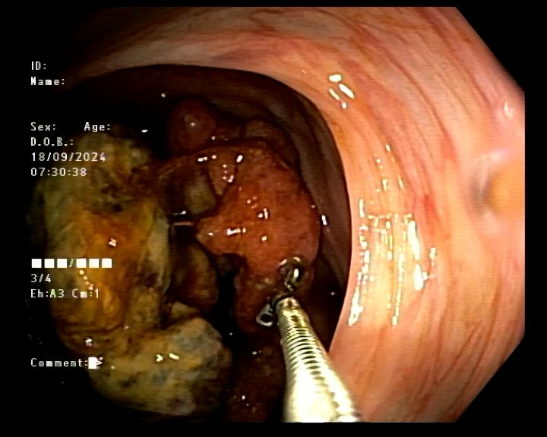

Discussion
MiNENs are a rare gastrointestinal neoplasms.They represent roughly 1–2% of all colorectal malignancies⁽²⁾. These neoplasms have two different types of tissues that include both neuroendocrine and non neuroendocrine cells. The neuroendocrine component could be either well-differentiated or more frequently poorly differentiated⁽³⁾.Both types of tissues should normally account for at least 30% of the whole neoplasm^{(2),(3)}.
The management of MiNEN has not been codified yet due to their rarity and heterogeneity.Generally, aggressiveness and prognosis are driven by the most aggressive neoplastic component⁽³⁾.

Due to limitations and unavailability of the diagnostic methods and poor awareness of the disease, the diagnosis of MINEN is underestimated⁽⁴⁾.MINENs are usually treated as pure neuroendocrine tumour management or pure adenocarcinoma management based on the assumptions of molecular equality of their counterparts⁽⁴⁾.
Acknowledging these limitations, the biological behaviour of MiNENs is mostly driven by the neuroendocrine component, which is poorly differentiated in approximately 90% of cases, and often occupies the distant metastatic sites⁽⁴⁾.
Mainstay of management is surgery with or without pre operative and post operative chemo-radiotheraphy as pure adenocarcinoma. But prognosis of MINEN is poor compared to pure cancer and recurrence with in one year is high⁽⁵⁾.
Selection of chemotherapy regime is complex and it usually done after identification of the component which is responsible for metastasis⁽⁶⁾.If metastatic disease is mainly adenocarcinoma 5-Flurouracil bases regime and Oxaliplatin combination use as first line treatment⁽⁶⁾. If the neuroendocrine part is predominantly responsible for metastasis Cisplatin and stoop side regime is a good combination ⁽⁶⁾.

References
(1) Zakaria El Barkaoui et al. Mixed neuroendocrine-non-neuroendocrine neoplasms of the right colon: a case report. Pan African Medical Journal. 2021;40(243). 10.11604/pamj.2021.40.243.30627
(2) Verdasca, F.R. et al. (2024a) ‘Mixed neuroendocrine-non-neuroendocrine neoplasms of the rectum: A case report’, Case Reports in Oncology, 17(1), pp. 587–595. doi:10.1159/000538384.
(3) de Mestier, L. et al. (2017a) ‘Digestive system mixed neuroendocrine-non-neuroendocrine neoplasms’, Neuroendocrinology, 105(4), pp. 412–425. doi:10.1159/000475527.
(4) Frizziero, M. et al. (2020) ‘Mixed Neuroendocrine Non-Neuroendocrine Neoplasms: A systematic review of a controversial and underestimated diagnosis’, Journal of Clinical Medicine, 9(1), p. 273. doi:10.3390/jcm9010273.
(5) Frizziero M, Wang X, Chakrabarty B, Childs A, Luong TV, Walter T, Khan MS, Morgan M, Christian A, Elshafie M, Shah T, Minicozzi A, Mansoor W, Meyer T, Lamarca A, Hubner RA, Valle JW, McNamara MG. Retrospective study on mixed neuroendocrine non-neuroendocrine neoplasms from five European centres. World J Gastroenterol. 2019 Oct 21;25(39):5991-6005. doi: 10.3748/wjg.v25.i39.5991. PMID: 31660035; PMCID: PMC6815794.
(6) Silva, D.J. et al. (2021) ‘Rectal mixed adenoneuroendocrine carcinoma’, Medicine, 100(40). doi:10.1097/md.0000000000027348.

(7) World Health Organisation classification of tumors-Digestive system tumors -5th edition-2019

