Orthopedic surgery and autoimmune diseases. What do you need to know?
Dra. Marcela Catalina Fandiño Vargas.
Rheumatologist. Hospital Obregón. Ciudad de México. México.
Abstract:
There are not many guidelines that contemplate the management that should be done in patients who require orthopedic-type surgeries secondary to damage associated with autoimmune diseases, which are relatively frequent in this type of disease. It is not popular knowledge that many of the DMARDs (disease-modifying antirheumatic drugs) have frank interactions and present side effects related to the surgical act itself and its inherent complications. In this presentation we will make a summary of the management according to the existing literature at each moment (pre-surgical, surgical and post-surgical act) related to the most common autoimmune diseases. We know that there is almost a general rule of joint compromise in most of this type of ailments, with special predilection in the knee, hip, hands, shoulder and spine that sooner or later will require the intervention of the orthopedist so that together they can guarantee a improvement in the quality of life of patients.
On the other hand, we will divide this review into 3 parts, in the pre-surgical section, we will emphasize the recommendations for each of the rheumatological diseases to arrive at surgery in the best way. In the surgical act, we will review the recommendations within the ideal operating room for these patients and in the postoperative period when to restart the medication and some expected side effects and/or complications.

Biography:
Dr. Marcela Catalina Fandiño Vargas is an Adult Rheumatologist, graduated from the Rheumatology and Osteoporosis Unit of the Ignacio Morones Prieto Central Hospital, jointly with the Autonomous University of San Luis Potosi. She also has a specialty in internal medicine from Hospital Juarez de Mexico. She is currently in private practice and in 2023 she will perform a high specialty in interstitial lung disease. She acted as a contributor to the Gladel Lupus Cohort and also has two publications as the author of chapters of 2 books on autoimmunity.
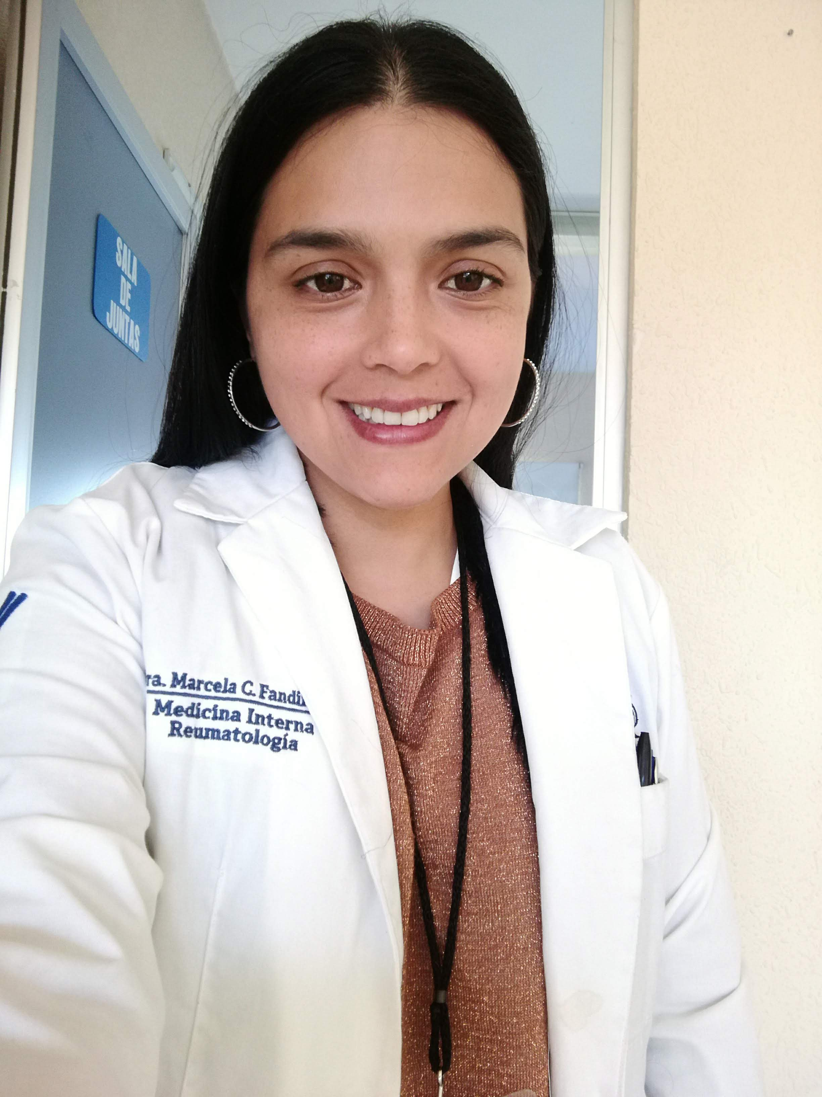

Mail: doctorcita.markitty@gmail.com
Presenter Name: Marcela Catalina Fandiño Vargas
Type of Presentation: Speaker
Contact Number: +525584504946

