Nipple Reconstruction: A Regenerative Medicine Approach using 3D Printed Tissue Scaffolds
Denver Khoo, BSc, MBBS Honsª; Owen Ung, MBBS, FRACS^{a,b}; Daniela Blomberger^{c}; Dietmar W. Hutmacher, PhD (corresponding author)^{c,d}
ªFaculty of Medicine, University of Queensland, 288 Herston Rd, Spring Hill QLD 4000, Brisbane, Australia
^{b}Centre for Breast Health, Unit 1 Surgery - Breast Endocrine Unit, Royal Brisbane and Women’s Hospital, Herston QLD 4029, Brisbane, Australia.
^{c}Centre in Regenerative Medicine, Institute of Health and Biomedical Innovation, Queensland University of Technology, 60 Musk Avenue, Kelvin Grove QLD 4059, Brisbane Australia
^{d}ARC Centre in Additive Biomanufacturing, Queensland University of Technology, 60 Musk Avenue, Kelvin Grove QLD 4059, Brisbane Australia

Abstract

Nipple-areola complex reconstruction is a common procedure that often accompanies breast reconstruction. Historically, local skin flaps were utilised for nipple reconstruction, with more recent techniques exploring the addition of implanted material. Tissue engineering and regenerative medicine (TE&RM) represents a potential source of stable and biocompatible implantable tissue which may have a positive effect on cosmetic outcomes. Conventional TE&RM techniques involve seeding a scaffold with the patients’ own cells and using growth factors to promote survival. The clinical applicability of these techniques is limited by its cost and ability to produce sufficient volumes of viable tissue. This article reviews the evolution of nipple reconstruction techniques and current TE&RM protocols; these two fields are then combined to propose a novel approach of using TE&RM scaffolds to augment conventional nipple reconstruction.
Image
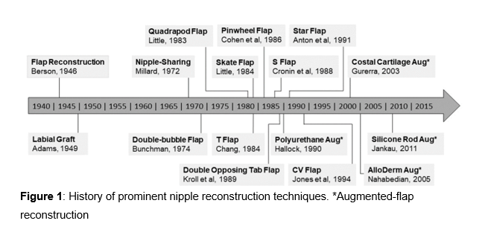
Recent publications (minimum 5)
- Khoo D, Ung O, Blomberger D, Hutmacher DW. Nipple Reconstruction: A Regenerative Medicine Approach using 3D Printed Tissue Scaffolds. Tissue Eng Part B Rev. 2018 Oct 31. DOI: 10.1089/ten.TEB.2018.0253

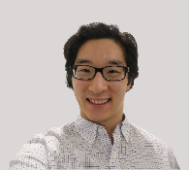
Biography
Dr Denver Khoo completed his Bachelor of Science, and Bachelor of Medicine, Bachelor of Surgery at the University of Queensland, Australia. He is an associate lecturer at this institution with a special interest in medical education. He is also involved with the research team at the Centre in Regenerative Medicine, a part of the eminent Institute of Health and Biomedical Innovation. Denver works as a resident medical officer at the Royal Brisbane and Women’s Hospital and has published his works in the journal Tissue Engineering.
Email: denver.khoo94@gmail.com

Presenting author details
Full name: Denver Khoo
Contact number/Mobile Number: +610421047359
Session name/ number: Plastic and Reconstructive Surgery
Category: Poster/Oral presentation

