Closed thoracic bypass between the internal mammary artery and the coronary artery to the beating heart by means of minimally invasive surgery
Nelson R. Torales, MD General Surgeon, Hospital Central Argentina

At the level of morbidity and mortality in the United States, the number of adults with a diagnosis of heart disease is 28.4 million patients, which in percentages of adults diagnosed with heart disease: 17.7% of the population of the adult population. The coronary disease is the first cause of death. Of this percentage, it is more frequent in men (7.2%) than in women (4.3%) and that there is a predominance of coronary disease in people over 45 years of age. Thinking about the group of patients to whom we are going to propose a better quality of life, most patients have some type of medical coverage, which is encouraging in terms of the improvements that can be achieved in health policies. Bypass or coronary artery bypass is the most important surgical technique to treat acute myocardial infarction and angina pectoris in the last 50 years. Currently more than 415,000 people undergo myocardial revascularization surgery or coronary bypass surgery every year in the United States, according to data from the Center for Disease Control (CDC). The purpose of this study project is to propose a minimally invasive procedure to perform a coronary bypass, which is reproducible and accessible to the entire population of the USA, in comparison with current surgical methods. Methodology and theoretical orientation: it is a prospective study, which is in the prototype phase (figure 1). Results: at the level of laboratory tests in bioengineering has promising results for the realization of an anastomosis. Conclusions: Minimally invasive surgery is a fact in all surgical pathologies, what was previously impossible is not so.

Image
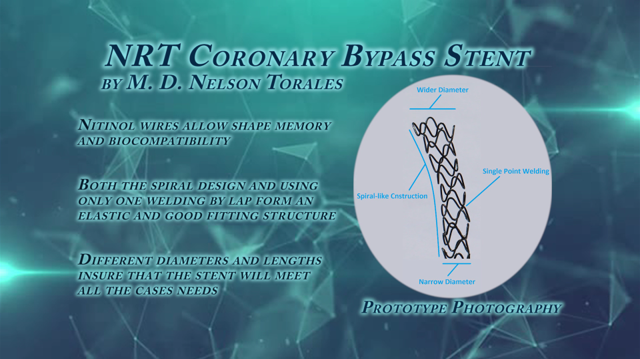
Figure 1

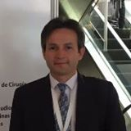
Nelson Rene Torales MD (UBA), is a general surgeon, inventor and researcher who works at the Hospital Central Formosa Argentina, Specialist in General Surgery (MAAC), Specialist in Phlebology and Lymphology (UNE) and Magister in Clinical and Healthcare Effectiveness (UBA and Harvard University). He is passionate about cardiovascular surgery, has worked for 4 years in this research project related to minimally invasive surgery and coronary heart disease. Where, through an idea, a medical device is designed that can revolutionize cardiac surgery.
. Email: nelson.torales100@yahoo.com

Notes/Comments:

