Abstract

Innovative Systems for Accelerated Construction of Concrete Bridges

MORCOUS, G.
Durham School of Architectural Engineering and Construction, University of Nebraska-Lincoln, Nebraska, USA

Keywords: precast/prestressed concrete, post-tensioning, self-consolidated concrete, ultra-high-performance concrete.

- Abstract Body
Precast/prestressed concrete is commonly used in short and medium span bridges because of its assured quality, inherent durability, and economy due to optimized use of materials. Recent research projects conducted at the University of Nebraska – Lincoln (UNL) focused on developing innovative systems and using high performance materials in precast/prestressed concrete bridges to improve their speed of construction while maintaining their economics. This presentation discusses these systems and their implantation in the construction of three medium span bridges in Nebraska. The innovative features in these systems include the use of Ultra-High Performance Concrete (UHPC), self-consolidating concrete (SCC), large diameter prestressing strands and a unique post-tensioning system to achieve simplicity of production and accelerated construction. Precast/prestressed concrete girders with large diameter prestressing strands are designed to achieve span-to-depth ratio of over 30. Design and production challenges associated with these strands and their implementation in the Oxford South Bridge are presented. Full-width full-depth precast/prestressed concrete deck panels eliminate deck forming, reinforcing, casting, and curing operations. These panels are connected to the supporting girders using discrete high strength shear connectors and shear pockets that minimize cast-in-place operations and eliminate the need for deck overlay. Deck panels can be either connected transversely using UHPC reinforced connections, or using the unique post-tensioning system that was developed to eliminate ducts and grouting operations. High performance SCC is used instead to encase the post-tensioning strands and fill the shear pockets. The implementation of these features to the construction of Kearney East Bypass and Belden-Laurel Bridge are presented

Image:
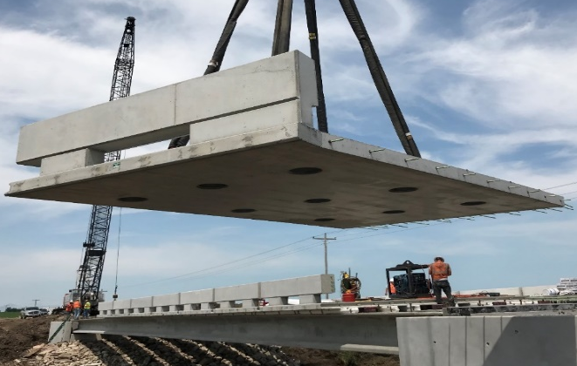
- Reference:

- Morcous, G., Hatami, A., and Jaber, F. (2018) “A New Precast Concrete Deck System for Accelerated Bridge Construction”, Journal of Advances in Civil Engineering Materials, ASTM International, 7(3).
- Morcous, G., Assad, S., Hatami, A., and Tadros, M. K. (2014) “Implementation of 0.7 in. Diameter Strands at 2 in. by 2 in. Spacing in Pretensioned Bridge Girders”, PCI Journal, 59(3), 145-158
- Tawadrous, R. and Morcous, G. (2019) "Design of Shear Pocket Connection in Full-Depth Precast Concrete Deck Systems", Journal of Engineering Structures, Elsevier, V179, 367-386.

Biography:

Dr. George Morcous is a professor at Durham School of Architectural Engineering and Construction at the University of Nebraska-Lincoln since January 2005. He has a B.S. and M.S. degrees in Civil Engineering from Cairo University-Egypt. He earned his doctorate degree from Concordia University – Canada in 2000. He is currently a registered professional engineer in the State of Nebraska. He has 25 year experience in bridge engineering. His research and teaching interests include design and construction of precast prestressed concrete structures. He has three patents and over 150 publications.

Presenting author details


George Morcous (402) 554-2544
https://engineering.unl.edu/durhamschool/faculty/george-morcous/
Oral presentation

