Title: A Numerical Investigation on the Mode of Failure for a Composite Beam Subjected to Combined Negative Bending and Axial Loads

Ma. Bavan¹, Shahrizan Bin Baharom², Siti Aminah Osman²
1Student, Department of Civil Engineering, Universiti Teknologi Malaysia, Malaysia
2Department of Civil and Structural Engineering, National University of Malaysia, Malaysia

Keywords: Steel concrete composite beam, combined negative bending and axial load, degree of shear interaction, reduced section on web, failure mode, strength behaviour.

- Abstract Body (up to 300 words)
In the past, a few investigations on modes of failures, have been put forward to determine the ultimate strength of composite beam. These determinations summarized elsewhere were on the mode of failure for reduced section of web of the composite beam subjected to monotonic loads. There has been a certain experimental works for a composite beam subjected to combined negative bending and axial load, and the mode of failure was reinforcement fractures. In this present study, a numerical model was developed for a composite beam subjected to combined negative bending and axial load, validated with existing experimental analysis, and applied openings with different sizes and shapes, which were a significant investigation on the mode of failure of reduced web section of composite beam subjected to combined negative bending and axial loads. In addition, the influences of degree of shear connection on failure mode with different shapes of opening such as circle and square were investigated. In summary, the reduced web section was found as substantial to influence a failure in the web of composite beam at any degree of shear interactions.

Image:
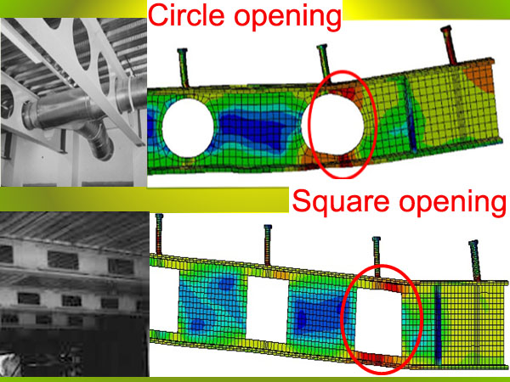
Reference:

- Bavan M, Baharom S.B, Mutalib A.A, Osman S.A (2013), “Numerical prediction of a composite beam subjected to combined negative bending and axial tension”. Journal of Engineering Science and Technology, Vol. 8, No. 4 (2013) 428-447.

- Bavan M, Baharom S.B, Mutalib A.A, “Refined FEM analysis of steel-concrete composite beam subjected to negative bending and axial compressive forces”. Jurnal Teknologi Vol.65:No2 (2013) 143-156.

- Bavan M, Baharom S.B, Mutalib A.A, “Strengthening of composite beam with web openings subjected to combined hogging moment and axial tension”. International Conference on Structural and Civil Engineering Research 2018, Netherlands.

Biography:
Bavan has completed his MSc in Civil and Structural Engineering from National University of Malaysia and Master of Engineering (Geotechnics) from University Technology Malaysia. He is a Senior Engineer in Civil and Structural Engineering with fourteen years of vast professional experiences and currently he is enduring the research to read PhD. He has published more than 50 papers in reputed journals and international conferences.

Presenting author details


Full Name: Mahesan Bavan Linked In account: Mahesan Bavan
Session name/ number:
Category: Oral presentation

