

Abstract Template

Title: Historic Landmark and its role as a Catalyst for Urban Regeneration: Al Mahatta, Sharjah

Ashok Ganapathy Iyer1, Dhruv Parekh1, Shweta Gandhi3, Kairmein Deboo⁴
1Department of Crop Improvement, International Rice Research Institute, Manila, Philippines
2Department of Genetics and plant Breeding, National Rice Research institute, Osaka, Japan

Keywords: Precursor, Al Mahatta Museum, Urban Revival, Trucial States of Oman

- Abstract Body (up to 250 words)
It is known development of cities has largely been influenced by the presence of a precursor, either natural or built. Built form precursors such as structures that are political, religious or cultural symbols have often guided and stimulated this growth, whereas natural precursors have dictated their morphology through settlement patterns and urban fabric. Such has also been the case of the then Sharjah Village, a sheikhdom in the Trucial States of Oman, that settled in an organic form along the Persian Gulf coast. This village has now evolved into a mega city of 1.5 million inhabitants, the Emirate of Sharjah located in the United Arab Emirates and is striving to be the Cultural Capital of the Arab World. Rapid urbanization has resulted in a dense urban fabric with no focus on livability. A key historic and cultural component lost amidst the urban fabric is Al Mahatta, the Aviation Museum established within the Rest House built in 1933 as a part of the Sharjah Airfield. Al Mahatta played a major role in shaping the city’s growth and influencing the grid it follows today. The paper illustrates the historic role of Al Mahatta as a precursor, and identifies the potential it holds for urban regeneration, with an attempt to be catalyst of influence on the city’s urban fabric.

The current relationship of Al Mahatta within the urban fabric of Sharjah will be analyzed through both, the macro context of its place in Sharjah’s cultural vision and micro layers of the neighborhood it sits in. This paper will then conclude by re-establishing the role and future of Al Mahatta, as a cultural symbol, and a catalyst renewing the urban discourse of Emirate of Sharjah

Images:
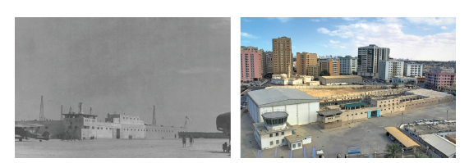
Fig 1.1: 1959 View of Al Mahatta Fig 1.1: 2015 View of Al Mahatta
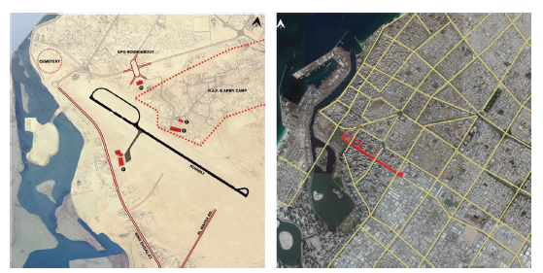
- Reference:

1 Stanley-Price, N. (2012). Imperial Outpost in the Gulf (1st ed.). Great Britain: Book Guild Publishing. Retrieved 2016
- Air Outpost (1937). [Motion Picture].
- Al Qasimi, S. b. (2012). Sharjah Air Station between East and West (1st ed.). (P. R. Davey, Ed., & D. Ali, Trans.) Sharjah: Al Qasimi Publications. Retrieved 2016
- O’ Sullivan, M. (2012). Planning and the Significance of Built and Cultural Heritage in Urban Centres. Geographical Journal, 31 - 37.

Biography:
Ashok is the Chairperson of School of Design & Architecture (SoDA), Manipal Academy of Higher Education; Dubai since 2004 and is currently pursuing his PhD Studies at Welsh School of Architecture (2011). His research is looking at the classification of the approaches to learning adopted by students in their design coursework through the five years of the architecture program. An architect by profession, he has pursued his architectural studies at Sir J.J. College of Architecture, Mumbai; India (Master in Architecture, 2004) and at Pillais’ College of Architecture, Navi Mumbai; India (Bachelor of Architecture, 1997). He was a faculty at Sir J.J. College (2002-04) & Rizvi College of Architecture (1999-2002), Mumbai; India before establishing interior design & architecture programs at SoDA – Dubai. His other research interests include urban studies & historic developments through architectural documentation, issues of sustainability in contemporary architecture; fine arts & architecture heritage. His hobbies include philately & numismatics; fountain pens & sketching.

Presenting author details
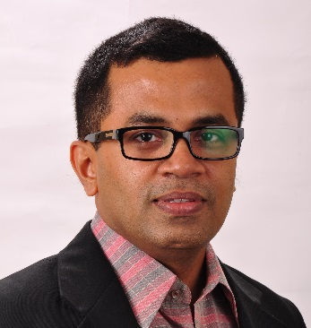
Full Name: Ashok Ganapathy Iyer
Contact number: +971508995705 / +97144290774
Linked In account: https://www.linkedin.com/in/ashok-ganapathy-iyer-a643219
Session name/ number: Session-5 ‘Traditional Architecture VS Modern Architecture’
Category: Oral presentation)
Passport Number: Z2510967 (Indian)
Fig 2.1: Post 1974 Map of Sharjah Fig 2.2: 2014 Map of Sharjah

Copyright © 2016-2018 Meetings Int PTE Ltd, All Rights Reserved.
Meetings Int.Pte Ltd

Company Registration No: 201524282R,28 MAXWELL ROAD, #03-05 RED DOT TRAFFIC, SINGAPORE (069120)
Tel:; +6531080483| Toll Free no. +800-852-6126
Web: https://www.meetingsint.com/conferences/structuraldesign | E-mail: structuraldesign@meetingseries.com

