Title: Risk factors for the Stroke in high altitude Andean inhabitants. (Case report)
Alvarado B. J. Ximena ₁
_{1.}Emergency department at the Hospital Obrero N°1. Caja Nacional de Salud. La Paz- Bolivia.

Keywords: High Andean inhabitants. (Bolivia 3650meters).
- Abstract
52 year old man from La Paz Bolivia (altitude 3650 meters). He was seen in the emergency departament because of an episode of loss of consciousness and left hemiparesis. Laboratory results showed 6¨850.000 red cells
CT head without contrast showed right medial cerebral artery infarction with cerebral edema. The patient was transferred to intensive care at the local hospital and hours latter died.
The native inhabitant and resident of high altitude (La Paz Bolivia, 3650 meters), its genetic composition mixes Native Americans, Europeans and Africans.
It has printed physiological characteristics: Cerebral blood flow is decreased by around 20%, increase in the mean time of cerebral transit (15%).
The poor adaptation to this environment hypobaric hypoxia, is known as chronic mountain disease, characterized by: severe hypoxemia, which generates increased erythrocyte mass, increases the risk of stroke.

The exaggerated response to systemic oxidative-inflammatory-nitrosating stress: defined by an increase in the formation of free radicals and decreased bioavailability of vascular nitric oxide, is associated with impaired cerebrovascular function.
The formation of free radicals in lowland individuals that are exposed to high altitude acutely is moderate with vascular dysfunction, similar response in well-adapted high altitude inhabitants without vascular manifestation. In high altitude inhabitants with mountain sickness, the exaggerated oxidative response was associated with systemic vascular dysfunction: demonstrated by flow-mediated dilation, arterial stiffness and thickness of the carotid intima-media.

Most strokes may be due to vascular occlusion, poor perfusion through narrowed cerebral vessels and Erythrocythemia, plays the most prominent role in people living at high altitude.

- Image
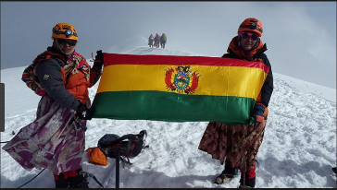
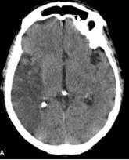

- Reference
- RChacón, D. J., et al, 2018. Latin Americans show wide-spread Converso ancestry and imprint of local Native ancestry on physical appearance. Nature Communications, 9:1-11.
- Bailey M. D., Brugniaux V.J. Filipponi T., et al, 2018. Exaggerated systemic oxidative-nitrosative-inflammatory stress in chronic mountain sickness is associated with cognitive decline and depression. The Journal of physiology. 1-50.
- Bailey M.D., Rimoldi F.S., Rexhaj E, et al, 2013. Oxidative-Nitrosative Stress and Systemic Vascular Function in Highlanders With and Without Exaggerated Hypoxemia. Chest, 143(2), 444–451.
- Biography:
J. Ximena Alvarado B. Medical Doctor, specialist in Internal Medicine. Member of the Society of Bolivian of Medicina Interna, since 2010. Adherent member of the Neurology Society, since 2008. Member World Stroke Organization, since 2012. Delegate World Sleep Day Bolivia, since 2012. Member of the Bolivian Association of Atherosclerosis, since 2015. Professor of Internal Medicine residency at the Hospital de Clínicas Universitario, since 2010-2018. Guest professor in the chair of Physiopathology UMSA 2013. Medical Doctor, specialist in Internal Medicine in Emergency department at the Hospital Obrero No. 1. C.N.S., since 2016.
Chairman of meeting Stroke 20-22th of may 2009. La Paz Bolivia. Member of the local organization committee of the Panamerican Congress of Neurology 4 to 8 march 2012 in La Paz- Bolivia.
Autor. “High altitude erythrocytosis as risk factor for stroke. Case Report”. 8th World Stroke Congress. 10 al 14 de Octubre, 2012. Brasilia-Brazil.
Autor. “Incidence of Chronic Headache Diagnoses and Etiologies at Altitude". The 16th Congress of the International Headache Society, June 27-30, 2013, in Boston, Massachusetts.
Autor. “CASE REPORT(narcolepsy)”. 5th World Congress on Sleep Medicine. 2-5 de Septiembre, 2013. Valencia-España.
Autor. ““Prevalence of restless legs syndrome secondary to hemodialysis unit Clinicas hospital””. 5th World Congress on Sleep Medicine. 2-5 de Septiembre, 2013. Valencia-España.
Extraordinary Award of the World Sleep Day 2013. 5th World Congress of Sleep Medicine Palau is Reina Sofía Arts of Valencia, Spain September 28, 2013.
Title: Alterations of sleep and cardiovascular risk. Bolivian Association of Atherosclerosis. June 17, 2015
Title: Obstructive sleep apnea syndrome and cardiovascular risk. Bolivian Association of Atherosclerosis. February 17, 2016.
- Presenting author details

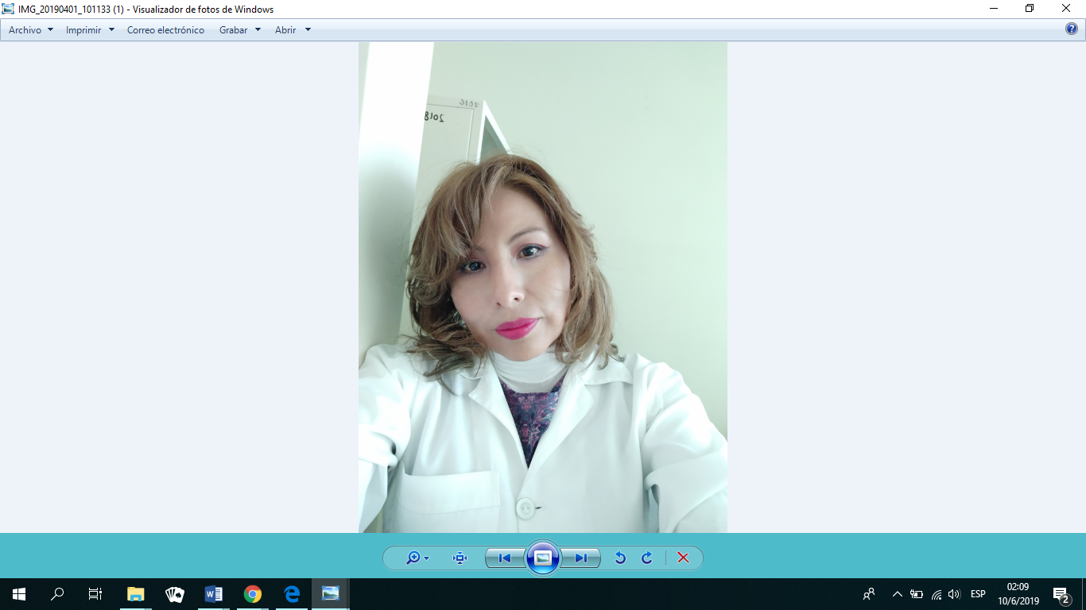
Full Name: Alvarado B. J. Ximena.
Contact number: 591-2-70177759
Twitter account:---
Linked In account: ximena alvarado
Session name/ number: Neurophysiology and Neurodegeneration
Category: (Oral presentation/ Poster presentation)
Passport Number: 4282827

