
GENETIC STRUCTURE OF CRONA VIRUS
Mahdi Tajalifar.Master genetics and plant breeding.Iran.Qazvin.
Tell:00982833367725 Email:Mahdi.tajalifar@yahoo.com
History
Crona virus were first discovered in the1960. On 2002 was (sars) or (sars-cov) published on china. On 2012 mers virus was published on Saudi arabia. On December 2019 discovered covid19 on china and publication on world.
Acute respiratory syndrome: sars, mers and covid19
Taxonomy
Kingdom | Viruses
Family | Cronavirdae
Sub family | Orthocoronavirinae
Order | nidovirales
realm | riboviria

Picture orthocoronavirinae
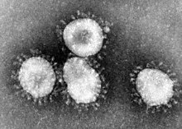
Introduction
This virus is of family coronavirdae; single strand; positive sense RNA genom; ranging of 26 to 32 kb.
Host this virus: camels, bats, mice, dogs, cats and human.
Structure
SEMN. S: Spike. E: Envelope. M: Memberane. N: Nucleocapsid
Cycle crona virus
The corona virus RNA genome has a 5ˊ methylated cap and a 3 ˊ polyadenylated tail, which allows the RNA to append to the host cells ribosome for translation.
Crona virus genomeshave encode protein called RdRp, that lets the viral genome to be transcribed into new copies using the host cells system. RdRp is first protein, next process is translation. Result translation is stopped by a stop codon, introduction a nested transcript. Transcript have enzyme transcriptase.Mrna just encode one gene.
Corona virus non- structural proteins and a protease provide additional correctness to replication. The genome is along polyprotein is shaped.
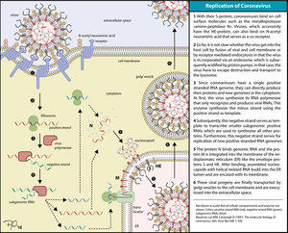
Reference
www.wikipedia.org/wiki/Coronavirus
www.ncbi.nlm.nih.gov
www.thelancet.com
www.link.springer.com
www.vox.com
Biography
Agricultural expert, homeopathic specialist, home plant monitoring designer. Cocomoss planting platform translator in Iran and the world. MSc in Genetics and Plant Breeding. Member of the American Chemical Society. Author of The Most Viewed Corn and Glory Articles in omics Online. Leading the way in reporting on apartment plants in Iranian news agencies.The Rosary Shawl article has over 4600 views and has 195 downloads. This article highlights the importance of this plant in the prevention of cancer in China and the treatment of muscle spasms. The shawl is from the Corn family. The goal is to control your body weight.
Presenting author detail
Full name: Mahdi tajalifar
Contact number:00982833367725
Twwiter account:no
Linked in account: Mahdi.tajalifar
Session name/ number:no
Category:poster presentation

