A novel direct co-culture assay of fibroblast and adipose derived mesenchymal stem cell using a pig skin scaffold
Karla E Hernández G. MSc, National Rehabilitation Institute, México city

Abstract (300 word limit)
The multipotency of mesenchymal stem cells have shown effectiveness in enhancing the regeneration and repair of different tissues types by upregulating multiple growth factors and directly differentiating into particular cell types contributing to healing. Adipose-derived stem cells (ADSC) are a particularly attractive type of adult stem cell because this tissue is routinely discarded from liposuction procedures which are also relatively non-invasive and low risk. Furthermore, ADSC are easily harvested from the stromal vascular fraction obtaining higher yields compared to bone marrow.
Pig skin has been used as a protective barrier while keeping hydration which helps prevent infections. Recently Sánchez S. and his team proposed using pork skin that has been radio-sterilized like a scaffold to support ADMSC due to its capacity to maintain their viability and to promote proliferation. Leading to the hypothesis that the high similarity between pork and human ECM composition (mainly by collagen type I) plays an important role, although there is not an official scientific report on it.
The objective of this project was to generate an ADMSC and fibroblast co-culture, using a scaffold of radio-sterilized pork skin to evaluate the release of growth factor and the ECM-related protein expression. The results suggested PPR is regulating collagen I and III mRNA expression, modifying the proportion between them (against the control group) while stimulating VEGF, EGF and bFGF secretion.

Image

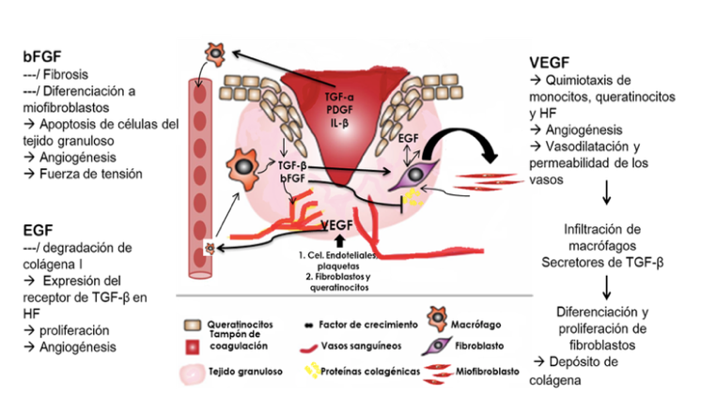
Recent Publications (minimum 5)
- Sánchez-Sánchez R, Brena-Molina A, Martínez-López V, et al. Generation of Two Biological Wound Dressings as a Potential Delivery System of Human Adipose-Derived Mesenchymal Stem Cells. ASAIO J. 2015;61(6):718-725. doi:10.1097/MAT.0000000000000277

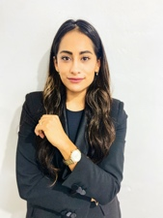Biography (150 word limit)
Karla E. Hernández González has her experience in Regenerative medicine and engineering tissue research and deeply passionate for science communication. Expertise in providing strategic scientific insight and medical direction based on relevant ongoing and completed studies as well as creating accurate educational materials for a variety of audiences.
Email: karlaestefaniahg@gmail.com

Notes/Comments:

