Wharton’s Jelly-derived Mesenchymal stem cells and osteoinductive herbal scaffolds for critical-size calvarial bone defect regeneration
Shivaji Kashte, Department of Stem Cells & Regenerative Medicine and Medical Biotechnology, Centre for Interdisciplinary Research, D. Y. Patil Education Society (Institution Deemed to be University), Kolhapur 416006, India
Rohit Dhumal, Livestock Development Officer, Department of Animal Husbandry, Government of Maharashtra, Aurangabad, Maharashtra. India.
Pradip Chaudhary, Division of Animal Oncology, Advanced Centre for Treatment, Research and Education in Cancer (ACTREC). Navi Mumbai, India
R.K. Sharma, D. Y. Patil Medical College, D. Y. Patil Education Society (Deemed to be University), Kolhapur 416006, India
Vikas Dighe, National Centre for Preclinical Reproductive and Genetic Toxicology, National Institute for Research in Reproductive Health (NIRRH), Parel, Mumbai-400012, India
Sachin Kadam, Advancells Group, NOIDA, Uttar Pradesh 201301, India

Abstract (300 word limit)
Statement of the Problem: Critical size calvarial bone defects and their repair is the major challenge in orthopaedic surgery. Bone tissue engineering using varied combinations of scaffolds, stem cells, and growth factors is an emerging choice of treatment for variety of bone defects. The study aimed to compare and evaluate the potential of poly ε-caprolactone (PCL), PCL- graphene oxide (GO), PCL-GO-Cissus quadrangularis (CQ), and human umbilical cord-derived mesenchymal stem cells (hUCMSCs) seeded PCL (PCL- hUCMSCs), PCL-GO-CQ-hUCMSCs to heal critical size calvarial bone defect in the rat models. Methodology & Theoretical Orientation: Healthy adult Wister female rats (N = 30) with average body weight of 350±30 g were divided to 6 groups with five animals in each group. A single critical size calvarial defect of 8 mm was created in the skull of each rat and were treated with respective scaffolds. The outcome of the treatments was evaluated at 6 weeks and 12 weeks in terms of weight, haematological parameters and biochemical parameters for biocompatibility. New bone regeneration/healing was analysed using digital radiography and micro-computed tomography. Quality of bone formed was analysed by bone mineral density. Histological analysis of the bone tissues was performed using an optical microscope. Findings: All the scaffolds were biocompatible and there was no adverse effect of these scaffolds on animals. Higher bone regeneration was observed after 12 weeks of transplantation than 6 weeks. However, PCL-GO-CQ-hUCMSCs scaffolds exhibited highest bone regeneration after 12 weeks. Conclusion & Significance: The unique combination of PCL-GO-CQ-hUCMSCs scaffold proved to be beneficial in bone regeneration by aiding nearly complete healing of defect site. Further studies with PCL-GO-CQ-hUCMSCs could pave the way for human clinical trials.

Image
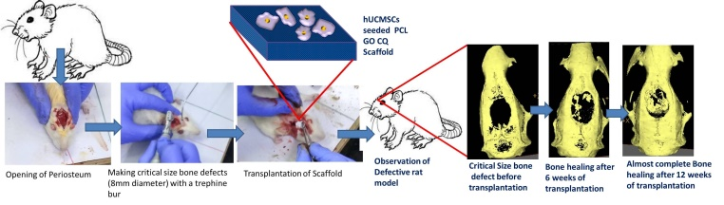
Figure 1: Graphical Abstract
Recent Publications (minimum 5)
- Gupta A, Shivaji K, Kadam S, Gupta M, Rodriguez HC, Potty AG, El-Amin SF 3rd, Maffulli N. Immunomodulatory extracellular vesicles: an alternative to cell therapy for COVID-19. Expert Opin Biol Ther. 2021 May 24:1-10. doi: 10.1080/14712598.2021.1921141.
- Shivaji Kashte, Rohit Dhumal, Pradip Chaudhary, R.K. Sharma, Vikas Dighe, Sachin Kadam. Bone regeneration in critical-size calvarial defect using functional biocompatible osteoinductive herbal scaffolds and human umbilical cord Wharton’s Jelly-derived mesenchymal stem cells. Materials Today Communications. 2021: 102049.
- Gupta, A., Shivaji Kashte., Gupta, M., Rodriguez, H. C., Gautam, S. S., & Kadam, S. Mesenchymal stem cells and Exosome therapy for COVID-19: current status and future perspective. Human Cell, 2020, 1-12.
- Shivaji Kashte, Anshuman Dwivedi, Shraddha Gautam, R.K. Sharma and Sachin Kadam. Treatment of gingival recession defect using mesenchymal stem cells cultured pcl based bone regenerating scaffold: a randomized controlled clinical study. International journal of applied pharmaceutics, 2020;12 (4);31-33
- Shivaji Kashte, Sharma RK, Kadam S. Layer-by-layer decorated herbal cell compatible scaffolds for bone tissue engineering : A synergistic effect of graphene oxide and Cissus quadrangularis. J Bioact Compat Polym. 2020;35(1):57–73

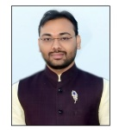Biography (150 word limit)
Dr. Shivaji Kashte has core interests in Stem cells, biomaterials and their applications bone tissue engineering and wound healing. He has developed the biocompatible and biofunctional herbal scaffolds and along with mesenchymal stem cells used to regenerate the bone tissue. He is working as an Assistant professor in the D Y Patil University (DU), Kolhapur, India. He has received the CSIR-UGC, New Delhi Junior research fellowship and senior research fellowship during 2013 to 2016 at Defense Institute of Advanced Technology (DU), Pune and during 2016-2018 at D Y Patil University (DU), Kolhapur, respectively. He has received Intramural research grant for project on wound healing during 2021. He has published more than 15 research articles in international peer reviewed journals and recently filed one Indian patent.
Email: kashtesb@gmail.com

Notes/Comments:

