Title : significance and function of rhods and cons cell in ear .
Name : Kunal Joon
Affiliation : student
University : NIIMS university
Country : India
Email address : kunaljoon37@gmail.com
Contact Number : +919992201535
Abstract
It deals with the role of rhods and cons cell present in the ear. It helps in vision acuity tactical location , reflexes like vision blurring and ear pain and their main role in the balancing of the body .
Keywords
1)Inner ear
2)Ribbons
3)Calcyen process
4)Rhods
5)Cones
6)Photo transduction
7)Photo protein

Location
Rhods and cones are located in the inner ear . These are photo transduction protein and photo transmitter connected with
Hair cells and cilia in the inner ear [1]

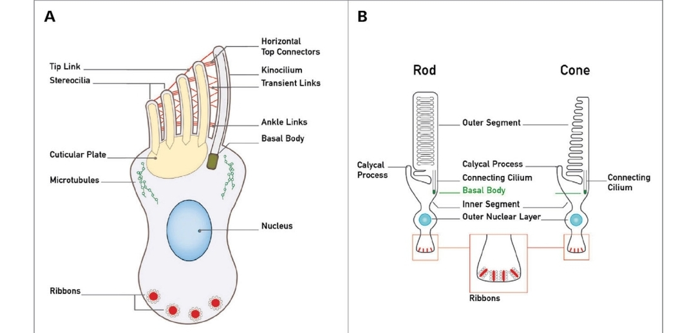
These shows the structure of rods and cones cells in the inner ear as shown in
Figure A and figure B
Significance and fate of rods and cons in the inner ear
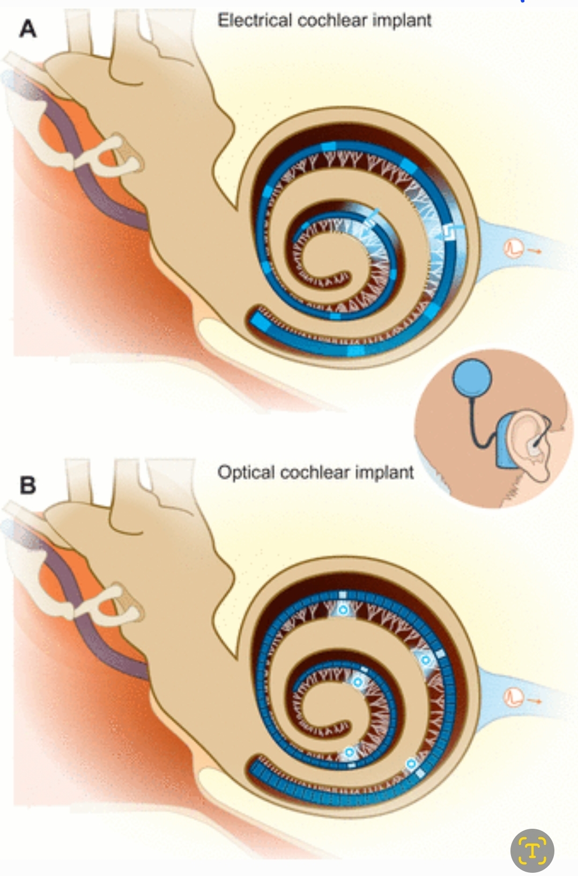
Here both figure shows electrical and optical cochlear implants .
If we see clearly these are basically the work like rhods and cons
So role of the rods and cons in the inner ear is its ia attached below the hair cell convert the impulse generated by hair cell into the electromagnetic waves and impulses
Process of conversion and carrying impulse from hair cell to nerve to cortex
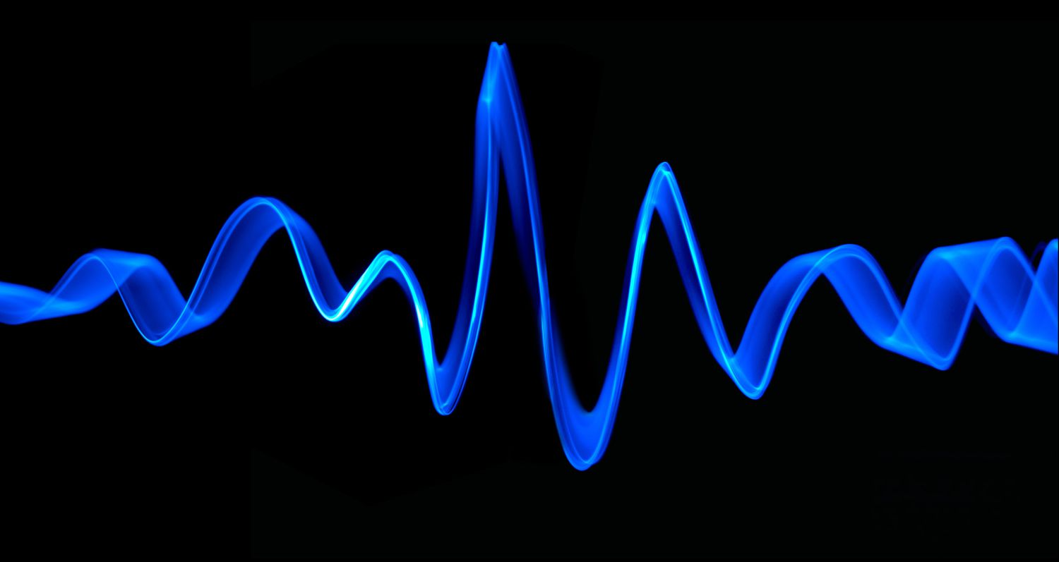

This shows the sound wave patterns coming to the ear and external ear and magnifies it
And just enter the inner ear and stimulate the inner ear and rhod cells[2]
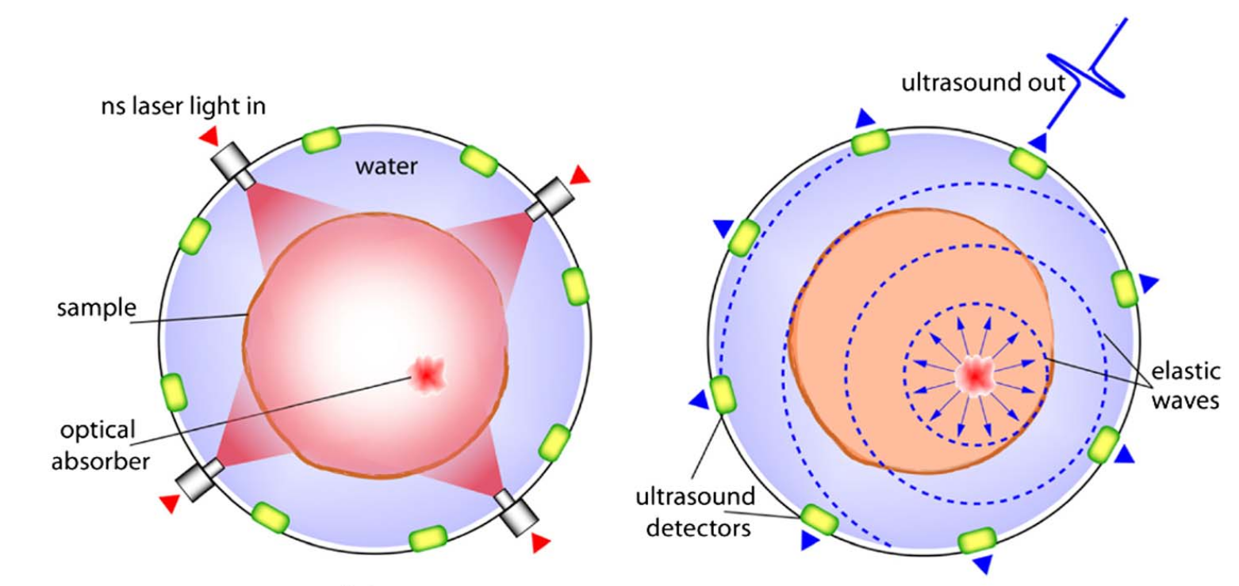
Electromagnetic waves
This shows how sound waves are converted into electromagnetic waves as shown as the hair cells are stimulated and the waves are travel it travel to rhod cells and cone cells and converted to electromagnetic waves and are emitted by rhods and cones cells.

These waves travel to the nerve and than goes to the cochlear nerve to the cerebral cortex and are stored .[3]

Fate of rods and cons cell in ear

Fate of the rods and cons cells are that these cells convert the sound waves into electromagnetic waves these waves travel through cochlear nerve .[4]
These cochlear nerve take to the cerebral cortex and than these rhods and cons cells are again stimulated than these cells stimulated and release the electromagnetic waves.
Process of sound recognize [5]
From the cerebral cortex the electromagnetic waves recogination the cortex stimulated and than the electromagnetic waves are generated by the rhods and cons cell than the hair cells recognize the electromagnetic waves recognize by hair cells and sound gets recognize .
Significance of rods and cones cells in inner ear[6]
The only the Significance of rods and cones cells in the inner ear is that just these are photoaransductor these help in the conversion of the sound wave into the[7] electromagnetic waves which helps neural transmission of sound waves impulses .[8]

Conclusion
The rods and cons cells help on the transmission of sound waves into electromagnetic waves. [9]
Discussion
-) photo transmission [10]
-) photo transduction
-) electromagnetic waves
-) sound wave transmission
Result
Function of rods and cones cells are the transmission of the sound wave into the electromagnetic waves and for nerve impulse transmission.
Reference
- https://treblehealth.com/emf-and-tinnitus/#:~:text=The%20occurrence%20of%20tinnitus%20was,in%20response%20to%20electromagnetic%20radiation
- https://www.ncbi.nlm.nih.gov/pmc/articles/PMC2657824/
- https://www.sciencedirect.com/science/article/pii/S1808869415001639
- https://www.researchgate.net/figure/Diagram-of-the-sensory-cells-in-the-inner-ear-and-retina-A-The-apical-side-of-the_fig1_6806318
- https://www.sciencedirect.com/science/article/abs/pii/S1095643308007022
- https://www.ncbi.nlm.nih.gov/pmc/articles/PMC4712787/
- https://entokey.com/structure-and-function-of-rod-and-cone-photoreceptors/
- https://www.amplexhearing.com.au/ears-and-eyes-a-common-architecture/
- https://www.sciencedirect.com/topics/immunology-and-microbiology/photoreceptor-inner-segment
- https://www.ncbi.nlm.nih.gov/pmc/articles/PMC5629997/

