ABSTRACT

Epidural Injections with biological molecules

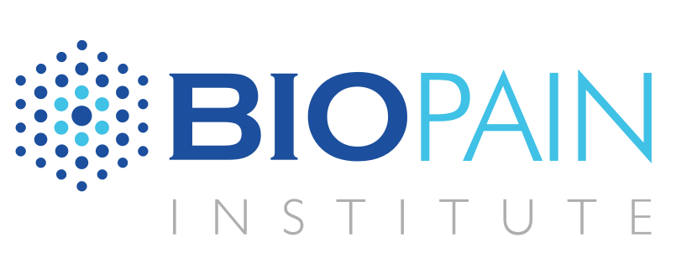

Presentation of the Speaker

DR. JOÃO PAULO BEZERRA LEITE
Medical Director of Biopain Institute ( SP)
Orthopedics. Shoulder & And Surgeon, Regenerative medicine SSpecialist, Ultrasound Specialist, Medical Thermology Specialist
- Coordinator of Pain & Tissue Regeneration Committee os Brazilian Society of (SBED)
- Assistant Professor of Medical Thermoly in University of São Paulo ( FMUSP-SP)
- Assistant Professor of Pain in University of São Paulo
- Faculty of the American Academy of Regenerative Medicine (AABRM)
- Board Member of the Interventional Orthopedic Foundation ( IOF)
- International Board Member of the International Society for Medical Shockwave Therapy (ISMST)
- Member of the editorial Board of the CPQ Orthopedics

We Know that 9 million – Nº of epidural corticosteroid injections performed annually in the US ( Bicket MC,. Epidural steroid injections: an updated review on recent trends in safety and complications. Pain Manag. 2015;5:129-146.). Epidural administration of corticosteroids is one of the commonly used interventions in managing chronic low back pain. Effectiveness range: 18% to 90% ( Manchikanti L, Singh V, Kloth D et al. Interventional techniques in the management of chronic pain: Part 2.0. Pain Physician 2001:4:24-96.). REGENERATIVE TREATMENTS – Study if the damage can be reversed by replacing lost cells or biological products derived from cells that restore de internal millieu disability and that can mature into nerve cells, the so-called “NEURAL STEM CELLS”, specially in degeneration and pain disorders

- But we have a lot of CHALLENGES
  - Diversity of central ( CNS) and peripheral ( PNS) nerve cell types
  - CNS has a limited intrinsic capacity to regenerate following most types of injury, often leading to permanent disability
  - The complex and precise interactions amongst them and the availability of appropriate cellular sources.
  - What’s the best way to deliver these cells / molecules?

- The Neuro Regenerative Medicine ( Neuro – RM) try to understand The complex pathways involved in neurodegenerative disorders, should be evaluated with care, in the attempt to extend the current understanding of the pathogenesis of these diseases and identifying targets for interventions. To be suitable for cellular neuroregenerative therapy, the mechanisms that govern the self renewal capacity of MSCs should be characterized in depth

Regenerative medicine approaches, such as stem cell technologies; tissue engineering and gene therapy to nervous system disorders are capable nowadays to slow or reverse the deterioration associated with debilitating neurodegenerative disorders. (Daar, A.S. and Greenwood, H.L. (2007) A proposed definition of regenerative medicine. Journal of Tissue En- gineering and Regenerative Medicine, 1, 179-184.).

The World Health Organization Perspective (2030)
- Alzheimer’s and other dementias 46.7%
- Parkinson’s disease 12.3%
- Neurological injuries 15.9%
(World Health Organization (2006) Neurological disorders: Public health challenges. World Health Organization, Geneva)

Nerve regeneration through precise guidance is revolutionary Blesch A, Lu P, Tuszynski M. Neurotrophic factors, gene therapy, and neural stem cells for
spinal cord repair. Brain Res Bull. 2002;57:833-838.
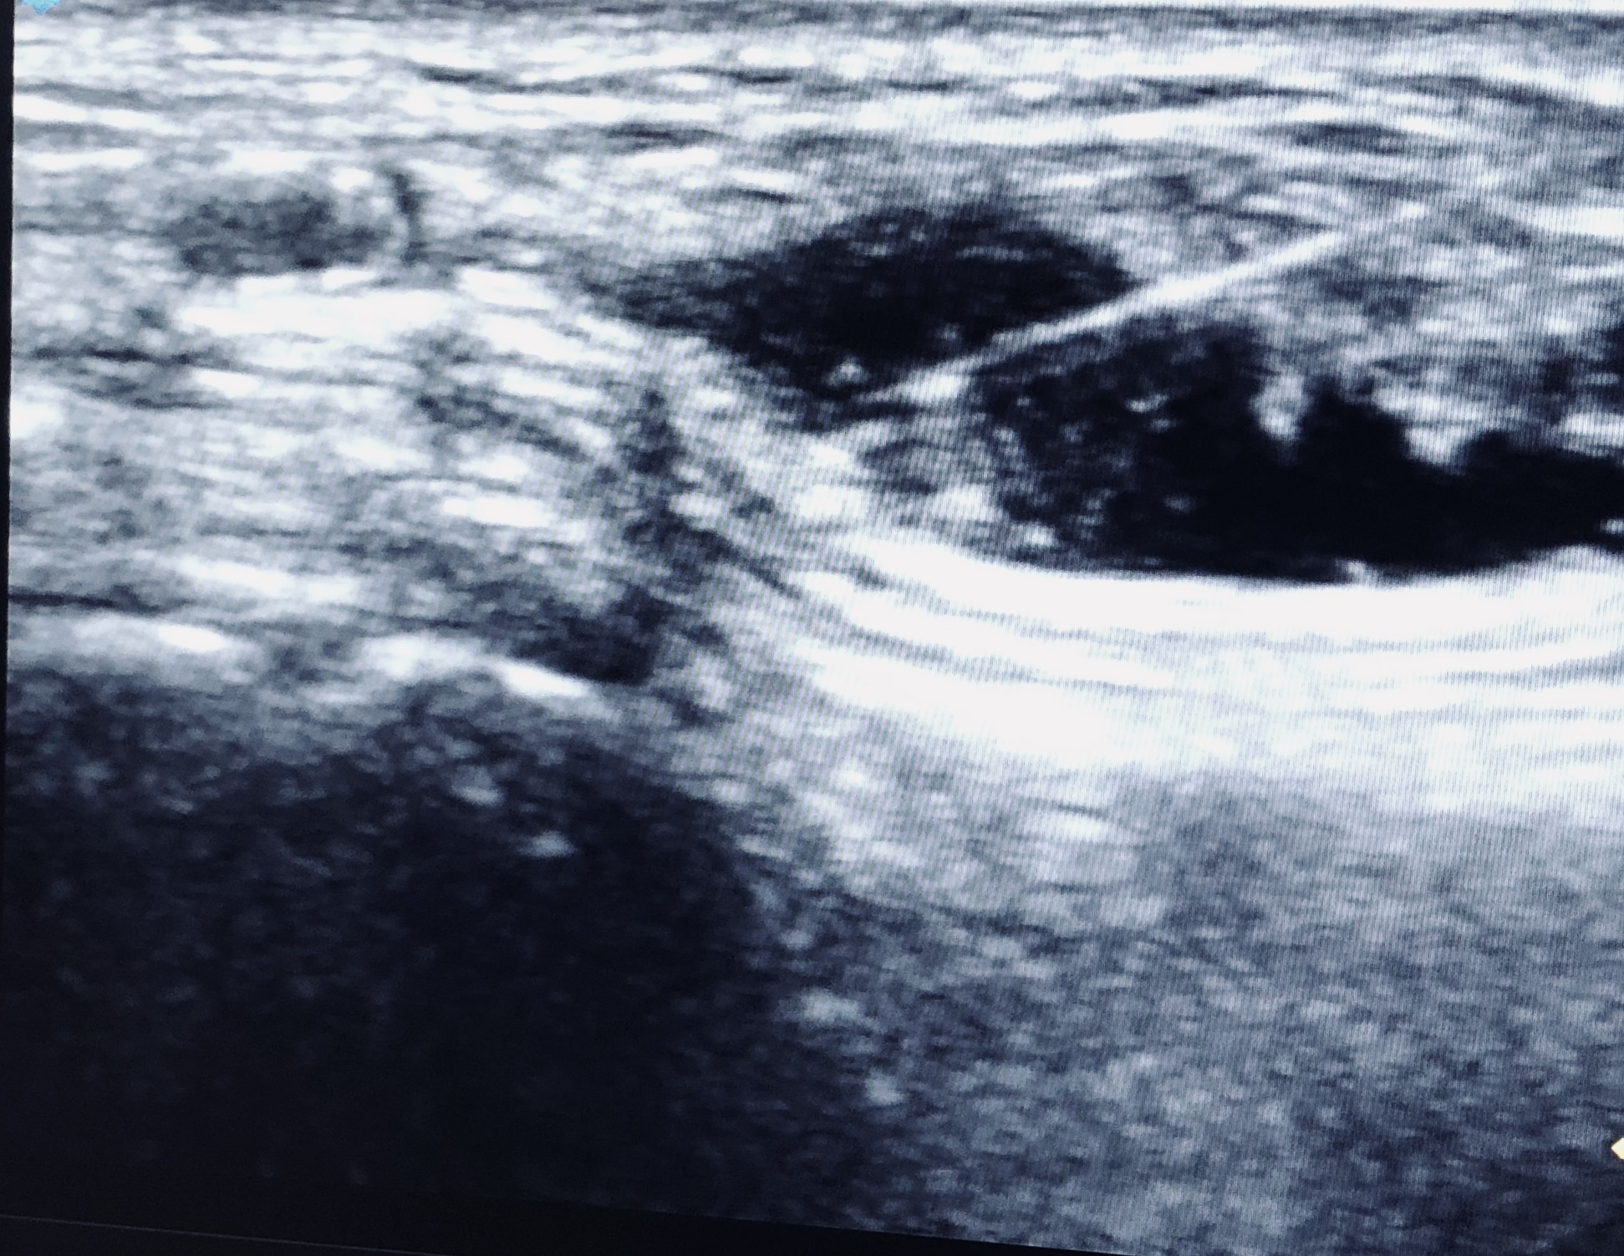

Posterior Tibial Nerve

Therapeutic cell transplantation and other biological approaches has shown promise results in animal and human models of neurological disorders, including spinal cord injuries (SCIs) (Michael C. Jin, BS. Stem cell therapies for acute spinal cord injury in humans: a review. Neurosurg Focus 46 (3):E10, 2019)

In this presentation we are going to talk about the use of regenerative medicine with Epidural Injections to treat nerve and pain disorders.

