Mathematical Algorithm of Convolution Neural Network for Cancer Detection .
Siddharth Madhav and Syed Maasir Azeem Husain

Abstract—Life is an equation , everything we see around us is a Mathematical Equation , right from picking up a pen to writing with a pen , from planting a tree to even cutting or watering it everything can be denoted in the form of a mathematical equation
. Mathematical studies have given birth to many fascinating techniques in the field on Computer Science . Today the whole world is talking about Artificial Intelligence for disease detection and the most hot Topic on board is Cancer , so the goal of this Research Paper is to create and show a mathematical pattern of Convolutional Neural Network to detect Cancer .

- INTRODUCTION
Mathematics simply means to learn or to study or gain knowledge. The theories and concepts given in mathematics help us understand and solve various types of problems in academic as well as in real life situations.
Mathematics is a subject of logic. Learning mathematics will help students to grow their problem-solving and logical reasoning skills. Solving mathematical problems is one of the best brain exercises.
Often , there are times when people say that Art and Mathematics have no Relations but what I feel is that Art and Maths are the left and right hands of Creativity . The goal of this Research Paper is to show about the different Patterns in Art .
- WHAT IS CONVOLUTIONAL NEURAL NETWORK Convolutional neural networks, also called ConvNets, were
first introduced in the 1980s by Yann LeCun, a postdoctoral computer science researcher. LeCun had built on the work done by Kunihiko Fukushima, a Japanese scientist who, a few years earlier, had invented the neocognitron, a very basic image recognition neural network.
The early version of CNNs, called LeNet (after LeCun), could recognize handwritten digits. CNNs found a niche market in banking and postal services and banking, where they read zip codes on envelopes and digits on checks.
But despite their ingenuity, ConvNets remained on the side- lines of computer vision and artificial intelligence because they faced a serious problem: They could not scale. CNNs needed a lot of data and compute resources to work efficiently for large images. At the time, the technique was only applicable to images with low resolutions.
In 2012, AlexNet showed that perhaps the time had come to revisit deep learning, the branch of AI that uses multi-layered neural networks. The availability of large sets of data, namely the ImageNet dataset with millions of labeled pictures, and vast compute resources enabled researchers to create complex CNNs that could perform computer vision tasks that were previously impossible.
- HOW DOES CONVOLUTIONAL NEURAL NETWORK WORKS
Convolutional neural networks are composed of multiple layers of artificial neurons. Artificial neurons, a rough imita- tion of their biological counterparts, are mathematical func- tions that calculate the weighted sum of multiple inputs and outputs an activation value.
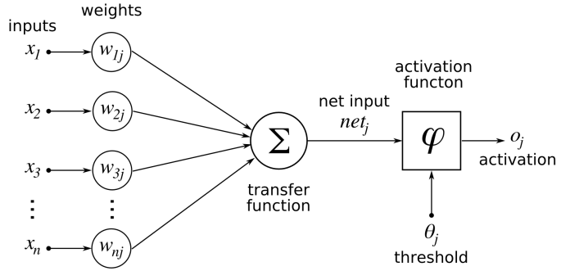
Fig. 1.

The behavior of each neuron is defined by its weights. When fed with the pixel values, the artificial neurons of a CNN pick out various visual features.
When you input an image into a ConvNet, each of its layers generates several activation maps. Activation maps highlight the relevant features of the image. Each of the neurons takes a patch of pixels as input, multiplies their color values by its weights, sums them up, and runs them through the activation function.
The first (or bottom) layer of the CNN usually detects basic features such as horizontal, vertical, and diagonal edges. The output of the first layer is fed as input of the next layer, which extracts more complex features, such as corners and combinations of edges. As you move deeper into the convolutional neural network, the layers start detecting higher- level features such as objects, faces, and more. As you move deeper into the convolutional neural network, the layers start detecting higher-level features such as objects, faces, and more.
The operation of multiplying pixel values by weights and summing them is called “convolution” (hence the name convo- lutional neural network). A CNN is usually composed of sev- eral convolution layers, but it also contains other components. The final layer of a CNN is a classification layer, which takes the output of the final convolution layer as input (remember, the higher convolution layers detect complex objects).
Based on the activation map of the final convolution layer, the classification layer outputs a set of confidence scores

(values between 0 and 1) that specify how likely the image is to belong to a “class.” For instance, if you have a ConvNet that detects cats, dogs, and horses, the output of the final layer is the possibility that the input image contains any of those animals.
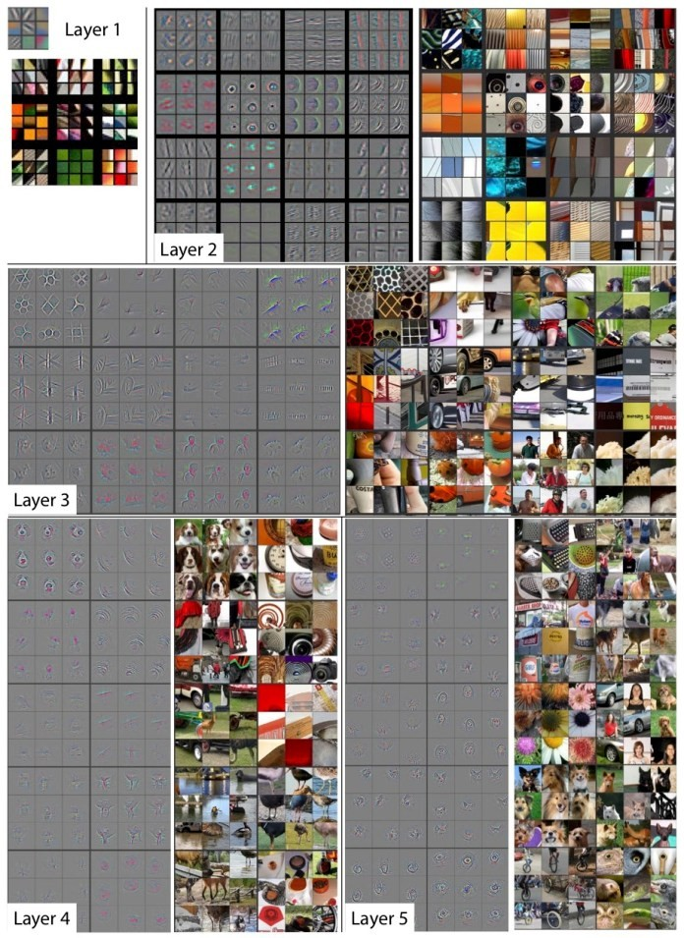
Fig. 2.

A. Training of a Convolutional Neural Network
In the beginning, the CNN starts off with random weights. During training, the developers provide the neural network with a large dataset of images annotated with their correspond- ing classes (cat, dog, horse, etc.). The ConvNet processes each image with its random values and then compares its output with the image’s correct label. If the network’s output does not match the label—which is likely the case at the beginning of the training process—it makes a small adjustment to the weights of its neurons so that the next time it sees the same image, its output will be a bit closer to the correct answer.
The corrections are made through a technique called back- propagation (or backprop). Essentially, backpropagation opti- mizes the tuning process and makes it easier for the network to decide which units to adjust instead of making random corrections.
Every run of the entire training dataset is called an “epoch.” The ConvNet goes through several epochs during training, adjusting its weights in small amounts. After each epoch, the
neural network becomes a bit better at classifying the training images. As the CNN improves, the adjustments it makes to the weights become smaller and smaller. At some point, the network “converges,” which means it essentially becomes as good as it can.
After training the CNN, the developers use a test dataset to verify its accuracy. The test dataset is a set of labeled images that are were not part of the training process. Each image is run through the ConvNet, and the output is compared to the actual label of the image. Essentially, the test dataset evaluates how good the neural network has become at classifying images it has not seen before.
If a CNN scores good on its training data but scores bad on the test data, it is said to have been “overfitted.” This usually happens when there’s not enough variety in the training data or when the ConvNet goes through too many epochs on the training dataset.
The success of convolutional neural networks is largely due to the availability of huge image datasets developed in the past decade. ImageNet, the contest mentioned at the beginning of this article, got its title from a namesake dataset with more than 14 million labeled images. There are other more specialized datasets, such as the MNIST, a database of 70,000 images of handwritten digits.
You don’t, however, need to train every convolutional neural network on millions of images. In many cases, you can use a pretrained model, such as the AlexNet or Microsoft’s ResNet, and finetune it for another more specialized application. This process is called transfer learning, in which a trained neural network is retrained a smaller set of new examples.

- WHAT IS BIOINFORMATICS
Bioinformatics is an interdisciplinary field that develops methods and software tools for understanding biological data, in particular when the data sets are large and complex. As an interdisciplinary field of science, bioinformatics combines biology, computer science, information engineering, mathe- matics and statistics to analyze and interpret the biologi- cal data. Bioinformatics has been used for in silico analy- ses of biological queries using mathematical and statistical techniques.[clari f icationneeded]
Bioinformatics includes biological studies that use computer programming as part of their methodology, as well as a specific analysis "pipelines" that are repeatedly used, particularly in the field of genomics. Common uses of bioinformatics include the identification of candidates genes and single nucleotide poly- morphisms (SNPs). Often, such identification is made with the aim of better understanding the genetic basis of disease, unique adaptations, desirable properties (esp. in agricultural species), or differences between populations. In a less formal way, bioinformatics also tries to understand the organizational principles within nucleic acid and protein sequences, called proteomics
Even many Technology and Computer Science Topics such as Artificial Neural Network and Convolutional Neural Net- work are used in Bioinformatics .

- CNN BASED CAD
CNN models are computational models that are composed of multiple processing layers to retrieve features from raw data with multilevel representations and hierarchical abstraction . As shown in the right of Figure 1, a general architecture of CNN models is made up of convolutional layers, full- connection layers, and pooling layers in addition to the input and output layers. Specifically, Figure 2 shows the architecture of VGG16 which consists of 13 convolutional layers, 3 full- connection layers, 5 pooling layers, and 1 softmax layer . For further improvement in object classification, many techniques can be embedded, including nonlinear filtering, data augmen- tation, local response normalization, hyperparameter optimiza- tion, and multiscale representation . At present, widely used deep learning models include, but are not limited to, VGG
, LeNet , AlexNet , GoogLeNet , ResNet , YOLO , faster R-CNN and LSTM .
Mathematically, the procedure of using a pretrained CNN- based CAD model for the prediction of lesion malignancy can be described as following. Given a suspicious region (I_{x}), the output of a CNN-based model can be formalized as where n stands for the number of hidden layers and f_{i} denotes the acti- vation function in the corresponding layer i. Furthermore, how to design the architecture of deep learning models in addition to the comprehensive analysis and systematic methodologies of learning representation can be referred from.
It should be noted that CNN models are data-driven and can be trained end-to-end. The models enable the integration of feature extraction, feature selection, and malignancy prediction into an optimization procedure. Therefore, these retrieved features are not designed by human engineers but learned from the input data . In general, remarkable performance of CNN- based CAD models comes from advanced computing hardware resource (i.e., graphic processing units and distributed comput- ing system), open-source software, such as TensorFlow (https:/
/www.tensorflow.org/), and open challenges based on millions of high-quality labeled images, such as ImageNet (http://www. image-net.org/). Its success also benefits from the novel design of architectures for deep learning, such as inception [43] and identity mapping .

- DATA SET TRAINING
The purpose of this layer is to receive a feature map. Usually, we start with low number of filters for low-level feature detection. The deeper we go into the CNN, the more filters we use to detect high-level features. Feature detection is based on ‘scanning’ the input with the filter of a given size and applying matrix computations in order to derive a feature map.Feature detection is based on ‘scanning’ the input with the filter of a given size and applying matrix computations in order to derive a feature map.Feature detection is based on ‘scanning’ the input with the filter of a given size and applying matrix computations in order to derive a feature map.Feature detection is based on ‘scanning’ the input with the filter of a given size and applying matrix computations in order to derive a feature map.

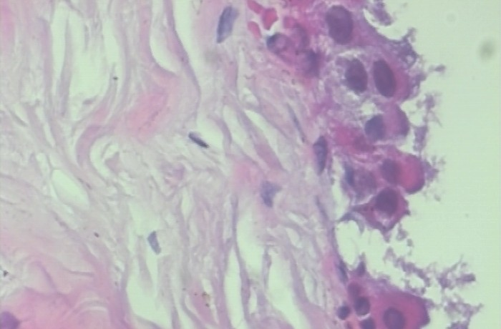

Fig. 3. Benign Tumor

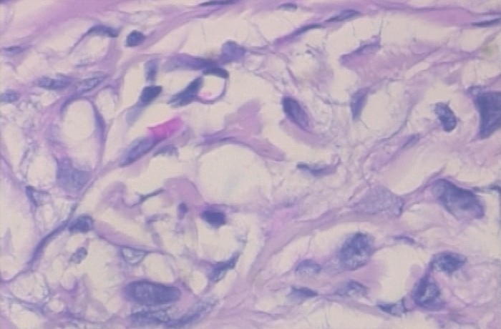

Fig. 4. Malignant Tumor

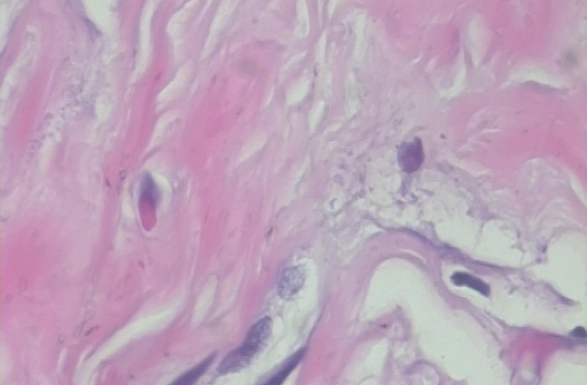

Fig. 5. Transformation of Benign to Malignant Tumor

- TRAINING OF THE DATASET
Split the data-set into two sets — train and test sets with 80% and 20% images respectively. Let’s see some sample benign and malignant images.
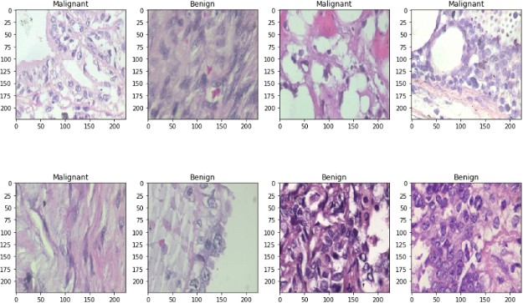

Fig. 6.

I used a batch size value of 16. Batch size is one of the most important hyperparameters to tune in deep learning. I prefer to use a larger batch size to train my models as it allows computational speedups from the parallelism of GPUs. However, it is well known that too large of a batch size will lead to poor generalization. On the one extreme, using a batch equal to the entire dataset guarantees convergence to the global optima of the objective function. However this is at the cost of slower convergence to that optima. On the other hand, using smaller batch sizes have been shown to have faster convergence to good results. This is intuitively explained by the fact that smaller batch sizes allow the model to start learning before having to see all the data. The downside of using a smaller batch size is that the model is not guaranteed to converge to the global optima.Therefore it is often advised that one starts at a small batch size reaping the benefits of faster training dynamics and steadily grows the batch size through training.
I also did some data augmentation. The practice of data augmentation is an effective way to increase the size of the training set. Augmenting the training examples allow the network to see more diversified, but still representative data points during training.
The next step was to build the model. This can be described in the following 3 steps:
I used DenseNet201 as the pre trained weights which is already trained in the Imagenet competition. The learning rate was chosen to be 0.0001.On top of it I used a globalaver- agepooling layer followed by 50% dropouts to reduce over- fitting.I used batch normalization and a dense layer with 2 neurons for 2 output classes ie benign and malignant with softmax as the activation function.I have used Adam as the optimizer and binary-cross-entropy as the loss function.
Before training the model, it is useful to define one or more callbacks. Pretty handy one, are: ModelCheckpoint and ReduceLROnPlateau.
ModelCheckpoint: When training requires a lot of time to achieve a good result, often many iterations are required.

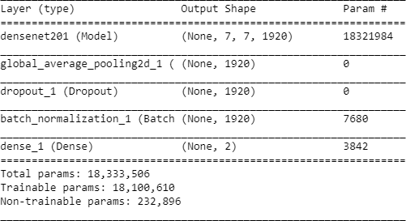

Fig. 7.

In this case, it is better to save a copy of the best perform- ing model only when an epoch that improves the metrics ends.ReduceLROnPlateau: Reduce learning rate when a met- ric has stopped improving. Models often benefit from reducing the learning rate by a factor of 2–10 once learning stagnates. This callback monitors a quantity and if no improvement is seen for a ‘patience’ number of epochs, the learning rate is reduced.
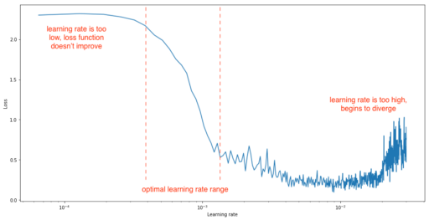
Fig. 8.

- PERFORMANCE METRICS
The most common metric for evaluating model performance is the accurcacy. However, when only 2% of your dataset is of one class (malignant) and 98% some other class (benign), misclassification scores don’t really make sense. You can be 98% accurate and still catch none of the malignant cases which could make a terrible classifier.However, when only 2% of your dataset is of one class (malignant) and 98% some other class (benign), misclassification scores don’t really make sense. You can be 98% accurate and still catch none of the malignant cases which could make a terrible classifier.

- PRECISION, RECALL AND F1-SCORE
For a better look at misclassification, we often use the following metric to get a better idea of true positives (TP), true negatives (TN), false positive (FP) and false negative (FN).
Precision is the ratio of correctly predicted positive obser- vations to the total predicted positive observations.

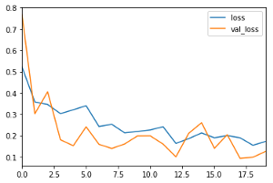

Fig. 9.

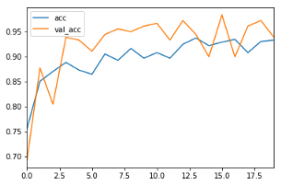

Fig. 10.

Recall is the ratio of correctly predicted positive observa- tions to all the observations in actual class.
F1-Score is the weighted average of Precision and Recall.

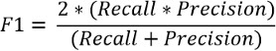
Fig. 11.

The higher the F1-Score, the better the model. For all three metric, 0 is the worst while 1 is the best.

Fig. 12.

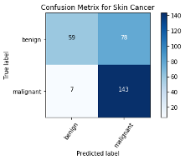
XI. ROC CURVES
The 45 degree line is the random line, where the Area Under the Curve or AUC is 0.5 . The further the curve from this line, the higher the AUC and better the model. The highest a model can get is an AUC of 1, where the curve forms a right angled triangle. The ROC curve can also help debug a model. For example, if the bottom left corner of the curve is closer to the random line, it implies that the model is misclassifying at Y=0. Whereas, if it is random on the top right, it implies the errors are occurring at Y=1.
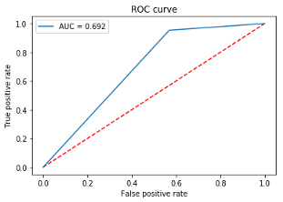
Fig. 13.

- CONFUSION MATRIX
Confusion Matrix is a very important metric when analyz- ing misclassification. Each row of the matrix represents the instances in a predicted class while each column represents the instances in an actual class. The diagonals represent the classes that have been correctly classified. This helps as we not only know which classes are being misclassified but also what they are being misclassified as.

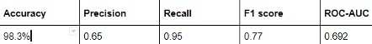
Fig. 14.

- RESULTS

- CONCLUSION
By this Paper we can once again conclude that Mathematics is found in all phases of life wether be it life , science , medical
, art or Computer Science in this Paper each and every point was given .

ACKNOWLEDGMENT
The reference and images were taken from www.wikipedia.org https://bdtechtalks.com/ https://towardsdatascience.com/
https://www.researchgate.net/publication/348914761

View publication stats

About The Authors



Siddharth Madhav

Founder and Chief Technical Officer at Techno Hub Laboratories Private Limited
Dehradun – 248001 , Uttarakhand , India



Syed Maasir Azeem Husain

Engineer and Innovation Manager at Techno Hub Laboratories Private Limited
Dehradun – 248001 , Uttarakhand , India

