Bone Marrow Aspirate Concetrate for the treatment of cartilage injury and knee arthrosis and pain management using stem cells.
Luiz Felipe Chaves Carvalho, Orthopedic Surgeon and Regenerative Medicine Specialist. Member of the scientific committee of hospital blanc Brazil
ABSTRAT. 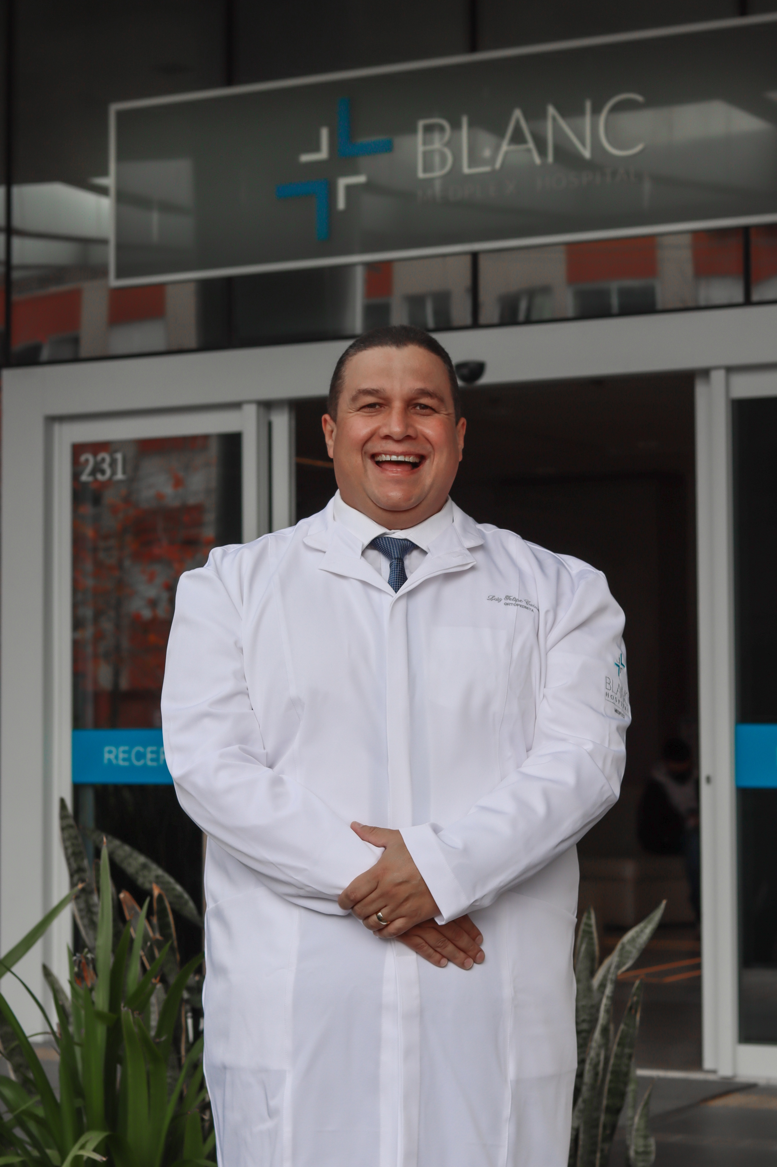
Purpose : The author will talk about the importance of using cell therapy in the treatment of cartilage lesions and knee arthrosis.
He will also talk about the clinical experience of using BMAC as a treatment in athletes and common patient recovering cartilage injuries in record time and without pain. 125 knees with osteoarthritis and cartilage injury were treated from 2015 to 2022, with the use of BMAC and scaffold hyaluroinic acid using a protocol of 4 applications with an interval of 15 days.
They were selected by MRI (Grade 3 and 4) and VAS pain index.
They were evaluated by the improvement of the VAS index. With 80% improvement in pain and gain in quality of life.
There is growing evidence that BMAC appears as a therapeutic option in the recovery of cartilage injury and in the modulation of pain resulting from knee arthrosis. (1)
In the case of cartilage injury and arthrosis is the most common articular disease and MSCs have the potential to differentiate into the cell lineage of interest to form chondrocytes, in addition, MSCs can favorably alter the microenvironment conditions for regeneration and repair due to the regulation of inflammatory cytokines including interleukin 1 ( IL-1) and interleukin 6 (IL-6) and tumor necrosis factor alpha (TNF-a), managing to modulate pain in this way. (2)
Studies suggest that the use of intra-articular BMAC with use of Hyaluronic Acid scaffolds may reduce the need for additional surgery. (3)
It has been shown that this method autologous therapy, is safe and brings many benefits in the treatment of the above pathologies. (4)

References
- Eric j cotter, kevin C. Wang, Adam B Yanke, Susan Chubinskaya. Bone Marrow Aspirate Concentrate for Cartilage Defects of the Knee: From Benc to Bedside Evidence, 2018 Apr;9(2):161-170. doi: 10.1177/1947603517741169. Epub 2017 Nov 10.
- Carlson A.K., Rawle R.A., Wallace C.W., Brooks E.G., Adams E., Greenwood M.C., Olmer M., Lotz M.K., Bothner B., June R.K. Characterization of synovial fluid metabolomic phenotypes of cartilage morphological changes associated with osteoarthritis. Osteoarthr. Cartil. 2019;27:1174–1184. doi: 10.1016/j.joca.2019.04.007.
- Jacques Hernigou, pascale Vertongen, Joanne Rasschaert, Philippe Hernigou. Role of Scaffolds, Subchondral, Intra-Articular Injections of Fresh Autologous Bone Marrow Concentrate Regenerative Cells in Treating Human Knee Cartilage Lesions: Different Approaches and Different Results,. 2021 Apr 8;22(8):3844. doi: 10.3390/ijms22083844.
- Cugat R., Alentorn-Geli E., Navarro J., Cuscó X., Steinbacher G., Seijas R., Álvarez-Díaz P., Barastegui D., Laiz P., Samitier G., et al. A novel autologous-made matrix using hyaline cartilage chips and platelet-rich growth factors for the treatment of full-thickness cartilage or osteochondral defects: Preliminary results. J. Orthop. Surg. 2020;28 doi: 10.1177/2309499019887547

