Title: DJ-1 Can Replace FGF-2 for Long-Term Culture of Human Pluripotent Stem Cells in Defined Media and Feeder-Free Condition
Julee Kim, University of Ulsan College of Medicine, Asan Medical Center, Seoul, Republic of Korea

Keywords: Human embryonic stem cells, feeder-free culture, recombinant protein human DJ-1, Pluripotency

I. Abstract

Conventional human pluripotent stem cell (hPSC) cultures require high concentrations of expensive human fibroblast growth factor 2 (hFGF-2) for hPSC self-renewal and pluripotency in defined media for long-term culture. The hPSC culture media need to be changed every day partly due to the hFGF-2 thermal instability in solution at 37°C. It has been known that the binding site of human DJ-1 (hDJ-1), also known as PARK-7 is FGF receptor-1. In the present study, for the first time, we have demonstrated that recombinant protein human FGF-2 can replace hDJ-1 in the essential eight media to maintain the pluripotency of H9 human embryonic stem cells (hESCs) under feeder-free condition. After more than ten passages, H9 hESCS cultured with human FGF-2 or human DJ-1 successfully sustained the distinctive hESC morphology. Furthermore, H9 hESCs revealed high expression levels of pluripotency markers including SSEA4, Tra1-60, Oct4, Nanog, and Alkaline phosphatase. DNA microarray revealed that more than 97% of the 21,448 tested genes, including the pluripotency markers, Sox2, Nanog, Klf4, Lin28A, Lin28B, and Myc, have similar mRNA levels between the two groups. Karyotyping revealed no chromosome abnormalities in both groups. They also differentiated sufficiently into three germ layers by forming in vitro embryoid bodies and in vivo teratomas. There were moderate difference in H9 hESCS in both groups was shown in the real-time PCR assay using several pluripotency markers and three germ layer markers. The proliferation rate measured at different concentration of growth factors and the structural analysis of mitochondria using transmission electron microscopy demonstrated the distinguishable feature of H9 hESCs in two groups, namely hFGF2 and hDJ-1. On the whole, in-house made recombinant protein hDJ-1 can maintain the self-renewal and the pluripotency of H9 hESCs in a feeder-free system for long-term without alteration of their characteristics.

II. Image

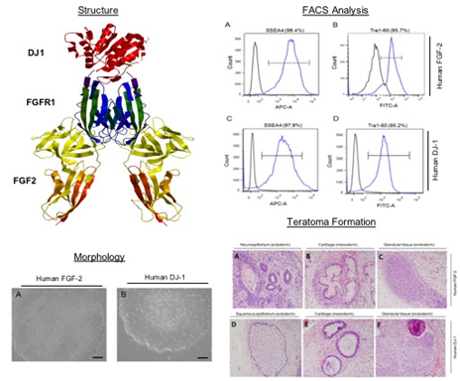

III. Reference

Levenstein, M.E.; Ludwig, T.E.; Xu, R.H.; Llanas, R.A.; VanDenHeuvel-Kramer, K.; Manning, D.; Thomson, J.A. Basic fibroblast growth factor support of human embryonic stem cell self-renewal. Stem Cells 2006, 24, 568–574.

Chen, G.; Gulbranson, D.R.; Yu, P.; Hou, Z.; Thomson, J.A. Thermal stability of fibroblast growth factor protein is a determinant factor in regulating self-renewal, differentiation, and reprogramming in human pluripotent stem cells. Stem Cells 2012

Song, J.A.; Koo, B.K.; Chong, S.H.; Kwak, J.; Ryu, H.B.; Nguyen, M.T.; Vu, T.T.; Jeong, B.; Kim, S.W.; Choe, H. Expression and purification of biologically active human FGF2 containing the b’a’ domains of human PDI in Escherichia coli. Appl. Biochem. Biotechnol. 2013, 170, 67–80.

IV. Biography

Dr. Julee Kim received her diplom degree in Biotechnology at the Westfaelisch Wilhelms University of Muenster in 2007. She graduated from the Westfaelisch Wilhelms University of Muenster with a PhD degree in Biology at the Max Planck Institute for Molecular Biomedicine in 2013. She completed her post-doctoral training at the University of California San Francisco and at Columbia University, Irving Cancer Research Center. She worked as a research assistant professor at the University of Ulsan College of Medicine, Asan Medical Center and as a research professor at CHA University. She has 8 publications in international journals. She presented papers in more than 10 national and international conferences.

V. Presenting author details



Full name: Julee Kim
Contact number: +82 1042958075
Account: http://www.linkedin.com/in/ju-lee-kim- 273174197
Session name/number: Stem Cell and Regenerative Medicine
Category: Oral presentation
Passport number: M99473516

