How to pick optimized stem cells and enhance their differentiation for bone graft cells using artificial ligands for purinergic receptors
Edda Tobiasch, PhD, H-BRS, Germany
Margit Schulze, PhD, H-BRS, Germany

Abstract
Autologous bone grafts are still considered to be the gold standard for critical size bone defects treatment due to their osteoconductive, osteoinductive and osteogenetic properties. However autograft procedures have several disadvantages such as e.g. a limited amount of available bone and an associated morbidity. On the other hand, mesenchymal stem cells are already used in transplantation for various regenerative approaches and show the potential of healing mechanisms. Although (differentiated) stem cells combined with a tailored biomaterial might therefore be a reasonable good approach, several hurdles still have to be overcome to provide adequate results in the future. While mesenchymal stem cells (MSCs) can presumably restore the osteogenetic and osteoinductive properties in bone grafts, they never differentiate altogether fully in vitro. Is has therefore been suggested that those which do not differentiate, might be already committed towards another lineage of differentiation.
We have shown recently that adult stem cells derived from dental follicles are pre-committed towards the osteogenic lineage. However, the availability of these cells derived from wisdom teeth is restricted to very young donors. Therefore we focused on mesenchymal stem cells from various body parts and induced pluripotent stem cells (iPSC) cells and compared their suitability during differentiation into several lineages with emphasis on osteogenesis and angiogenesis. In addition the osteogenic and angiogenic capacity of these cells was enhanced using specific artificial ligands for purinergic receptors to further optimize the result for an improved and safer potential bone graft using scaffolds and adult stem cells in future tissue engineering.

Image
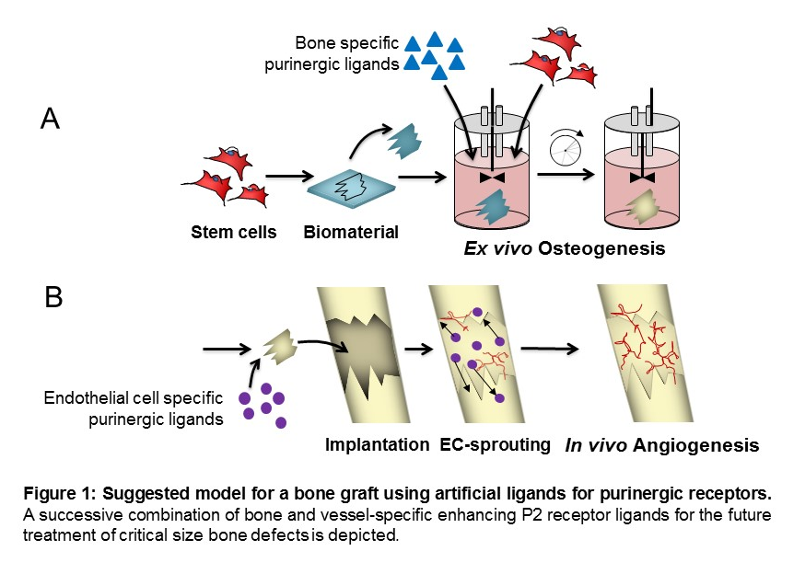
Recent Publications
- Zippel N, Limbach CA, Ratajski N, Urban C, Luparello C, Pansky A, Kassack MU, Tobiasch E. (2012) Purinergic receptors influence the differentiation of human mesenchymal stem cells. Stem Cells Dev. 2012 Apr 10;21(6):884-900.
- Hielscher D, Kaebisch C, Braun BJV, Gray K, Tobiasch E. Stem Cell Sources and Graft Material for Vascular Tissue Engineering. Stem Cell Rev. 2018 Oct;14(5):642-667.
- Ottensmeyer PF, Witzler M, Schulze M, Tobiasch E. Small Molecules Enhance Scaffold-Based Bone Grafts via Purinergic Receptor Signaling in Stem Cells. Int J Mol Sci. 2018 Nov 14;19(11).
- Götz W, Tobiasch E, Witzleben S, Schulze M. Effects of Silicon Compounds on Biomineralization, Osteogenesis and Hard Tissue Formation. Pharmaceutics. 2019 Mar 12;11(3).
- Witzler M, Ottensmeyer PF, Gericke M, Heinze T, Tobiasch E. Schulze M. Non-Cytotoxic Agarose/hydroxyapatite Composite Scaffolds for Drug Release. Int J Mol Sci 2019 Jul 21;20(14).

Biography
Edda Tobiasch is a professor for cell culture and genetic engineering and a member of the steering committee of the stem cell network North-Rhine Westphalia. She has many presentations, papers, patents and more than 150 posters to her credit and was awarded for "Outstanding Scientific Research" at the DKFZ, and for “Innovation” at her university. She was “visiting professor” at the University Palermo, and is currently on a sabbatical at the university of Ferrara, Italy. She is a member of the Steering Committee of the Stem Cell Network North Rhine Westphalia. Dr. Tobiasch leadership includes being a referee for a variety of different journal and funding agency in Europe and worldwide. Being interested in signal transduction, she is currently engaged in research and development projects dealing with various adult stem cells and iPSCs for future applications in regenerative medicine with a major focus on bone tissue.
Email: edda.tobiasch@h-brs.de

Notes/Comments:

