Induced pluripotent stem cell-derived endothelial cells from human diabetic donors carry an imprint of the diabetic milieu.
M. Eleftheriadou¹, T. Morrison¹, M. Vilà-González¹, S. Kelaini¹, S. Flanagan¹, G. Lopez Campos¹, N. Lois¹, D. Grieve¹, A.W. Stitt¹ and A. Margariti¹.
¹ Queens University Belfast, The Wellcome-Wolfson Institute of Experimental Medicine. School of Medicine, Dentistry and Biomedical Sciences. Belfast. United Kingdom. Correspondence: a.margariti@qub.ac.uk , meleftheriadou01@qub.ac.uk.

Key words: iPSC, endothelial dysfunction, vasculopathy, endotheliopathy, diabetes

Abstract
Diabetic endotheliopathy is the main cause for impaired angiogenesis and reduced neovascularization that lead to microvascular injury and vascular complications. The pathogenic basis for vascular complications arising from diabetes is complex. Elucidation of key underlying mechanisms will help the development of novel therapies and the discovery of potential biomarkers. The ability to generate functional endothelial cells (ECs) from induced pluripotent stem cells (iPSCs) from small amounts of blood is a novel and powerful tool for cell-based therapies. Human iPSC-derived ECs (iPS-ECs) have a broad range of clinical applications including cell-based therapy, disease modelling and drug screening; they can be used in mechanistic studies towards the development of novel therapies and in the discovery of new biomarkers to be applied in regenerative medicine and treatment of diabetic vasculopathy. Here we utilize transcriptomic and proteomic technologies to assess patient-specific iPS-ECs from diabetic (DiPS-ECs) and non-diabetic (NiPS-ECS) donors 1-5 in order to investigate the mechanisms driving endotheliopathy in diabetes.
Our in vitro and in vivo models recapitulate the effects of hyperglycaemia on the vasculature in the clinical setting. RNA-seq data showed that genes and proteins involved in angiogenesis and EC function were significantly downregulated in DiPS-ECs in comparison to NiPS-ECS (n=3, p<0.05). Our data showed an impaired balance between pro- and anti-angiogenic growth factors, Moreover factors involved in E-cadherin signalling, endothelial-to-mesenchymal transition and fibrosis were increased in DiPS-ECs. We detected abnormal capillary permeability and barrier integrity in DiPS-ECs using xCELLigence®. DiPS-ECs had significantly reduced barrier integrity and barrier recovery (n=3, p<0.001, ±SEM) and also displayed impaired tube formation in vitro (n=3, ±SEM, p<0.05). DiPS-ECs displayed impaired function demonstrated by decreased blood flow recovery (BFR) compared to NiPS ECs (n=3) when injected to the hindlimb of mice following femoral artery ligation.
Finally, proteomic and transcriptomic analysis confirmed imbalances in angiogenic factors and pathways related to angiogenesis and barrier stability. Those data support the impaired angiogenic functionality of DiPS-ECs cells in vitro and in vivo and show that DiPS-ECs carry an imprint of the diabetic milieu which is reflected in their dysfunction. To the best of our knowledge, we have identified a novel disease-specific signature in diabetic iPS-ECs. Our human iPS-EC model may serve as a valuable tool to study biological pathways and identify new treatments for diabetes-induced endotheliopathy.

Image

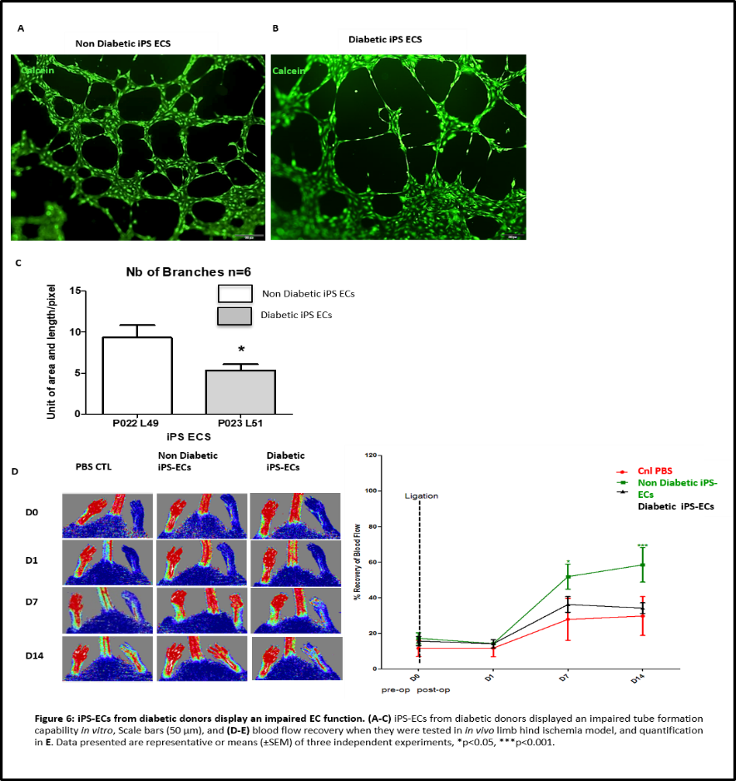
Recent Publications

- Cochrane A, Kelaini S, Tsifaki M, Bojdo J, Vila-Gonzalez M, Drehmer D, Caines R, Magee C, Eleftheriadou M, Hu Y, Grieve D, Stitt AW, Zeng L, Xu Q, Margariti A. Quaking is a key regulator of endothelial cell differentiation, neovascularization, and angiogenesis. Stem Cells. 2017
- Vilà-González M, Kelaini S, Magee C, Caines R, Campbell D, Eleftheriadou M, Cochrane A, Drehmer D, Tsifaki M, O'Neill K, Pedrini E, Yang C, Medina R, McDonald D, Simpson D, Zampetaki A, Zeng L, Grieve D, Lois N, Stitt AW, Margariti A. Enhanced Function of Induced Pluripotent Stem Cell-Derived Endothelial Cells Through ESM1 Signaling. Stem Cells. 2019
- Kelaini S, Vilà-González M, Caines R, Campbell D, Eleftheriadou M, Tsifaki M et al. FSTL3 Enhances the Function of Endothelial Cells Derived from Pluripotent Stem Cells by Facilitating β-catenin Nuclear Translocation Through Inhibition of GSK3β Activity. Stem Cells. 2018 Mar 23;1-12. Available from, DOI: 10.1002/stem.2820.
- The RNA Binding Protein QKI Controls Alternative Splicing as a Model of Vascular Therapies. Rachel Caines, Amy Cochrane, Sophia Kelaini, Marta Vila Gonzalez, Chunbo Yang, Magdalini Eleftheriadou, Arya Moez, Alan W. Stitt, Lingfang Zeng, David J. Grieve, Andriana Margariti. Journal of Cell Science 2019.
- Targeting QKI-7 in vivo Restores Endothelial Cell Function in Diabetes Chunbo Yang1, Thomas Morrison, Magdalini Eleftheriadou, Marta Vilà González, Sophia Kelaini1, Rachel Caines1, Andrew Yacoub1, Arya Moez1, Alex Ivetic2, Anna Zampetaki2, Lingfang Zeng2, Noemi Lois, Alan W Stitt, David Grieve, and Andriana Margariti, manuscript submmited.

Biography
Experienced researcher with a demonstrated history in higher education and industry. Skilled in Stem cell and cardiovascular research. Her knowledged further expands to the fields of Biomedical Engineering, material science and management. She has a strong research and business professional background. She is currently working as a PhD researcher in cardiovascular research at Queens University Belfast, The Wellcome-Wolfson Institute of Experimental Medicine. She is working on Diabetic endotheliopathy implementing patient specific induced pluripotent stem cells (iPSCs).
Email: meleftheriadou01@qub.ac.uk

