Ageing, parturition, and stem cells: labour-associated functional loss of decidual mesenchymal stem/stromal cells
Joan C Wijaya, MPhil (Medicine), the University of Melbourne affiliated with the Royal Women’s Hospital, VIC, Australia.

Abstract (300 word limit)
Statement of the Problem: During labour, functional changes such as senescence and inflammation of decidua closely resemble changes of ageing process. These findings provide initial evidence of an association between ageing and parturition, which remains unclear despite sharing many common pathways. Decidua is thought to age and weaken its attachment to fetal membranes and placenta during labour, thereby allowing newborn delivery and placental detachment. These ageing-related changes of decidua are thought to originate at the cellular level leading to spontaneous onset of labour (SOL) at term. Given that loss of stem cell function is a hallmark of ageing, this study hypothesises that decidual mesenchymal stem/stromal cells (DMSCs) from SOL patients (SOL-DMSCs) experience loss of function at term, compared with DMSCs from Caesarean-section patients, where no clinical signs of labour is observed (not in labour control [NIL-DMSCs]).
Methodology & Theoretical Orientation: Primary cells were isolated from decidua basalis attached to term-placentae of SOL (n = 8) and NIL (n = 7) patients and characterised based on ISCT and Parolini et al. (2008) minimum criteria for defining DMSCs. SOL and NIL DMSC functions were compared (i.e., clonogenicity, proliferation, migration, cell death, lipid peroxidation, ALDH production, and IL-6 secretion).
Findings: In comparison to NIL-DMSCs, SOL-DMSCs showed significant increase in necrosis, lipid peroxidation, IL-6 secretion, and migration (p ≤ 0.05). Although differences were not significant (p > 0.05), SOL-DMSCs also showed trends towards reduced clonogenicity, proliferation, and ALDH production and increased apoptosis.
Conclusion & Significance: This study provides evidence of an association between ageing, parturition, and stem cells. Specifically, SOL-DMSCs showed evidence of ageing-related reduced functionality compared with NIL-DMSCs, which may be essential in initiating natural labour at term. This study may serve as a conceptual framework to develop diagnostic tools for pregnancy disorders based on the disruptions in these natural aspects of labour.

Image
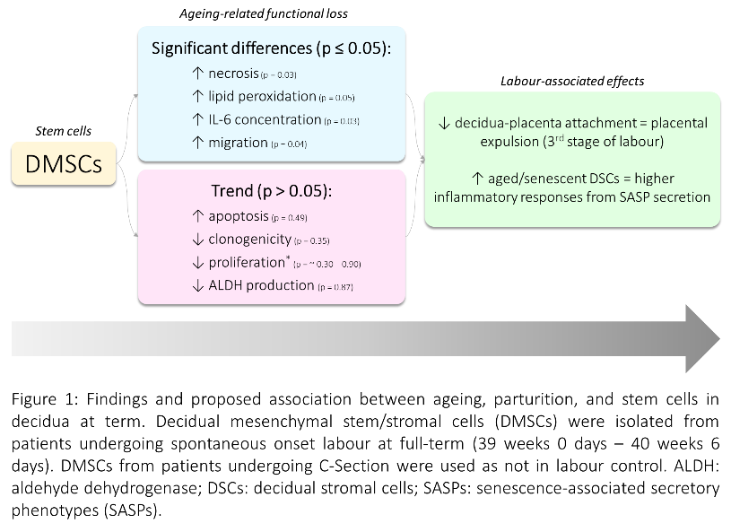

Recent Publications (maximum 5)
- Valerie, Wijaya, J.C., & Pinontoan, R. (2018). Kajian Pustaka: Pemanfaatan Mikroba yang Berpotensi sebagai Agen Bioremediasi Limbah Pewarna Tekstil [A Review: Utilization of Potential Microbes as Bioremediation Agent for Textile Dyes Waste water]. FaST-Jurnal Sains dan Teknologi (Journal of Science and Technology), 2(1), 32-47.
- Wijaya, J.C., Kiranadi, B., & Pinontoan, R. (2017). Potensi Sumber Energi Alternatif Berbasis Mikroorganisme sebagai Solusi yang Bekelanjutan dan Ramah Lingkungan dalam Mengatasi Krisis Energi [Potential of Microorganism-based Alternative Energy Resources as the Sustainable and Ecofriendly Solution for Energy Crisis]. Proceedings of National Seminar of Science, Engineering, and Technology UPH (pp. V.35 – V.44). Tangerang, Indonesia: Faculty of Science and Technology UPH.

 Biography (150 word limit)
Joan C Wijaya is a final year Master of Philosophy (Medicine) student from the University of Melbourne (affiliated with the Royal Women’s Hospital), VIC, Australia. Her project is the Role of Decidual Mesenchymal Stem/Stromal Ageing in Labour and the study presented in this abstract is a part of this project. Joan was granted with Australia Awards Scholarship, a fully-funded scholarship from DFAT, Australia, for her Master’s degree. Prior to studying medical science in Australia, Joan studied Biology with focus on Biotechnology for her undergraduate degree (B.Sc. [Hons]) in Universitas Pelita Harapan (UPH), Indonesia. Joan graduated top of her student cohort (GPA. 3.94/4.00) and has received several national-level academic awards and student research grants from the Ministry of Research, Technology and Higher Education, Indonesia during her undergraduate study (2012 – 2016). She also worked as an assistant lecturer in Dept. of Biology, UPH from 2016 – 2017.

Email: joanchristie@student.unimelb.edu.au

Notes/Comments:

