“Optimised protocol for generating clinical grade umbilical cord mesenchymal stem cells (UC-MSCs) for cells therapy in liver disease”
Kumari Rekha¹, Mathur K Dhananjay¹, Maheshwari Deepanshu¹, Nautiyal Nidhi¹, Sinha swati⁵, Parashar Anupama¹, Bihari chagan³, Biswas subhrajit⁴, Kumar Anupam¹, Sarin Kumar Shiv²
1 Dept of Molecular and Cellular Medicine, 2 Dept of Hepatology, 3 Dept of Pathology, Institute of Liver and Biliary Sciences, New Delhi, India 4 Department of Amity institute of Molecular Medicine & Stem Cell Research, Amity University Noida, Uttar Pradesh 5 Obstetrician Gynaecologist, Sitaram Bharti Institute of Science and Research Hospital, New Delhi, India
*Correspondences- shivsarin@gmail.com dr.anupamkumar.ilbs@gmail.com,
Background
Mesenchymal stem cells are being used for therapeutic purposes because of their regenerative capabilities such as immunomodulation, mitochondrial transfer and signalling.
Healthy UC was collected in PBS with 2% Antibiotics, cleaned with povidone. UC-MSCs were isolated by three different methods UC dissociation kit (Miltenyi Biotech), Explant culture and collagenase type IV digestion from 1gm of cord tissue. The MSCs were grown in three different medias MSC-Brew GMP Medium (Miltenyi Biotech), Stempeutics (Stem cell technology) and Alpha MEM with 10% FCS (Gibco Life Technology). All cells were characterized for morphology, surface marker expression, population doubling time, CFU-F and bioenergetics. In-vivo therapeutic potential of UC-MSC were compared with adult bone marrow MSCs in animal model of drug induced liver injury.
The yield (cells per gram) observed maximum in short time in dissociation kit (3.5x10⁶ in 15 days) as compared to collagenase type IV (2.3×10⁵ in 15 days) and explant method (1.53×10⁵ in 21 days). Cells showed spindle morphology in all three methods and similar surface marker expression of (CD105, CD73, CD90, CD14,20,34 & 45). CFU-F efficiency was highest in UC-Dissociation kit (43/1000 cells) as compare to Explant (28) and Collagenase (30). Kit have lowest population doubling time of 22hr while explant and collagenase had 28 & 40 hr. In comparison to all medias MSC in Brew media showed more spindle shaped morphology with increase both baseline and maximum respiration capacity. In-vivo UC-MSCs showed better therapeutic effect in terms of prevention of liver injury and survival in comparison to BM-MSCs
Our study showed that UC-dissociation kit and GMP Basal Brew Media was best among all for isolating and expanding clinical grade MSCs.
Of
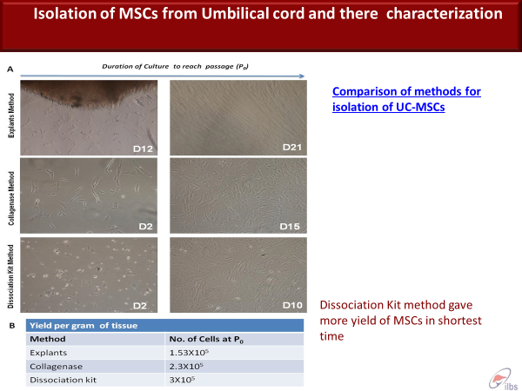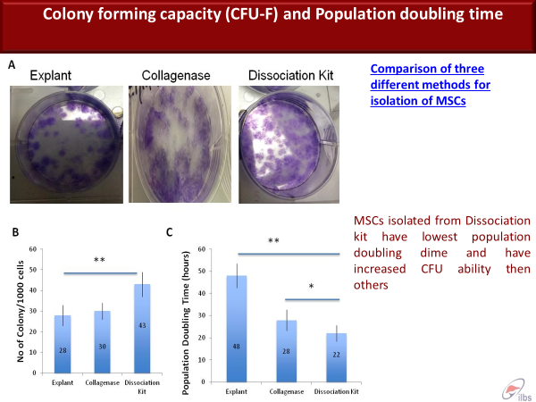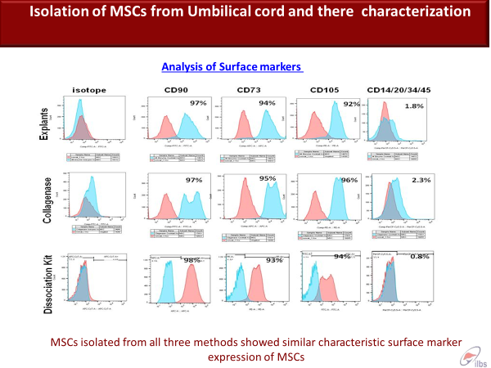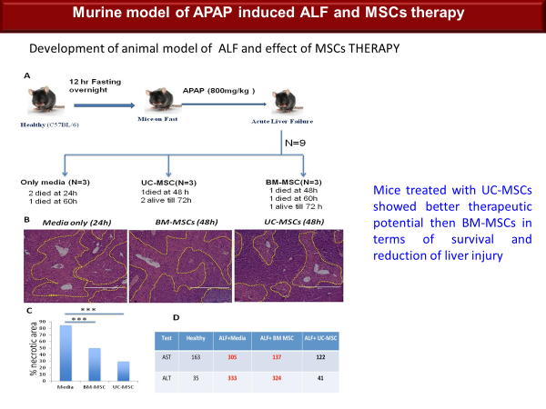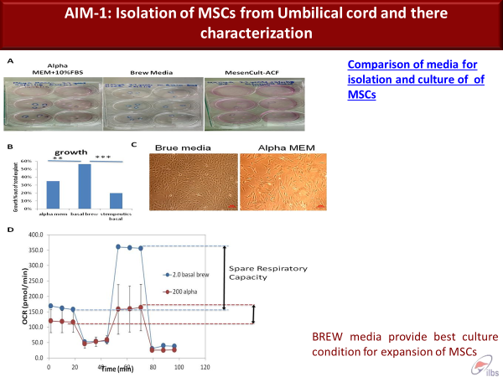
Mice treated with UC-MSCs showed better therapeutic potential then BM-MSCs in terms of survival and reduction of liver injury

