Cartilage regeneration via peripheral blood stem cells
Caroline SY Jee, BEng, PhD, KLSMC Stem Cells; Malaysia
Khay Yong Saw, MCh Orth (Liverpool), FRCS Ed, Kuala Lumpur Sports Medicine Centre, Malaysia
Alisha Ramlan, BSc Biology, KLSMC Stem Cells, Malaysia
Amal Mohd Dawam, BSc, KLSMC Stem Cells, Malaysia

Abstract (300 word limit)
Statement of the Problem: One of the most common and challenging injuries for physicians to treat is cartilage damage in joints. The structure and function of articular cartilage leads to non-healing lesions or the formation of fibrocartilage after injury occurs. Well-established arthroscopic methods utilize controlled healing with marrow stimulation or transferring of non-injured cartilage to areas of injury. Historically, these arthroscopic methods as well as open and two-stage methods have shared common marginal outcomes. Recent study has investigated synthetic and biologic adjuncts to current methodology, including the use of: hyaluronic acid (HA), platelet rich plasma, mesenchymal stem cells (MSC) and peripheral blood progenitor cells (PBPC). Cell therapy has produced exciting results in animal models and has been shown to regenerate hyaline cartilage clinically in the knee joint. The purpose of this study is to histologically evaluate the quality of articular cartilage regeneration from the medial compartment after arthroscopic subchondral drilling followed by postoperative intra-articular injections of autologous peripheral blood stem cells (PBSCs) and hyaluronic acid. Methodology & Theoretical Orientation: Patients underwent arthroscopic subchondral drilling of International Cartilage Repair Society (ICRS) grade 4 bone-on-bone lesions of the medial compartment. PBSCs were harvested and cryopreserved. At 1 week after surgery, 8 mL of PBSCs was mixed with 2 mL of hyaluronic acid and injected intra-articularly into the knee joint; this was repeated once a week for 5 consecutive weeks. Three additional intra-articular injections were administered weekly at intervals of 6, 12, and 18 months postoperatively. Informed consent was obtained at the time second-look arthroscopy and chondral biopsy. Biopsy specimens were stained with H&E, safranin O, and immunohistochemical staining for type I and II collagen. Specimens were graded using the 14 components of the ICRS Visual Assessment Scale II, and a total score was obtained. Conclusion & Significance: Chondrogenesis with stem cells of the knee joint regenerates cartilage that closely resembles the native articular cartilage.

Image
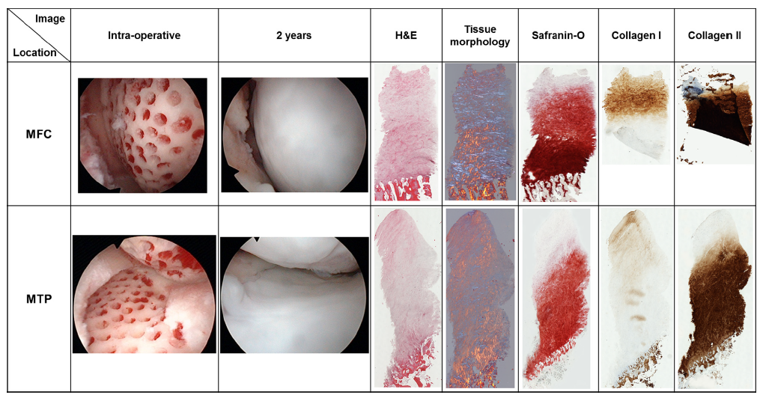
Figure: Findings of second-look arthroscopy and histologic assessment of medial femoral condyle (MFC) and medial tibial plateau
(MTP) at 2 years in a 49-year-old male patient.
Recent Publications (minimum 5)
- Saw K-Y, Anz A, Jee CSY et al (2015) High Tibial Osteotomy in Combination with Chondrogenesis after Stem Cell Therapy: A histological Report of 8 Cases. Arthroscopy 31: 1909-1920.
- Saw K-Y, Anz AW, Jee CS-Y, et al (2013) Articular cartilage regeneration with autologous peripheral blood stem cells versus hyaluronic acid: A randomized controlled trial. Arthroscopy 29:684-694.
- Saw K-Y, Anz AW, Merican S, et al (2011) Articular cartilage regeneration with autologous peripheral blood progenitor cells and hyaluronic acid after arthroscopic subchondral drilling: A report of 5 cases with histology. Arthroscopy 27:493-506.
- Saw KY, Anz AW, Stabile K, et al (2011) Articular cartilage regeneration with stem cells. In: Dragoo JL, ed. Modern arthroscopy. Rijeka, Croatia: InTech: 130-174.
5. Saw KY, Hussin P, Loke SC, et al (2009) Articular cartilage regeneration with autologous marrow aspirate and hyaluronic acid: An experimental study in a goat model. Arthroscopy 25:1391-1400.

Biography (150 word limit)
Caroline Jee specialized in stem cells research in regeneration of musculoskeletal system. She has been working with Dr Khay Yong Saw from Kuala Lumpur Sports Medicine pioneering in cartilage regeneration which currently conducting a Phase 2B US FDA trial. Graduated from Queen Mary University of London with a degree in Biomedical Materials Science and Engineering then pursuing her PhD in Materials Manufacturing, she has them worked in both academia and industry both in the UK and Malaysia. In addition she is also patent holder for a novel osteotomy surgical tool.
Email: carolinejee@klsmc.com

Notes/Comments:

