Long-term Follow-up Study Following Subchondral Drilling and Autologous Peripheral Blood Progenitor Cells Treatment for Cartilage Regeneration in the Knee Joint
Alisha Ramlan, BSc, KLSMC Stem Cells, Malaysia
Amal Mohd Dawam, MSc, KLSMC Stem Cells, Malaysia
Saw Khay Yong, MCh Orth, FRCS, KLSMC, Malaysia
Malar Muniandy, BSN, KLSMC Stem Cells, Malaysia
Caroline Siew-Yoke Jee, PhD, KLSMC Stem Cells, Malaysia

Abstract (300 word limit)
Wear-and-tear of articular cartilage, the resident tissue in the knee joint that mediates smooth movement, is a major cause of knee joint pain. Current surgical treatment options for articular cartilage repair are limited in terms of cartilage repair quality and durability. Stem cells have great potential in cartilage repair because of their ability to mediate tissue repair and regeneration. The combination of subchondral drilling surgery with intra-articular injection of autologous peripheral blood progenitor cells (PBPC) has been shown to improve knee cartilage regeneration. PBPC treatment is a solution for young people ages 18 to 55 with knee cartilage damage or injury, since they lead an active lifestyle and are too young for total knee replacement. Therefore, the sustainability of articular cartilage repair using PBPC treatment should be determined to gauge the effectiveness of the treatment in the long-term at 5 to 10 years follow-up.
This study is done by statistically analyzing treatment outcomes as measured by International Knee Documentation Committee (IKDC) Questionnaire and Magnetic Resonance Observation of Cartilage Repair Tissue (MOCART) scores. Study subjects are KLSMC patients with traumatic or degenerative knee cartilage injury classified as ICRS Grade 3 or 4, who had gone subchondral drilling with serial injections of autologous PBPC treatment, from 2007 to 2013.
After a period of 5-10 years since PBPC treatment, there is no significant decrease in IKDC scores, and MOCART scores remain high, which indicates knee joint function is maintained and the durability of repaired cartilage after PBPC treatment.
Knee functionality was improved and maintained over a long period of time after this treatment. This proves that the treatment is sustainable for up to 10 years follow-up.

Image
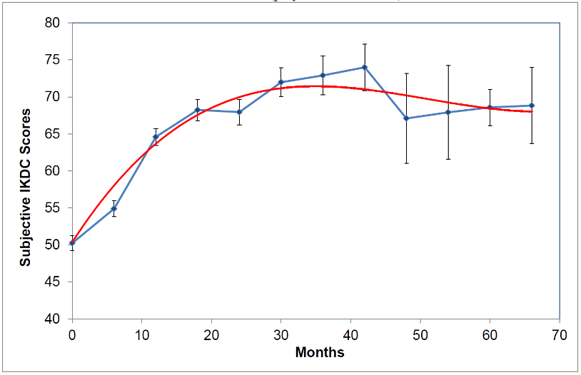
Figure 1: Long-term subjective IKDC clinical scores.
Recent Publications (minimum 5)
- Saw KY, Anz A, Jee CS, Merican S, Ng RC, Roohi SA, Ragavanaidu K (2013) Articular cartilage regeneration with autologous peripheral blood stem cells versus hyaluronic acid: a randomized controlled trial. Arthroscopy: The Journal of Arthroscopic & Related Surgery 29(4):684-94.
- Saw KY, Anz A, Merican S, Tay YG, Ragavanaidu K, Jee CS, McGuire DA (2011) Articular cartilage regeneration with autologous peripheral blood progenitor cells and hyaluronic acid after arthroscopic subchondral drilling: a report of 5 cases with histology. Arthroscopy: The Journal of Arthroscopic & Related Surgery 27(4):493-506.
- Saw KY, Anz A, Stabile K, Jee CS, Merican S, Tay YG, Ragavanaidu K (2011) Articular cartilage regeneration with stem cells. InModern arthroscopy. InTech.
- Saw KY, Hussin P, Loke SC, Azam M, Chen HC, Tay YG, Low S, Wallin KL, Ragavanaidu K (2009) Articular cartilage regeneration with autologous marrow aspirate and hyaluronic acid: an experimental study in a goat model. Arthroscopy: The Journal of Arthroscopic & Related Surgery 25(12):1391-400.
- Saw KY, Jee CS (2013) From ‘blade runner’ to ‘stem-cell player’ and beyond. Bone & Joint 360 2(1):6-11.

Biography (150 word limit)

Alisha Ramlan joined KLSMC Stem Cells 2 years ago, and has since continued its research on stem cell therapy for chondrogenesis. KLSMC Stem Cells is an R&D subsidiary of Kuala Lumpur Sports Medicine Centre (KLSMC), and has been doing research and development for more than 10 years. Currently, KLSMC Stem Cells is going through an FDA Phase 2b trial. She uses her experience in academic research to help build upon this study.
Email: alisha@klsmchospital.com

Notes/Comments:

