Title: “Eccentric Exercise” – Best Formula in Exercise Medicine

Professor Ken Nosaka, PhD¹

¹ School of Medical and Health Sciences
Edith Cowan University

Keywords: Lengthening muscle action, Descending stair walking, Insulin sensitivity, Blood lipid profile, Myokine

- Abstract Body (up to 250 words)

When going down stairs, front thigh muscles work to stop the body moving forward, in which “eccentric contractions” are performed. In eccentric contraction, contracting muscles are lengthened by greater external load than muscle force, in contrast to concentric contraction in which muscles are shortened. The exercise consisting of mainly eccentric contractions is called “eccentric exercise.” Less oxygen is required for going down than going up stairs, so eccentric exercise is easier to perform than concentric exercise. Our recent studies have shown that eccentric exercise training increases muscle strength and muscle mass, improves insulin sensitivity, decreases bad cholesterol but increases good cholesterol, lowers high blood pressure and improve functional physical fitness much greater than concentric exercise training. It is also possible that eccentric exercise stimulates the brain better than concentric exercise. It has been well known that “exercise is medicine,” but these potential benefits of eccentric exercise have not been focused until recently. One negative aspect of eccentric exercise is that it may induce muscle soreness that develops several hours after exercise, which is referred to as delayed onset muscle soreness (DOMS). However, DOMS can be minimised by pre-conditioning exercise in which low-intensity eccentric contractions are performed. Even if DOMS is induced, it is much reduced in the subsequent exercise sessions, when eccentric exercise is repeated. Thus, possible DOMS should not discourage people from starting eccentric exercise.. Our goal is to provide solid scientific evidence to promote eccentric exercise as medicine.

- Image

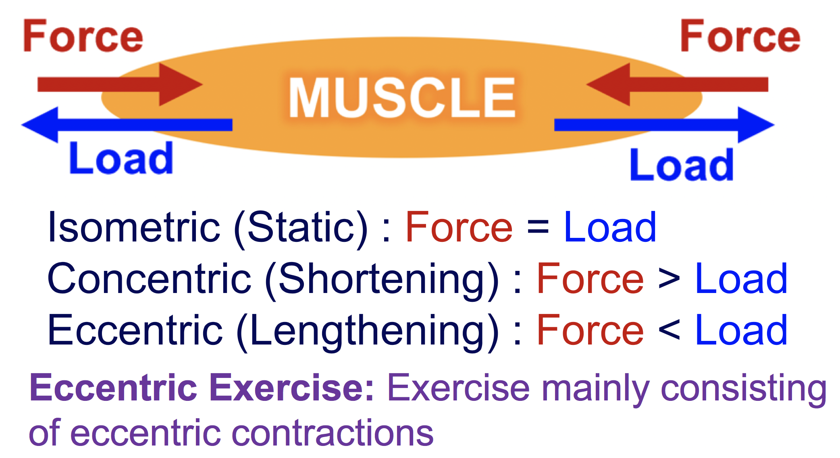

- References
- Katsura Y, Takeda N, Hara T, Takahashi S, Nosaka K. Comparison between eccentric and concentric resistance exercise training without equipment for changes in muscle strength and functional fitness of older adults. European Journal of Applied Physiology 119(7): 1581-1590, 2019.
- Chen TC, Hsieh C-C, Tseng K-W, Ho C-C, Nosaka K. Effects of descending stair walking on health and fitness of elderly obese women. Medicine and Science in Sports and Exercise 49: 1614-1622, 2017.
- Chen TC, Tseng W-C, Huang G-L, Tseng K-W, Nosaka K. Superior effects of eccentric to concentric knee extensor resistance training on physical fitness, insulin sensitivity and lipid profiles of elderly men. Frontiers in Physiology 8:209, 2017.

- Biography

Nosaka’s research area is exercise and sports science, and has published more than 260 peer-reviewed articles (his current Scopus h-index is 51), and about 80% of his articles are related to eccentric exercise. His research has been internationally recognised, and he is considered as a world leader in the area of eccentric exercise. His other research interests include neuromuscular fatigue, strength and power training, exercise as medicine, thermoregulation, and muscle cramp. He has established collaborations with numerous institutes nationally and internationally, and is actively involved in several international collaborative research projects; more than 70% of his publications include international collaborators.

- Presenting author details

Full Name: Ken (Kazunori) Nosaka
Contact number: (61) 8 6304 5655
Session name/ number:
Category: Oral presentation
Passport Number: TZ0775975 (Japan)

