Usage of Biosurfactants in Soil Remediation
Jinhong Min, Hankuk Academy of Foreign Studies, Republic of Korea

Abstract (300 word limit)
The current methodology of remediating contaminated soil in Korea is inefficient in many ways. The whole area needs to be excavated and transported to a professional facility, where it would use strong chemical agents to remove the pollutants. As a result, the process causes severe secondary pollution. This paper proposes an environmental way of utilizing biosurfactants in removing pollutants and to enhance the efficiency of the process. Biosurfactants are applied in bioremediation, which uses micro-organisms to treat organic contaminants like petroleum-based fuels. But as the contaminants are hydrophobic in nature, surfactants are used to enhance the solubilization of hydrocarbons and reduce surface tension. This paper experimented biosurfactants of glycolipids, fatty acids, and lipoproteins that can replace the existing surfactants made by petroleum by-products. For the force tensiometer, the Kruss K6 model was used to perform the Wilhelmy Plate Method. Furthermore, the research focused on tackling the biggest problem of this in-situ soil washing method: Cost. In order to reduce the amount of surfactant needed, the CMC (Critical Micelle Concentration) point needs to be achieved faster as solubilization of hydrocarbon occurs above it. The study was experimented in various ways such as mixing rhamnolipids and sophorolipid with existing surfactants, which yielded results that showed improvements in efficiency. The usage of biosurfactants in the in-situ washing method has great potential in establishing an environmental way of performing soil remediation.

Image
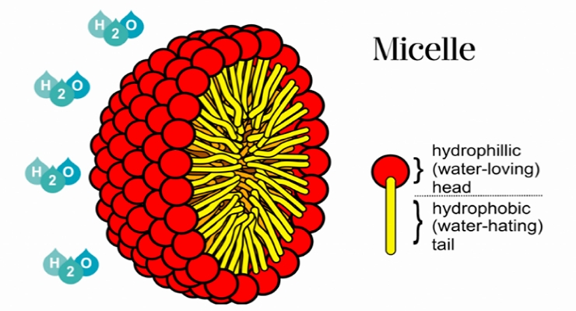
Recent Publications (minimum 5)

N/A

Biography (150 word limit)
I am a high school senior in Korea who is passionate about soil and environmental sciences. Along with this research, I am studying earth architecture to improve the resiliency of buildings and reduce pollution in construction sites. Recently I was invited to the Young Energy Researchers Conference and presented my research. (Title: Energy Democracy in Achieving Energy Efficiency and the Expected Benefits)
Email: pappies0827@gmail.com

Notes/Comments:

