“Evaluation of Urea Embedded Nano Silica to Enhance Nitrogen Use Efficiency in Rice–Wheat Sequence on Subtropical Mollisols of Northern India”
SHRI RAM AND PRADEEP SIRARI
DEPARTMENT OF SOIL SCIENCE COLLEGE OF AGRICULTURE
G.B.PANT UNIVERSITY OF AGRICULTURE & TECHNOLOGY , PANTNAGAR-263145 , UTTRAKHAND, INDIA

Abstract (300 word limit)
Green house study was conducted for evaluation of mesoporous nano silica (mNS) loaded with urea under rice–wheat sequence on Mollisols of northern India. Study consisted N levels ( 0, 30, 60 ,90 and 120 kg ha⁻¹) through ordinary urea and urea loaded mNS with uniform dose of P and K for both crops. Urea dissolved in magnetized distilled water (MDW) to enhance urea loading efficiency into mNS. Fourier Transform Infrared Spectroscopy (FTIR), Energy-dispersive X-ray (EDX), and Field Emission Scanning Electron Microscope (FESEM) used to characterized mNS. Results showed that growth, yield characteristics , yields and nutrients uptake by rice and wheat were more than double with nitrogen applied through mNS compared to N applied through ordinary urea. Whereas, lower doses of nitrogen @ 30 and 60 kg N ha⁻¹ through urea loaded mNS resulted at par growth parameters, yield attributes, yields and nutrients uptake by rice and wheat compared to N applied @ 120 kg ha⁻¹ through ordinary urea. Maximum increase in grain yields of rice (60.5%) and wheat (55.5 %) were by N applied @ 120 kg ha⁻¹ through urea embedded mNS over N applied @ 120 kg ha⁻¹ through ordinary urea followed by nitrogen applied @ 90 and 60 kg N ha⁻¹ through urea embedded mNS. All treatments of urea embedded mNS, showed significant increase in available N, P, K and S in soils over control and nitrogen @ 30 and 60 kg N ha⁻¹ through ordinary urea . Remarkable increase in root biomass and root volume occurred with urea loaded mNS compared N applied through ordinary urea over. It concluded that sustained release of nitrogen from the urea embedded mNS gave tremendous benefit to crops, which are preliminary indication but it opens doors to use nano materials as an efficient fertilizer material for saving nitrogen.

Keywords : (maximum 6 words) : Mesoporous nano silica, Urea, Magnetized distilled water, Loading, Rice-wheat, Alluvial soil
Themes: (Related Theme) : Characterization and use of nano materials in agriculture.

Image
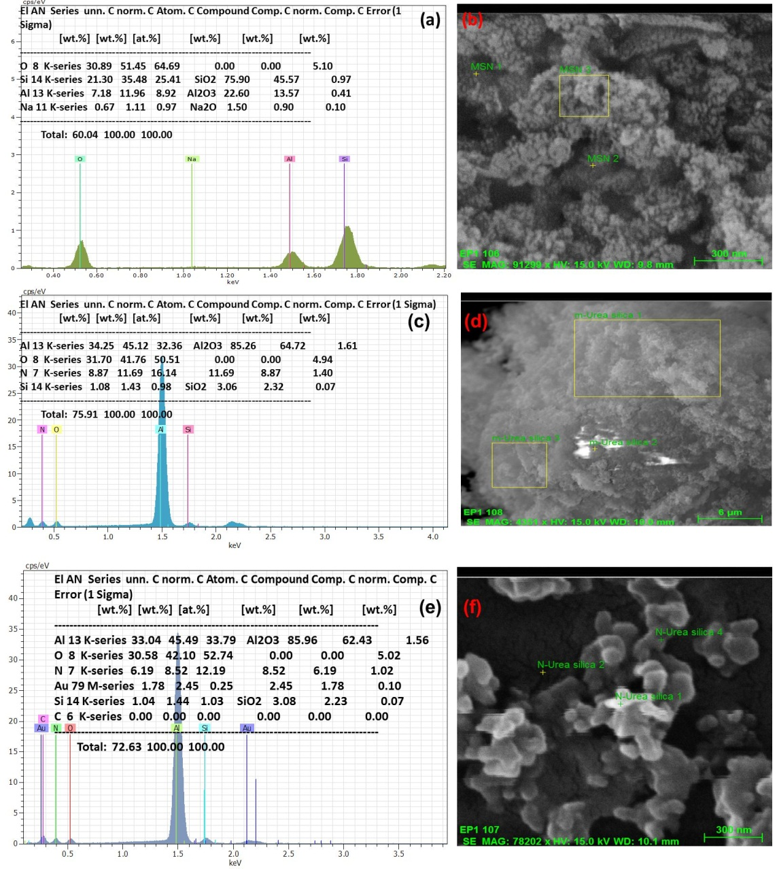

Fig. Energy-dispersive X-ray fluorescence (EDX) spectra of (a) mNS with the FESEM image as shown in (b); (c) mNSU with MDW with the FESEM shown in (d); and (e)mNSU with DW with the FESEM shown in (f).
Recent Publications (minimum 5)
- Shri Ram, Veer Singh, and Pradeep Sirari (2016) Effects of 41 Years of Application of Inorganic Fertilizers and Farm Yard Manure on Crop Yields, Soil Quality, and Sustainable Yield Index under a Rice-Wheat Cropping System on Mollisols of North India. COMMUNICATIONS IN SOIL SCIENCE AND PLANT ANALYSIS , VOL. 47, NO. 2, 179–193
- Pawan Kumar Pant1 • Shri Ram1 • Veer Singh1 (2016) Yield and Soil Organic Matter Dynamics as Affected by the Long-Term Use of Organic and Inorganic Fertilizers Under Rice–Wheat Cropping System in Subtropical Mollisols. Agric Res DOI7706 Volume 7 Number 07.
- Pawan Kumar Pant*, Shri Ram and Aakash Mishra (2017)Sequential extraction of different pools of phosphorus in alluvial and acid Soils of Uttarakhand. Journal of Applied and Natural Science 9 (4): 2280 - 2284
- Pawan Kumar Pant* and Shri Ram (2018) Long-Term Manuring and Fertilization Effects on Soil Physical Properties after Forty Two Cycles under Rice-Wheat System in North Indian Mollisols International Journal of Current Microbiology and Applied Sciences ISSN: 2319-

Singh, Kharag; Ram, Shri; Nehra, Anuj; Singh, Krishna Pal (2019) Effect of Magnetized Water on Urea-Loading Efficiency of Mesoporous Nano-Silica: A Seed Germination Study on Wheat Crop. Journal of Nanoscience and Nanotechnology Volume 19, Number 4, April 2019, pp. 2016-2026(11)

 Biography (150 word limit)
Dr Shri Ram is working as Professor, Soil Science and has expertise in evaluation of nano materials to enhance nutrients use efficiency by crops. He has done lot of work on improving the soil fertility and soil quality and recently dealing as Principal Investigator of All India Coordinated Research Project on Long Term Fertilizer Experiments. This study opens a new pathway to researchers involve in enhancing nutrients use efficiency by rice and wheat crops.

Email: shriram_189@yahoo.co.in

Notes/Comments:

