Distribution of organic carbon in different soil fractions in grasslands
Herath M.S.K. Herath, Department of Export Agriculture, Uva Wellassa University, Passara Road Badulla, Sri Lanka,
Zhu Tianqi, College of Pastoral Agriculture Science and Technology
Lanzhou University, 768, Jiayuguan, West Road, Lanzhou, China
Saman Bowatte, College of Pastoral Agriculture Science and Technology
Lanzhou University, 768, Jiayuguan, West Road, Lanzhou, China

Foujian Hou, College of Pastoral Agriculture Science and Technology
Lanzhou University, 768, Jiayuguan, West Road, Lanzhou, China

Abstract
Elucidating protective mechanisms and quantification of organic carbon (OC) in different pools are required for knowing the distribution pattern of OC in grasslands. An experiment was conducted to achieve the above objective using three contrasting soils under different climatic conditions with different vegetation types. Soils sampled at 0 – 10 and 10 – 20 cm depths from a desert grassland (LZ), a typical steppe (HX) and an alpine meadow (MQ) were physically fractionated into coarse free particulate organic matter (fPOM), fine fPOM, silt+clay and heavy fractions. The latter was further dispersed to separate the intra POM (iPOM) from silt+clay fraction. The two silt+clay fractions were subjected to acid hydrolysis with 6 N HCl and obtained chemically and biochemically protected pools. Irrespective of the soil depth, MQ showed significantly (P<0.05) greater OC content in fine fPOM, coarse fPOM and iPOM, over the LZ and HX. LZ had a significantly (P<0.05) lower OC content in silt+clay associated fraction after dispersion, however; the same fraction taken after wet sieving did not show a significant (P>0.05) difference. Total hydrolysable and non-hydrolysable fractions showed a similar pattern at the two depths: LZ showed a significantly (P<0.05) greater OC content in hydrolysable fraction over MQ and HX whereas MQ showed a significantly (P<0.05) greater OC content in the non-hydrolysable fraction, compared to LZ and HX. In LZ and HX, majority of the OC was chemically protected: 87.4 and 86.0% in LZ and 69.5 and 66.8% in HX for the 0 – 10 and 10 – 20 cm, respectively. In MQ, major protection mechanism was physical protection (iPOM): 47.2 and 41.7% for the 0 – 10 and 10 – 20 cm, respectively. MQ showed a significantly (P<0.05) greater total protected OC over the other two soils in both depths. As a conclusion, the soil type influenced on the soil OC content stored in different pools.


Image
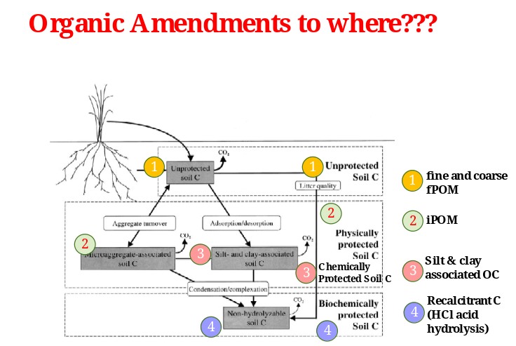
Recent Publications
- Congying Wang, Yingdi Wang, H.M.S.K. Herath (2017) Polycyclic aromatic hydrocarbons (PAHs) in biochar – Their formation, occurrence and analysis: A Review. Organic Geochemistry, 114, 1 – 11.
- Yun Xie, Zhenggui Gu, H.M.S.K. Herath, Minfen Gu, Chang He, Fang Wang, Xin Jiang, Jie Zhang, Yinping Zhang (2017) Evaluation of bacterial biodegradation and accumulation of phenanthrene in the presence of humic acid. Chemosphere, 184, 482 – 488.
- Wang, L., Butterly, C.R., Tian, W., Herath, H.M.S.K., Xi, Y., Zhang, J., Xiao, X. (2016) Effects of fertilization practices on Aluminum fractions and species in a wheat soil. Journal of Soils and Sediments, 16, 1933 – 1943.
- Herath, H.M.S.K., Marta Camps-Arbestain, Mike Hedley, Kirschbaum, M.U.F., Van Hale, R. (2015) Experimental evidence for sequestering C with biochar by avoidance of CO₂ emissions from original feedstock and protection of native soil organic matter. Global Change Biology-Bioenergy, 7 (3), 512-526.
- Wang, C., Anderson, C., Suárez-Abelenda, M., Wang, T., Camps-Arbestain, M., Ahmad, R., Herath, H.M.S.K. (2015) The chemical composition of native organic matter influences the response of bacterial community to input of biochar and fresh plant material. Plant and Soil 395 (1-2), 87-104.

Biography
Saman Herath is a Professor attached to Uva Wellassa University and conducts research under the scope of ‘soil carbon dynamics’. He has collaborative research work with different organizations. Saman has contributed to more than seventy scientific publications including two books. He has delivered scientific speeches in more than ten occasions in different countries. Saman has won several awards: President’s Awards in 2014 and 2015; NRC Merit Awards in 2012, 2013 and 2016. Vice Chancellor’s Award – 2017 for the Most Outstanding Senior Researcher by Uva Wellassa University. His PhD thesis was awarded as an ‘Exceptional PhD Thesis’; and included in the Dean’s List in Massey University. He is recognised as a Tier 04 Researcher as per the h-index. Also, Saman has received UWU Research Awards in 2014, 2015, 2016 and 2017. Currently, Saman serves as the Chairman/Research Committee and Editor-In-Chief/Journal of Agriculture and Value Addition, Uva Wellassa University.
Email: samanherath@uwu.ac.lk

Notes/Comments:

