CONVENTIONAL BANANA BREEDING IN UGANDA: “Challenges and The Future of Application of Marker Assisted Selection (MAS)”

Ivan Kabiita Arinaitwe^{1, 2, 4*}, Chee How Teo⁴, Fatimah Kayat³, Robooni Tumuhimbise², Brigitte Uwimana⁵, Jerome Kubiriba², Jennifer Ann Harikrishna^{1, 4} and Rofina Yasmin Othman^{1,}

- Institute of Biological Sciences (Genetics), Faculty of Sciences, University of Malaya
- National Banana Research Program, National Agricultural Research Organization, P.O. Box 7065, Kampala, Uganda
- University Malaysia, Kelantan Jeli, Malaysia
- Centre for Research in Biotechnology for Agriculture (CEBAR), University of Malaya
- International Institute of Tropical Agriculture (IITA), Kampala, Uganda
*Corresponding author, Email: ivanarinaitwe@yahoo.co.uk ; Tel: +256 782828151

Abstract
Banana is a major staple food for more than 20 million Ugandans with an annual domestic banana consumption of more than 400 kg/person and the highest in the world. Pests and diseases pose a great threat the future of sustainable banana production. Banana production in Uganda has reduced by more than 50% in the past decade. The National Banana Research Programme (NBRP) under National Agricultural Research Organisations (NARO)- Uganda’s objective is to develop hybrid banana varieties that with higher yield and better resistance to at least three of the target pests and diseases [Fusarium wilt (Fusarium oxysporum f. sp. cubensis (Foc), burrowing nematode (Rhadopholus similis) and banana weevils (Cosmoplites sordidus)] compared with the current local varieties grown by the farmers. As a result, several banana hybrids with multiple resistances have been developed and released to farmers through conventional breeding. Conventional breeding to develop new improved banana varieties is a complicated and time-consuming process (10-20yrs), but the farmers do not have the luxury of waiting as the banana crop is under serious threat from the three major pests and diseases. The project funded by the Bill & Melinda Gates Foundation (BMGF) and led by the International Institute of Tropical Agriculture (IITA) in collaboration NARO-Ugandan stepped in to assist the national banana breeding program work more efficiently and faster using advanced technologies such as molecular markers. Application of molecular markers will accelerate and or shorten banana breeding cycle through early identification of material resistant to various pests and diseases.

- Image
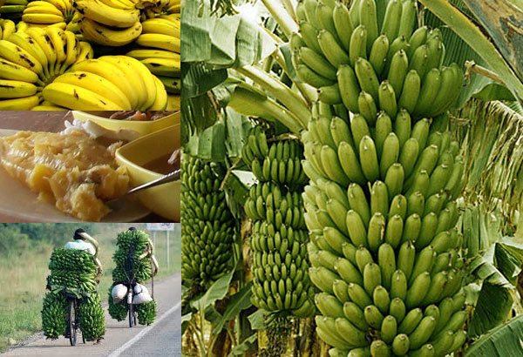

- Reference:

Brown, A., Tumuhimbise, R., Amah, D., Uwimana, B., Nyine, M., Mduma, H., … Swennen, R. (2017). Bananas and plantains (Musa spp.). In H. Campos & P. D. S. Caligari (Eds.), Genetic Improvement of Tropical Crops (pp. 219–240). Basel, Switzerland: Springer, Cham. https://doi.org/10.1007/978-3-319-59819-2_7
Heslop-Harrison, J. S., & Schwarzacher, T. (2007). Domestication, genomics and the future for banana. Annals of Botany, 100(5), 1073–1084. https://doi.org/10.1093/aob/mcm191
Lema, M. (2018). Marker Assisted Selection in Comparison to Conventional Plant Breeding : Review Article. Aricultural Research and Technolofy, 14(2), 1–10. https://doi.org/10.19080/ARTOAJ.2018.14.555914
Mbanjo, E. G. N., Tchoumbougnang, F., Mouelle, A. S., Oben, J. E., Nyine, M., Dochez, C., … Lorenzen, J. (2012). Molecular marker-based genetic linkage map of a diploid banana population (Musa acuminata Colla). Euphytica, 188(3), 369–386. https://doi.org/10.1007/s10681-012-0693-1
Pillay, M., Ashokkumar, K., Arun Siva Shunmugam, K., & Elayabalan, S. (2012). A Case for Molecular Breeding in Musa. In Genetics,Genomics and Breeding of Bananas (pp. 280–297). https://doi.org/10.13140/2.1.1246.7205

- Biography
Mr. Arinaitwe Ivan Kabiita is a banana breeder at the National Banana Research Programme of National Agricultural Research Organisation (NARO)-Uganda. Currently he is pursuing his Doctorate Degree in Genetics and Molecular Biology under Gates Foundation Scholarship and University (3rd yr) at the University of Malaya pursuing of Malaya, Malaysia. His topic of study is “Genetic Analysis of Resistance Against Fusarium oxysporum f. sp. cubense (Foc) in Selected Banana Populations Using Molecular Markers and Linkage Mapping Approaches”. Ivan undertakes the conventional part of research in Uganda and the molecular part of research at High Impact Research (HIR) at University of Malaya. Ivan holds a BSc. degree in Botany and Zoology from Makerere University-Uganda (2004-2007) and a Master of Science degree in Plant Breeding and seed Systems from Makerere University-Uganda (2012-2014) funded by the Alliance for the Green Revolution in Africa (AGRA) Scholarship in Collaboration with Bioversity International. Ivan worked as Laboratory technician at Agro-Genetic Technologies (AGT) banana tissue culture laboratory in between 2007-2008. Later, He worked with International Institute of Tropical Agriculture (IITA) - Uganda as Research Assistant, banana biotechnology department between 2008 and 2009. In 2009, Ivan joined National Banana Research programme under NARO-Uganda at National agricultural research laboratories (NARL) working as a banana breeder to date. The programme is mandated with improving banana mostly the East African Highland Bananas (EAHBs) and dessert bananas for farmer preferred traits such as yield and resistance to pests and diseases.

- Presenting author details



Full Name: Ivan Kabiita Arinaitwe
Contact number: +256 782 828151
Twitter account: @ArinaitweKIvan
Linked In account: Arinaitwe Ivan Kabiita
Category: (Oral presentation)
Passport Number:B0835897

