Title: Effectiveness of plant growth promoting rhizobacteria in improving the phytoremediation potential of Lathyrus sativus

Abdelkrim S^{1,2}, Jebara SH¹, Abid G¹, Mannai K¹, Louati F¹, Jebara M¹

¹Center of Biotechnology of Borj Cedria, Laboratory of Legumes. BP 901, 2050 Hammam Lif, Tunisia
²National Agronomic Institute of Tunisia, University of Carthage, Tunis, Tunisia

Keywords: L. sativus, Phytoremediation, Pb, PGPR, Association

- Abstract
Heavy metals pollution has become one of the most severe environmental problems today causing damage to water, air, and soil due to their stability and non-degradable properties which poses a potential risk to human health [1]. Bearing in mind the importance of the phytoremediation approach, in the present work, we selected Lathyrus sativus because of its fast growth and high tolerance to stressful conditions, as well as its great potential to accumulate lead. The bacterial strains used in this work (R. leguminosarum, P. fluorescens, Luteibacter sp, Variovorax sp) were isolated from root nodules of L. sativus cultivated in contaminated soils, and were selected for their resistance to lead, their efficiency and ability to produce plant growth promoting substances such as indole acetic acid, siderophore and HCN, and their potential for Pb-bioaccumulation and phosphate solubilization [2]. A pot experiment demonstrated that bacterial combination significantly improves L. sativus shoot and root dry weight as well as Pb uptake under lead stress (0.5 mM). We also found that PGPR inoculation helps in reduction of oxidative damage and enhanced the antioxidant enzymes activities, phenolic compound biosynthesis, proline and soluble sugars contents [3]. L. sativus plants were cultivated in a vineyard in northern Tunisia; this site contains high proportions of Pb and Zn. Plants inoculation with R. leguminosarum+ P. fluorescens+ Luteibacter sp+ Variovorax sp results in an increase in growth parameters and high metals accumulation. The rhizosphere inoculated plants showed reduction in metal availability, increases in soil nitrogen content and phosphorus availability. Astonishing, significant reduces in vine Pb uptake by up to 44 % was shown in inoculated plots, compared with uninoculated ones. The expression patterns of LsABC, LsPCS, LsGR, LsGST and LsCNGC in shoots of Lathyrus sativus indicated that these genes are differentially expressed under Pb treatments, suggesting their possible role in Pb stress tolerance mechanism. In this study, results also revealed that inoculation stimulated the expression of all studied genes.In summary, selected inoculum was able to maintain an efficient symbiosis with L. sativus plants in contaminated Pb-soils, improving plant performance under those conditions, which is likely to be due to a combination of biochemical physiological changes caused by the intimate relation between PGPRs and plant. The enhanced Pb uptake by bacterial inoculated L. sativus plants might be of interest for phytoremediation purposes.

- Image:

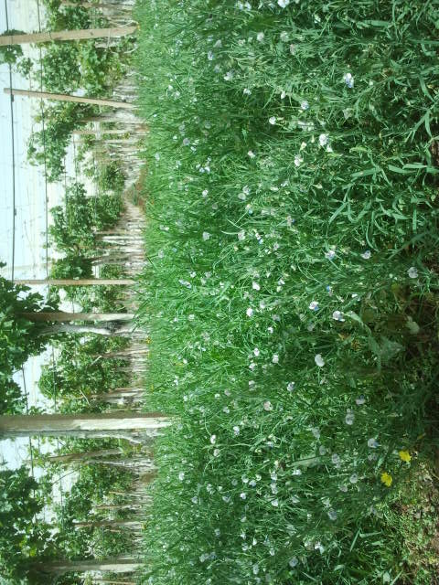

- Reference:
- Ogbomida, E.T., Nakayama, S.M.M., Bortey-Sam, N., Oroszlany, B., Tongo, I., Enuneku, A.A., Ozekeke, O., Ainerua, M.O., Fasipe, I.P., Ezemonye, L.I., Mizukawa, H., Ikenaka, Y., Ishizuka, M., 2018. Accumulation patterns and risk assessment of metals and metalloid in muscle and offal of free-range chickens, cattle and goat in Benin City, Nigeria. Ecotoxicol. Environ. Saf. 151, 98–108.

- Abdelkrim, S., Jebara, S.H., Saadani, O., Chiboub, M., Abid, G., Jebara, M., 2018. Effect of Pb-resistant plant growth-promoting rhizobacteria inoculation on growth and lead uptake by Lathyrus sativus. J. Basic Microbiol. 58, 579–589.

- Abdelkrim, S., Jebara, S.H., Saadani, O., Jebara, M., 2018. Potential of efficient and resistant plant growth-promoting rhizobacteria in lead uptake and plant defence stimulation in Lathyrus sativus under lead stress. Plant Biol. 20, 857–869.

- Presenting author details


Full Name: Abdelkrim Souhir
Contact number:+21699337358
Twitter account:
Linked In account:
Session name/ number:
Category: Poster presentation
Passport Number:

