Title: Germination of Lawsonia inermis L. under different abiotic constraints

Benziwa Nathalie Johnson¹, Marie-Luce Akossiwoa Quashie¹, Raoufou Radji¹and Kokou Kouami¹
¹Department of Botany, Faculty of sciences, Laboratory of Forestry Research, Université de Lomé, Togo

Keywords: Lawsonia inermis L., light, seed treatment, germination, in vitro etablishment

- Abstract Body
Henna (Lawsonia inermis L.) is one of the best known plants for its cosmetic, dyeing, ornamental and medicinal properties. It is grown in tropical and subtropical regions, particularly in countries such as Algeria, Egypt, India, Iran, Mali, Morocco, and Senegal. In main exporting regions of the Middle East, Asia and West Africa, the preferred method used for industrial plantations is seed sowing. However, several constraints have been reported as impediments to henna germination, thus limiting a large scale multiplication of the species. Those include the presence of a hard and resistant shell-seeds, low germination percentages that hardly reaching 20% and limited shelf life (<<90 days). In this study, seed multiplication improvement tests have therefore been carried out both in greenhouse and in vitro. In the greenhouse, the effect of light has been tested both by light intensity (0-120 μE.m-².s-1) and by the duration of illumination (variable from 0h, 12h, 14h, 16h then continuously 24/24) as well as of pre-treatments (immersion in distilled water and mechanical scarification). Seed burial tests - from 0 to 30 mm deep with 5 mm increments -were also conducted and the conservation of germinability was studied. In vitro, introduction of local ecotypes was carried out. The results show the necessity of light for the germination of Lawsonia inermis's seeds, which reacts positively to an elongation of the photoperiod from 0% in continuous darkness to 89% for 12h of light and 94% for 16h of light, with a decrease in average germination time of around 36 hours. From 5 mm deep, burial in the substrate causes a drastic drop in germination percentage. The most interesting result of this study was the possibility of preserving henna seeds at an ambient temperature of 25 ± 2°C in darkness conditions, for almost 9 months in simple plastic boxes. The seeds used retain a germination capacity exceeding 93%. In vitro culture test, seeds showed more than 90% of germination and a regular growth of seedlings was obtained.

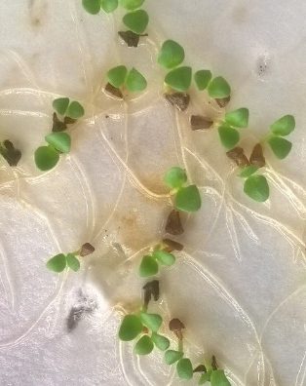
- Image:

- Reference:
- Al-Maskri, A., Khan, M., Khan, I., and Al-Habsi, K. (2003). Effect of accelerated ageing on viability, vigor (RGR), lipid peroxidation and leakage in carrot (Daucus carota L.) seeds. Int. J. Agric. Biol. 5, 580–584.
- Hsouna, A.B., Trigui, M., Culioli, G., Blache, Y., and Jaoua, S. (2011). Antioxidant constituents from Lawsonia inermis leaves: Isolation, structure elucidation and antioxidative capacity. Food Chem. 125, 193–200.
- Radji, R., and Kokou, K. (2014). Distribution of the horticultural plants in Togo according to decorative parts and medicinal value. Pak. J Sci 66, 257–268.
- Biography:
Benziwa N. Johnson has completed her Master degree at the age of 24 years from Université de Lomé, Togo and she has started her PhD degree in the same university in September 2017. She works in Laboratory of Forestry Research in “Physiology, Horticulture and Biotechnologies (PHOBIOT)” research team whose work focuses on the study and valorization of plants of local agrosystems. This research team has published more than 25 papers in reputed journals.
- Presenting author details


Full Name: Johnson Benziwa Nathalie Hélène
Contact number: +228 90866958
Twitter account: No account
Linked In account: Benziwa Johnson
Session name/ number: Plant Science and Agriculture
Category: Oral presentation
Passport Number: EB 213248

